FOI 2328

Date 28/07/2023

Dear Requester,

Thank you for your Freedom of Information request. Please note, this is a cross-site response for Bedford site and Luton site.

You asked:

1. The name and best contact details for your Chief People Officer, Head of recruitment, International recruitment lead or whoever would be the primary contact responsible for the recruitment of overseas Nurses. Please can you also provide the details for the Recruitment Lead, Recruitment Manager or the primary contact that would be responsible for the recruitment of UK based Band 5 & 6 Nurses and Allied Health Professionals (namely Radiographers & Physiotherapists)?

Please provide the following where available.

* Contact name
* Email address
* Best contact number

Exempt under Section 40 (Personal Information) of the FOIA.

1. Total spend on international recruitment activity with agency providers for the last financial year?
2. 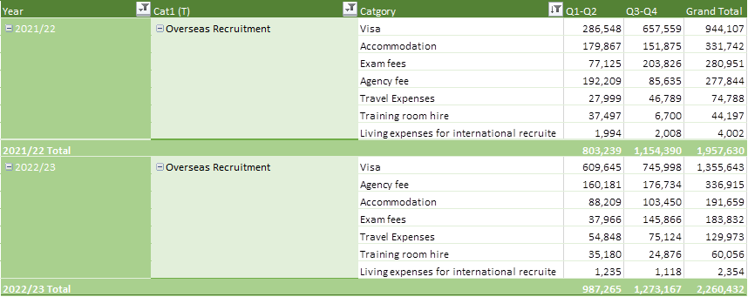Names, total number of agency providers currently being used for international recruitment and total spend with each provider for the last financial year?

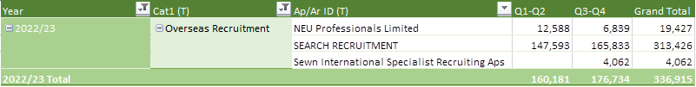

1. The average fee per Nurse, for International Recruitment via agency?

£2860

1. The main challenges faced by the Trust when recruiting overseas nurses?

OSCE exam capacity. During the last 12 months capacity at the examination centres has been limited and we have had to book exams at centres further afield as well as travel arrangements and in some cases overnight accommodation.

This information is provided for your personal use and is the property of Bedfordshire Hospitals NHS Trust and subject to any existing Intellectual Property and Database Rights. Any commercial application or use of this information may be subject to the provisions of the Re-use of Public Sector Information Regulations 2015 (RPSI). This means that if you wish to re-use the information provided for commercial purposes for any reason you must ask the Trust for permission to do so.

Please note that the Trust has a formal internal review and complaints process which is managed by the Information Governance Manager/Data Protection Officer. Should you have any concerns with our response, you can make a formal request for an internal review. Requests for internal review should be submitted within three months of the date of receipt of the response to your original letter, and should be addressed to: dataprotectionofficer@ldh.nhs.uk. This option is available to you for up to three calendar months from the date your response was issued.

If you are not satisfied with the Trust review under the Freedom of Information Act 2000 you may apply directly to the Information Commissioners Officer (ICO) for a review of your appeal decision. The ICO can be contacted at: ICO, Wycliffe House, Water Lane, Wilmslow, Cheshire, SK9 5AF www.ico.org.uk

Yours sincerely,

*FOI Officer*

Bedfordshire Hospitals NHS Foundation Trust