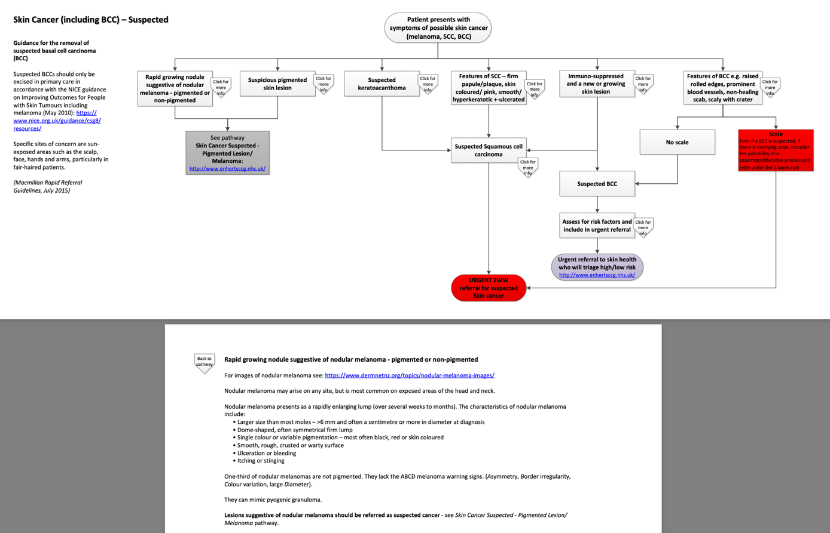
Figure 1: Guidance for removal of suspected basal cell carcinoma (East and North Hertfordshire CCG) / NHS Hertfordshire and West Essex Integrated Care Board (HWEICB)) - https://www.enhertsccg.nhs.uk/sites/default/files/pathways/Skin%20Cancer%20-%20Suspected.pdf

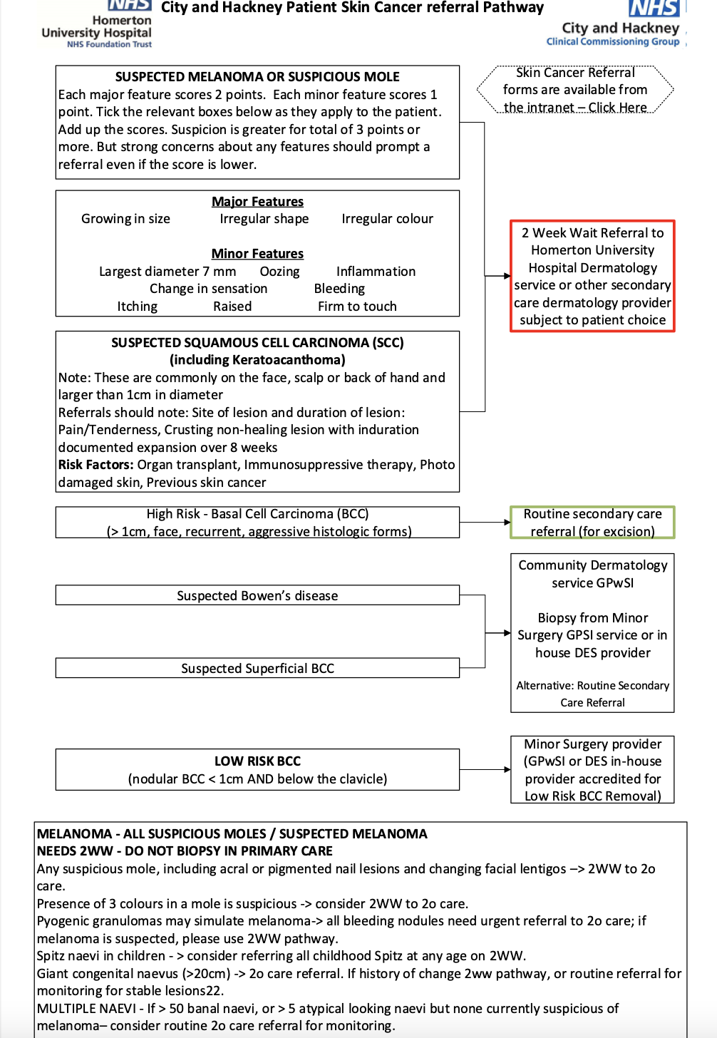
Figure 2: Patient skin cancer referral pathway (Homerton Healthcare NHS Foundation Trust) - https://gp-website-cdn-prod.s3.amazonaws.com/pathway-downloads/1518527621-3d8cfcf309d081e7aa8a3182a4100a01.pdf

