FOI 1959
Date 06/06/2023

Dear Requester,
Thank you for your Freedom of Information request. Please note, this is a cross-site response for Bedford site and Luton site.

You asked:

- The structure of the Clinical Coding Department including Clinical Coding Service Manager, Trainers & Auditors, Lead Clinical Coders, Coding Business Analysts, Clinical Coders, Trainee Clinical Coders.
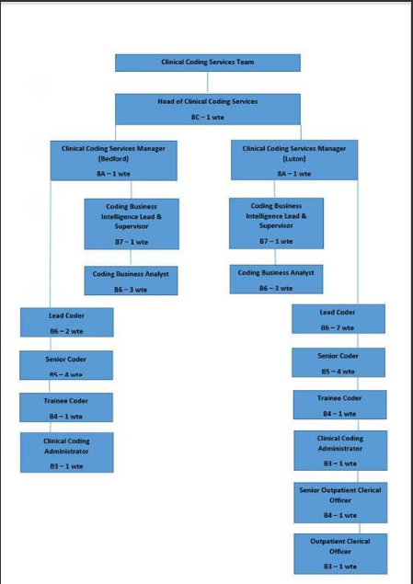

- The pay for each of these posts and how many people are employed within these posts.
See answer 1 and refer to the NHS website for the relative salaries for the banding established in the departmental structure provided.

- If the Clinical Coding Department offers a recruitment and retention incentive, how much percentage and which bands does this apply to.
N/A

- If overtime is offered within the department.
Yes

- Do you currently use Agency Coders? If so how many?
No

This information is provided for your personal use and is the property of Bedfordshire Hospitals NHS Trust and subject to any existing Intellectual Property and Database Rights. Any commercial application or use of this information may be subject to the provisions of the Re-use of Public Sector Information Regulations 2015 (RPSI). This means that if you wish to re-use the information provided for commercial purposes for any reason you must ask the Trust for permission to do so.
Please note that the Trust has a formal internal review and complaints process which is managed by the Information Governance Manager/Data Protection Officer. Should you have any concerns with our response, you can make a formal request for an internal review. Requests for internal review should be submitted within three months of the date of receipt of the response to your original letter, and should be addressed to: dataprotectionofficer@ldh.nhs.uk. This option is available to you for up to three calendar months from the date your response was issued.
If you are not satisfied with the Trust review under the Freedom of Information Act 2000 you may apply directly to the Information Commissioners Officer (ICO) for a review of your appeal decision. The ICO can be contacted at: ICO, Wycliffe House, Water Lane, Wilmslow, Cheshire, SK9 5AF www.ico.org.uk
Yours sincerely,

FOI Officer
Bedfordshire Hospitals NHS Foundation Trust

