23/02/2023

Dear Requester,

FOI 1990

Thank you for your Freedom of Information request. Please note, this is a cross-site response for Bedford site and Luton site.

You asked:
- Do you currently receive a neutral vendor managed service, or master vendor managed service, for the supply of temporary agency staff?

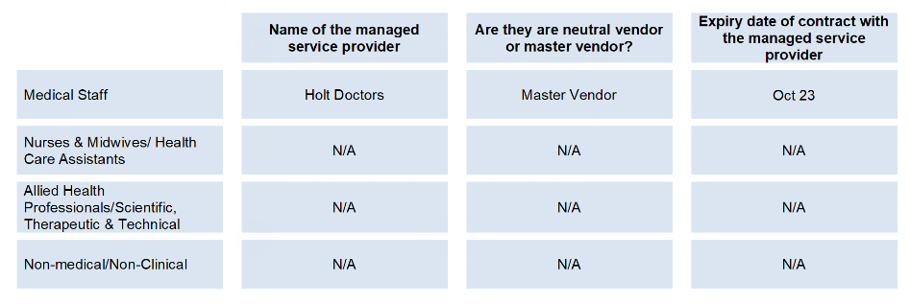
- Do you currently have a direct engagement (DE) provider in place, for VAT reclaim on agency spend?
Yes
i. Medical / Dental
- Name of the DE provider?
Bedford: Holt – Rolling contract
Luton: Allocate 247 – June 2024

- Expiry date of contract with the managed service provider? As above
ii. Allied Health Professionals (AHPs) / Scientific, Therapeutic and Technical
- Name of the DE provider?
Bedford: Holt – Rolling contract
Luton: Allocate 247 – June 2024

- Expiry date of contract with the managed service provider? As above
iii. Non-Medical, Non-Clinical (NMNC)
- Name of the DE provider? – Allocate 247 – June 2024
- Expiry date of contract with the managed service provider? As above

- Please can you provide 2022 full calendar year (01/01/2022 – 31/12/2022) spend figures on temporary agency staff (agency throughput)?
i. Medical / Dental
- 2022 spend on temporary agency staff (excluding VAT)?
£14,269,064
ii. Allied Health Professionals (AHPs) / Scientific, Therapeutic and Technical
- 2022 spend on temporary agency staff (excluding VAT)?
£3,004,718
iii. Nursing and Midwifery / Healthcare Assistants (HCAs)
- 2022 spend on temporary agency staff (excluding VAT)?
£6,019,715
iv. Non-Medical, Non-Clinical (NMNC)
- 2022 spend on temporary agency staff (excluding VAT)?
£731,651
- Please can you provide the name of the person who looks after temporary agency staffing at the Trust?

Exempt under Section 40 – Personal Information.

- Please can you provide the name of the person who leads temporary agency staffing at ICS level?

Exempt under Section 40 – Personal Information.

This information is provided for your personal use and is the property of Bedfordshire Hospitals NHS Trust and subject to any existing Intellectual Property and Database Rights. Any commercial application or use of this information may be subject to the provisions of the Re-use of Public Sector Information Regulations 2015 (RPSI). This means that if you wish to re-use the information provided for commercial purposes for any reason you must ask the Trust for permission to do so.

Please note that the Trust has a formal internal review and complaints process which is managed by the Information Governance Manager/Data Protection Officer. Should you have any concerns with our response, you can make a formal request for an internal review. Requests for internal review should be submitted within three months of the date of receipt of the response to your original letter, and should be addressed to: dataprotectionofficer@ldh.nhs.uk. This option is available to you for up to three calendar months from the date your response was issued.
If you are not satisfied with the Trust review under the Freedom of Information Act 2000 you may apply directly to the Information Commissioners Officer (ICO) for a review of your appeal decision. The ICO can be contacted at: ICO, Wycliffe House, Water Lane, Wilmslow, Cheshire, SK9 5AF www.ico.org.uk

Yours sincerely,

FOI Officer

Bedfordshire Hospitals NHS Foundation Trust

