

**Trauma and Orthopaedics**

# **Carpal bone Fracture and/or dislocation**

This is a fracture in one or more bones of your wrist

Non-displaced fractures are treated conservatively by cast immobilisation for 6 weeks.Displaced fractures usually require open reduction and internal fixation.

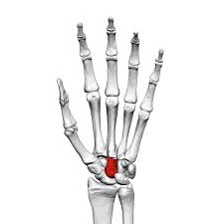

# **Healing:**

It normally takes 6 weeks to heal, but symptoms can continue for 3-6 months. For the first 4-6 weeks, the wrist is likely to be treated with a cast or a splint.

 Smoking will slow down your healing. We would advise that you stop smoking while your fracture heals. Talk to your GP or go to [www.smokefree.nhs.uk](http://www.smokefree.nhs.uk) for more information.

# **Pain and swelling:**

Painkillers are important to aid your recovery and should be used as required. Stop non-steroidal anti-inflammatory drugs (NSAIDS) e.g. Ibuprofen after 5-7 days as this will slow bone healing. You may find it continues to be a bit achy and swollen for a few months after your injury. An ice pack will help initially with pain and swelling (make sure the ice is not in direct contact with the skin).

**Splint/Strapping:**

If you have been given a splint after the cast is removed, this is for comfort and doesn’t affect the rate of healing

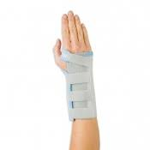

**Follow up:**

We do not routinely follow up patients with this injury as it heals well with time. However, if you continue to have pain or are limited in what you can do, please get in touch with us.

# **Caring for your injury – Week by Week**

# **0 - 2 weeks since injury**

* You will have a below elbow plaster cast or wrist support/splint
* Move your fingers gently to prevent stiffness – **See initial exercises below.**
* Cradle your arm around your waist if walking long distance and elevate

# **2 – 6 weeks since injury**

* Continue to regularly move any joints free from the plaster or splint such as elbow and fingers.
* You can use your injured hand for light tasks as pain allows.
* Cradle your arm around your waist if walking long distance and elevate

# **6 – 12 weeks since injury**

* The injury has healed. Swelling however can last for several months
* Heavy lifting could be painful for up to 8 weeks. Increase gradually using pain as a guide.

# **8+ weeks since injury**

* If you are still experiencing significant pain and swelling then please contact the Virtual Fracture Clinic for advice.

# **Caring for your injury – Initial Exercises**

**Exercise while in Plaster / Splint**

It is important to start finger exercises straight away to prevent stiffness. You will find pictures and instructions for your exercises below. Use your hand for light tasks within the limitations of pain. This will not cause further damage but failure to do so may lead to ongoing stiffness.

The following exercises should be performed slowly and regularly every day. The purpose of these exercises is to prevent stiffness in.

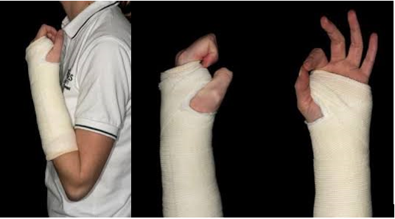

1. Bend / straighten elbow
2. Try and make a full fist.
3. Touch fingers with thumb

To be practiced every 2-3 hours.

# **Caring for your injury – Additional Exercises**

**Movement**

**Exercises on removal of plaster**

It is important to start gentle wrist exercises straight away once your plaster is removed to prevent stiffness. You will find pictures and instructions for your exercises below. Use your hand as normally as possible within the limitations of pain. This will not cause further damage but failure to do so may lead to on-going stiffness.

The following exercises should be performed slowly and regularly every 2-3 hours holding each stretch for 5-10 seconds. You can now use your other hand to add gentle pressure at the end of movement, but do not force movement.

Little and often (a few of each exercise every 2-3 hours) is better that doing lots of repetitions.

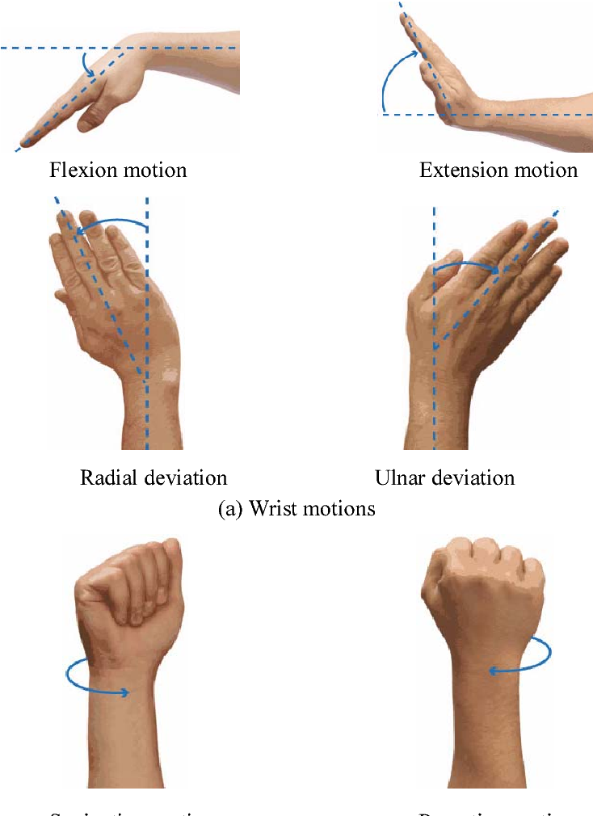

**Strength**

You can do some simple exercises to help increase strength. Practice up to 3 times a day starting with 5 repetitions, increasing to 10 as able.

 Use an elastic band around your fingers to strengthen the muscles in the hand.

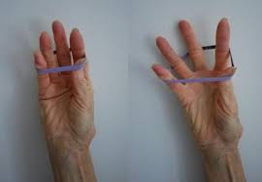

Using a light weight (1/2 – 1kg), place your wrist over the edge of the table and practice wrist flexion and extension.

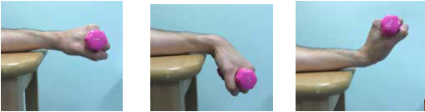

Using a light weight (1/2 – 1kg), place wrist over the edge of the table palm forward and then turn arm with palm up

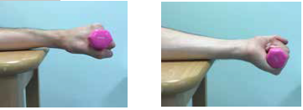

**Strength continued**

Using a light weight (1/2 – 1kg), place wrist over the edge of the table and on it’s side. Tilt wrist up and down.

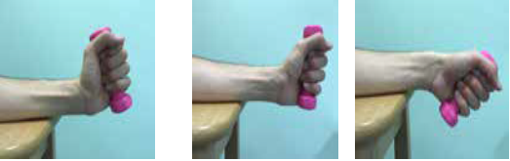

Using a light theraband, hold it with your injured hand and move the wrist down and up using the theraband to resist the movement. Also, with your wrist on its side, tilt wrist up and down using the theraband to provide some resistance.

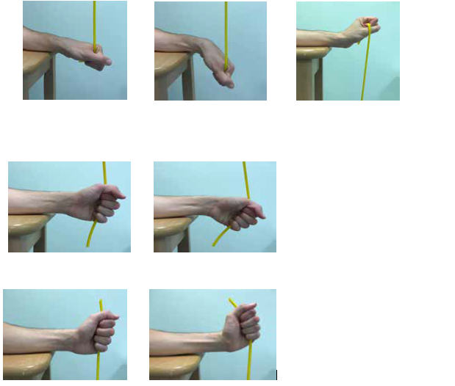

**Frequently Asked Questions**

**I’m concerned about my symptoms and/or I am struggling to return to exercise.**

Please contact the Virtual Fracture Clinic.

**I am struggling with my plaster/splint. What do I do?**

Contact the Virtual Fracture Clinic. We can give advice or change your splint if needed.

**When can I start driving?**

You can return to driving when:

* You can move comfortably and
* You can control the vehicle safely.

Always test your ability to drive in a safe environment first.

**How can I get a certificate for work?**

You can get a fitness for work statement from your GP.

**How do I contact the Virtual Fracture Clinic?**

Call 01582 718121. Our receptionist will arrange for a clinician to contact you. Email VFC@ldh.nhs.uk

*Some pictures and content produced by Brighton and Sussex University Hospital and shared with permission.*

**Bedfordshire Hospitals NHS Foundation Trust**

**Luton and Dunstable University Hospital**

**Lewsey Road**

**Luton, LU4 0DZ**

[**www.bedfordshirehospitals.nhs**](http://www.bedfordshirehospitals.nhs)**.uk**

**@LandDHospital**