Appendix 1 - The Trust’s Vision Statement, Values and Corporate Objectives

EDHR strategy needs to be embedded into all that the Trust does and particularly within corporate vision, values and objectives. Key words that describe this are Fair treatment, Access, Inclusion, Respect and dignity (FAIR). This means valuing diversity and difference and meeting different needs to attain good patient and workforce experience.

Our Vision statement

To attract the best people, value and develop them so that the teams they work in deliver outstanding care to our patients.

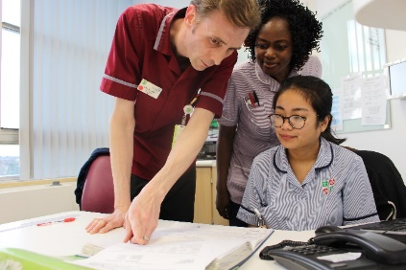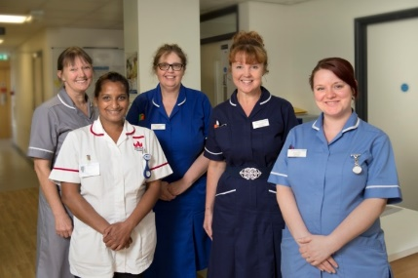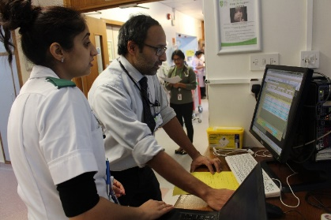

Our Values
Our values are based on this meaningful acronym which means to grow, develop, or be successful:

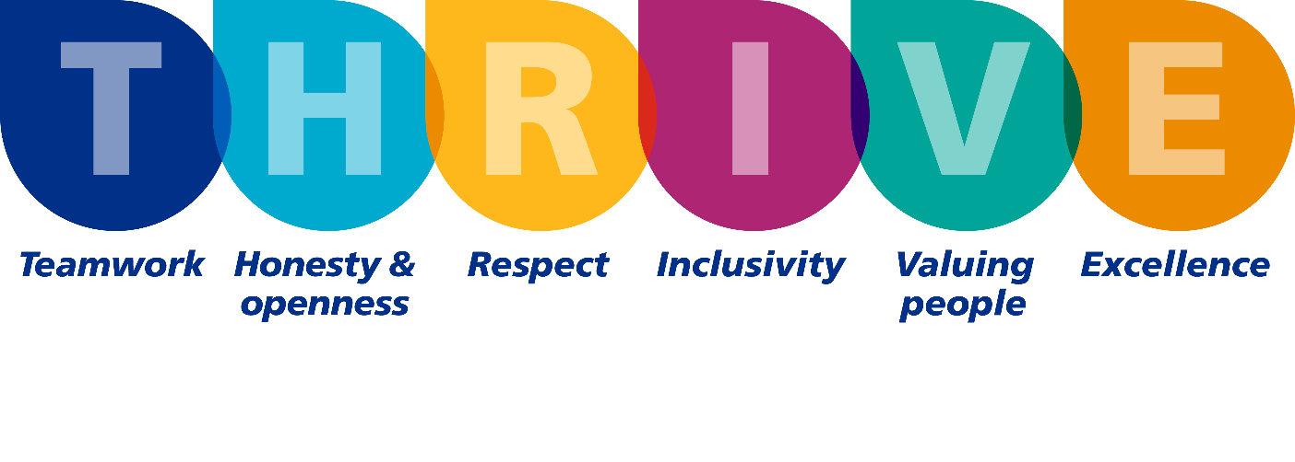
Teamwork
We work mindfully and collaboratively to create a well-organised, professional, and supportive atmosphere that achieves the best possible outcomes for all. We do this by:
- Communicating effectively and respectfully with our colleagues
- Valuing all contributions and taking the time to listen to each other
- Making decisions together to provide the best possible service for all.

Honesty & Openness

We are open, authentic and have integrity in all we do, reflecting on our actions to improve the quality of care and experience we deliver. We do this by:
- Openly sharing constructive feedback with others in a kind and empathetic way
- Understanding the impact and value of our role on patients, colleagues and carers
- Contributing to a just and learning culture by supporting colleagues to learn and reflect when things do not go as expected
- Being open about every aspect of our work and the challenges that come with performing our roles.

Respect
We respect colleagues, patients and carers by actively listening, responding, and providing everyone with a voice to create a positive reciprocal work atmosphere. We do this by:
- Showing empathy and understanding when communicating with others
- Valuing the importance of everyone’s role within the team and their distinct contribution to achieving goals
- Taking the time to actively listen and respond to patients, colleagues and carers
- Respecting each other as equally capable, independent people.

Inclusivity
We are fair and inclusive, giving access for all to our service and workforce by considering and valuing difference, and appreciating the diversity within our community and workforce. We do this by:
- Supporting the diverse communities we serve in our working life
- Confidently challenging discriminative behaviour
- Considering different needs in order to:
  - Provide fair access for everyone to our services
  - Ensure that our workforce has equal access to opportunities.

Valuing People
We value patients, colleagues and carers as individuals by showing care and empathy, working to create a culture where we look after each other’s wellbeing. We do this by:
- Acknowledging everyone’s efforts and successes
- Taking the time to care for our own wellbeing and check in on others
- Encouraging a supportive community that enables everyone to make a difference.

By demonstrating the first five values we are able to achieve the value of excellence:
Excellence
We share knowledge, information and support each other to develop, innovate and learn. Always looking at ways we can improve the care, safety and experience of our patients and the sustainability of our hospitals. We do this by:
- Being open to challenges and improvement
- Acting on and embracing constructive feedback
- Collaborating with others to share innovative ideas
- Consistently learning from and reflecting on the things we get right and wrong.

Our Corporate Objectives
- Deliver the Quality Priorities Outlined in the Quality Account
- Deliver National Quality and Performance Targets
- Implement Our Strategic Plan
- Secure and Develop a workforce to meet the needs of our Patients
- Optimise our Financial Plan.

