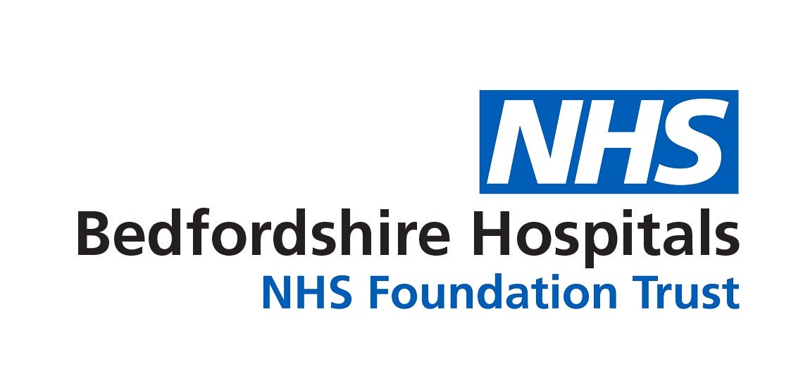
Workforce Race Equality Standard
WRES Report 2021
(With reference to 2015-2020 WRES results)
12th August 2021

Trust Board Leads for the WRES | Angela Doak - Director of Human Resources Liz Lees - Chief Nurse.
Lead manager compiling this report | Diane Brown – Equality and Diversity Lead
Date this report was approved by the Trust Board | TBC

Website URL where this report can be found: https://www.bedfordshirehospitals.nhs.uk/corporate-information/equality-and-diversity/annual-reports-and-relevant-documents/

Introduction and Background
Formation of Bedfordshire Hospitals NHS Foundation Trust BHFT:
The Trust was formed April 1, 2020 from the merger of Bedford General Hospital with Luton and Dunstable University Hospital NHS Foundation Trust. The 2 hospitals reported separately until 2021. This report covers BHFT results with some site specific details.

WRES requirements

The WRES has been mandated in the NHS Contract since 2015 to help ensure that Black Minority Ethnicities (BME) staff have equal access to career opportunities and fair treatment in the workplace. National NHS research data has indicated that less favourable treatment of BME staff can and does occur. NHS England and the NHS Equality and Diversity Council created the WRES as a tool to enable NHS organisations to address this.

Nine WRES Indicators

The Trust submits WRES data annually to demonstrate progress against 9 indicators of workforce race equality.

Two indicators (1 and 9) focus on BME representation across the Trust at Board Level, in senior management, and across all Pay Bands clinical and non-clinical.

Three relate to likelihood of shortlisting to appointment (2) disciplinary (3), and access to non-mandatory training and continued professional development (4).

The other indicators (5 to 8) are in the National NHS Staff Survey and highlight any differences in the experience and treatment of White and BME staff in relation to patient or colleague conduct, and their belief in Equal Opportunities.
Submitted data is benchmarked nationally for transparency and for sharing of learning and good practice. Trusts are expected to understand their data, report on it, make inquiry into causes of any poor results and have robust evidenced action plans.
The National Report produced covers progress and recommendations.
Care Quality Commission Inspections CQC

WRES performance is included in the CQC Inspection “well led” domain supported by WRES advisors. This includes analysis of the Trust’s WRES Report and action plan and how any issues have been addressed. The last main CQC inspection for both sites were in late 2018 where results were good for Luton but improvements were required for Bedford in the effectiveness and well led domains.

Covid 19 - Health inequalities – The WRES process was initially paused nationally in 2020 in response to COVID-19 but re-instated as the disproportionate impact of COVID-19 on Disabled and BME staff and communities was realised. There was an evident need to understand how best to respond and how any decisions may impact on BME and wellbeing. In 2021 and 2002 this process is unchanged.
Trust Commitment - The Trust publishes an Annual WRES report on the Trust website for transparency, scrutiny and an action plan for continuous improvement. The report format includes the responses required in the WRES data submission.

The Trust is one of the more diverse organisations in the NHS and in the UK and is committed to the WRES. Also to promoting EDI in the workforce, and to the inclusive leadership crucially associated with good workforce and patient experience, such as increased staff morale or access to a wider talent pool and improved patient-centered care and innovation.

The WRES General Data
National Changes to WRES reporting in 2021
National Changes to WRES reporting for 2021 were:
- Indicator 1 - clearer definition of “senior medical manager” / “very senior manager”.
- Indicator 2 and 3 have been simplified. The calculation has moved from using a two-year rolling average to using the year end figure. For Indicator 2, organisations are expected to include the shortlisting for internal and external recruitment activity
- Indicator 9 now requires submission of data that disaggregate: (i) the voting /non-voting members of boards, and (ii) the executive / non- executive members of boards. Also to ensure that no board members have unknown ethnicity.

National Changes in 2022 – “WRES phase two”
WRES Phase 2 focuses on enabling people to work comfortably with race equality by:
- Using communications and engagement to change any deep rooted cultures of race inequality in the system, learn more about the importance of equity, to build capacity and capability to work with race.
- Continuous embedding of accountability to ensure key policies have race equality built into their core, so that eventually workforce race becomes everyday business.
- The WRES will continue to work to evidence the outcomes of the work that is done, publishing data and supporting the system by sharing replicable good practice.
Completeness of data and reliability of year on year comparisons
Data is taken from the NHS Electronic Staff Record ESR payroll system. Staff provide their ethnicity on recruitment application and staff appointment forms as standard practice.

Workforce data

What period does our workforce data refer to? - This report captures annual data from 1st April to 31st March and data as of 31st March each year.

Total staff and Declaration of Ethnicity

At March 31st 2022 there were 8104 staff, an increase from the 8022 in 2021. In the 6 years up until 2021, a smaller percentage of LDH workforce had not declared their ethnicity at 1.5% to 3.97% whereas BH records 3.3 to 5.1% in the same period.

Percentage of staff who have not declared their ethnicity by site
Report @ | 2015 | 2016 | 2017 | 2018 | 2019 | 2020 | 2021
Luton | 3.5% | 2.5% | 3.5% | 4.0% | 2.3% | 1.5% | 2.6%
Total Staff | 3880 | 3813 | 3950 | 4206 | 4353 | 4649 | 4911
Bedford | 3.3% | 4.0% | 4.9% | 5.0% | 5.0% | 5.0% | 5.1%
Total staff | 2607 | 2746 | 2727 | 2812 | 2930 | 3035 | 3111
TOTAL STAFF | 6487 | 6559 | 6677 | 7018 | 7283 | 7684 | 8022

BHFT DECLARATION RESULT 2021 and 2022
 | 2021 | 2022
Total Staff | 8022 | 8104
Non declaration | 3.6% | 3.7%
Equates to staff of | 289 | 300

Measures to improve the level of self-reporting by ethnicity

Steps to date - ESR has internet and smart phone app access and a staff user guide. Staff are encouraged to apply for an account and use it. Our EDHR weeks have included a "what's it got to do with you?" initiative about organisational and personal benefits and values of declaration. Steps planned: further encouragement of ESR use, continued initiatives promoting data value via communications and BME network.

Site Specific details - in the line chart that follows, both sites have a trend of increasing BME to White ratios which is at a higher level at LDH than BH:

- 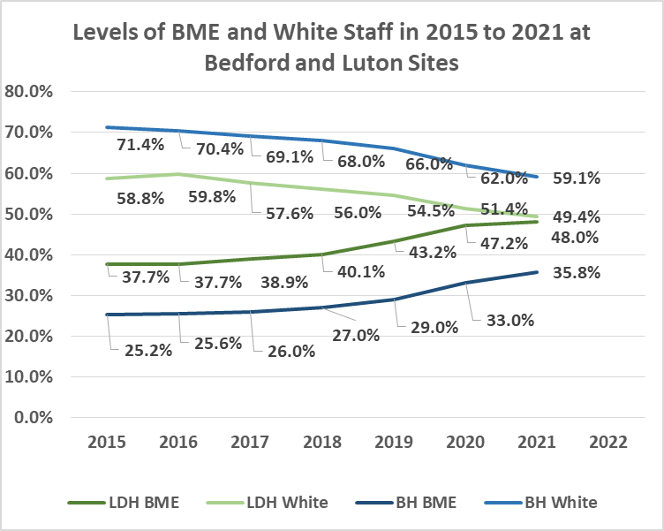
- LDH staff increased from 3813 in 2015 to 4911 in 2021 (by 29% / 836 staff)

BME ratio increasing from 37.7% to 48% (10.3% increase) in that period with an equivalent decrease in White ratio.

- BH staff increased from 2607 in 2015 to 3111 in 2021 (by 19%/ 504 staff) with the BME ratio increasing from 25.2% to 35.8% (10.6% increase) in that period with an equivalent decrease in White ratio.
- BME site ratios in 2021 – LDH 48% and BH 35.8%
- BHFT BME ratio in 2021 was 43.3% and in 2022 is 45.4% (a 2.1% increase).
BHFT Staff ratios and declaration | 2021 |  | 2022
Total Staff numbers | 8022 | 100% | 8106 | 100%
BME staff - | 3470 | 43.3% | 3680 | 45.4%
White staff - | 4265 | 53.2% | 4126 | 50.9%
Proportion self-reporting ethnicity | 7734 | 96.4% | 7806 | 96.3%
Non- declaration by staff | 288 | 3.6% | 300 | 3.7%

INDICATORS - Workforce Race Equality Indicators -
For each of these workforce indicators, we compare the data for White and BME staff.

- Indicator 1 - Percentage of BME staff in each salary range by clinical / non-clinical staff compared to the percentage of staff in the overall workforce.

SUBMITTED BHFT Results 2022 - For Indicator 1 BME Representation - (BME, White and Other in Clinical / Non Clinical Bands and Groups) - BY NUMBER
Grades Bands | Clinical |  |  |  | NON Clinical |  |  |  | Grand
Grades Bands | BME | White | other | Total | BME | White | other | Tot | Total
Band 1 |  | 3 |  | 3 | 11 | 24 | 1 | 36 | 39
Band 2 | 399 | 478 | 47 | 924 | 142 | 240 | 10 | 392 | 1316
Band 3 | 122 | 255 | 24 | 401 | 100 | 262 | 16 | 378 | 779
Band 4 | 116 | 157 | 15 | 288 | 119 | 320 | 8 | 447 | 735
Band 5 | 873 | 387 | 60 | 1320 | 54 | 136 | 3 | 193 | 1513
Band 6 | 558 | 643 | 30 | 1231 | 33 | 69 | 3 | 105 | 1336
Band 7 | 194 | 513 | 15 | 722 | 37 | 79 | 3 | 119 | 841
Band 8a | 65 | 102 | 9 | 176 | 22 | 46 | 1 | 69 | 245
Band 8b | 7 | 40 | 2 | 49 | 7 | 28 | 1 | 36 | 85
Band 8c | 1 | 14 |  | 15 | 3 | 20 |  | 23 | 38
Band 8d | 3 | 5 |  | 8 | 1 | 13 |  | 14 | 22
Band 9 |  | 3 |  | 3 | 1 | 5 |  | 6 | 9
VSM |  | 2 |  | 2 |  | 7 |  | 7 | 9
Ad hoc | 1 | 8 | 1 | 10 |  | 7 |  | 7 | 17
Junior | 289 | 84 | 14 | 387 |  |  |  | 0 | 387
Middle | 214 | 25 | 20 | 259 |  |  |  | 0 | 259
Consultant | 308 | 149 | 17 | 474 |  |  |  | 0 | 474
 | 3150 | 2868 | 254 | 6272 | 530 | 1256 | 46 | 1832 | 8104

SUBMITTED BHFT Results 2022 - For Indicator 1 BME Representation - by PERCENTAGE
Grades Bands | Clinical |  |  |  | NON Clinical |  |  |  | Grand
Grades Bands | BME | White | other | Total | BME | White | other | Tot | Total
Band 1 | 0.0% | 100.0% | 0.0% | 3 | 30.6% | 66.7% | 2.8% | 36 | 39
Band 2 | 43.2% | 51.7% | 5.1% | 924 | 36.2% | 61.2% | 2.6% | 392 | 1316
Band 3 | 30.4% | 63.6% | 6.0% | 401 | 26.5% | 69.3% | 4.2% | 378 | 779
Band 4 | 40.3% | 54.5% | 5.2% | 288 | 26.6% | 71.6% | 1.8% | 447 | 735
Band 5 | 66.1% | 29.3% | 4.5% | 1320 | 28.0% | 70.5% | 1.6% | 193 | 1513
Band 6 | 45.3% | 52.2% | 2.4% | 1231 | 31.4% | 65.7% | 2.9% | 105 | 1336
Band 7 | 26.9% | 71.1% | 2.1% | 722 | 31.1% | 66.4% | 2.5% | 119 | 841
Band 8a | 36.9% | 58.0% | 5.1% | 176 | 31.9% | 66.7% | 1.4% | 69 | 245
Band 8b | 14.3% | 81.6% | 4.1% | 49 | 19.4% | 77.8% | 2.8% | 36 | 85
Band 8c | 6.7% | 93.3% | 0.0% | 15 | 13.0% | 87.0% | 0.0% | 23 | 38
Band 8d | 37.5% | 62.5% | 0.0% | 8 | 7.1% | 92.9% | 0.0% | 14 | 22
Band 9 | 0.0% | 100.0% | 0.0% | 3 | 16.7% | 83.3% | 0.0% | 6 | 9
VSM | 0.0% | 100.0% | 0.0% | 2 | 0.0% | 100.0% | 0.0% | 7 | 9
Adhoc | 10.0% | 80.0% | 10.0% | 10 | 0.0% | 100.0% | 0.0% | 7 | 17
Junior | 74.7% | 21.7% | 3.6% | 387 |  |  |  | 0 | 387
Middle | 82.6% | 9.7% | 7.7% | 259 |  |  |  | 0 | 259
Consultant | 65.0% | 31.4% | 3.6% | 474 |  |  |  | 0 | 474
 | 3150 | 2868 | 254 | 6272 | 530 | 1256 | 46 | 1832 | 8104

BHFT RESULTS FOR 2021 - Submitted 2021 - Indicator 1 BME Representation - (BME, White and Other in Clinical / Non Clinical Bands and Groups) - BY NUMBER
 | CLINICAL STAFF |  |  |  | NON CLINICAL STAFF |  |  |  | Grand
 | BME | White | Not known | total | BME | White | Not known | total | total
Ad-hoc |  |  |  | 0 | 1 | 3 |  | 4 | 4
band 1 |  |  |  | 0 | 17 | 37 | 1 | 55 | 55
band 2 | 368 | 441 | 34 | 843 | 166 | 372 | 16 | 554 | 1397
band 3 | 68 | 162 | 13 | 243 | 101 | 288 | 18 | 407 | 650
band 4 | 190 | 190 | 15 | 395 | 106 | 336 | 7 | 449 | 844
band 5 | 805 | 441 | 66 | 1312 | 47 | 117 | 1 | 165 | 1477
band 6 | 485 | 682 | 32 | 1199 | 32 | 67 | 3 | 102 | 1301
band 7 | 182 | 497 | 13 | 692 | 29 | 81 | 2 | 112 | 804
band 8a | 55 | 109 | 8 | 172 | 24 | 41 | 2 | 67 | 239
band 8b | 8 | 36 | 1 | 45 | 4 | 30 | 1 | 35 | 80
band 8c | 2 | 12 | 1 | 15 | 2 | 19 |  | 21 | 36
band 8d | 2 | 6 |  | 8 | 2 | 15 |  | 17 | 25
band 9 |  | 2 |  | 2 | 1 | 8 |  | 9 | 11
Board |  |  |  | 0 | 1 | 9 |  | 10 | 10
Non Exec |  |  |  | 0 | 1 | 6 |  | 7 | 7
consultants | 293 | 143 | 15 | 451 |  |  |  | 0 | 451
junior | 409 | 97 | 32 | 538 |  |  |  | 0 | 538
middle | 69 | 18 | 6 | 93 |  |  |  | 0 | 93
 | 2936 | 2836 | 236 | 6008 | 534 | 1429 | 51 | 2014 | 8022

SUBMITTED BHFT Results 2021 - For Indicator 1 BME Representation - by clinical and non- clinical Bands and by PERCENTAGE
BHFT Trust: | CLINICAL STAFF |  |  |  | NON - CLINICAL STAFF
BHFT Trust: | BME | White | Unknown |  | BME | White | Unknown
Ad hoc |  |  |  |  | 25.0% | 75.0% | 0.0%
band 1 |  |  |  |  | 30.9% | 67.3% | 1.8%
band 2 | 43.7% | 52.3% | 4.0% |  | 30.0% | 67.1% | 2.9%
band 3 | 28.0% | 66.7% | 5.3% |  | 24.8% | 70.8% | 4.4%
band 4 | 48.1% | 48.1% | 3.8% |  | 23.6% | 74.8% | 1.6%
band 5 | 61.4% | 33.6% | 5.0% |  | 28.5% | 70.9% | 0.6%
band 6 | 40.5% | 56.9% | 2.7% |  | 31.4% | 65.7% | 2.9%
band 7 | 26.3% | 71.8% | 1.9% |  | 25.9% | 72.3% | 1.8%
band 8a | 32.0% | 63.4% | 4.7% |  | 35.8% | 61.2% | 3.0%
band 8b | 17.8% | 80.0% | 2.2% |  | 11.4% | 85.7% | 2.9%
band 8c | 13.3% | 80.0% | 6.7% |  | 9.5% | 90.5% | 0.0%
band 8d | 25.0% | 75.0% | 0.0% |  | 11.8% | 88.2% | 0.0%
band 9 | 0.0% | 100.0% | 0.0% |  | 11.1% | 88.9% | 0.0%
Ad hoc board |  |  |  |  | 10.0% | 90.0% | 0.0%
Ad hoc non |  |  |  |  | 14.3% | 85.7% | 0.0%
consultants | 65.0% | 31.7% | 3.3%
junior | 76.0% | 18.0% | 5.9%
middle | 74.2% | 19.4% | 6.5%
TOTAL % | 48.9% | 47.2% | 3.9% | 0 | 26.5% | 71.0% | 2.5%

Supplementary information and analysis for indicator 1 follows:

CLINICAL AND NON CLINICAL BY SITE (White, BME and Unknown)

The hospitals merged to form BHFT at April 2020 but the ESR payroll systems did not merge until April 2021. It is now not as easy to do site comparators. However for Y/E March 2021 the workforce percentage ratios for clinical to non-clinical were respectively for:

BHFT 2021 | CLINICAL | NON CLINICAL | Totals | Percentage Split
BHFT 2021 | 6008 | 2014 | 8022 | 74.9% clinical : 25.1% non-clinical
LDH | 3802 | 1109 | 4911 | 77.4% clinical : 22.6% non-clinical
BH | 2210 | 901 | 3111 | 71% clinical : 29% non-clinical

FOR BHFT at Year end 2021 – of the 8022 staff, the clinical staff at 6008 accounted for 74.9% of the workforce of which 48.9% are BME (workforce BME ratio at 43.3%)

AT 2021 -
- LDH workforce BME 48% clinical ratio of BME staff was 53.2% non-clinical 30.3%
- BH workforce BME 35.8% clinical ratio of BME staff was 41.4% non-clinical 22%

Comparing Clinical and Non Clinical by site 2021 |  |  |  |  |  | BHFT TRUST RESULTS 2021 Clinical - Non Clinical staff
CLINICAL STAFF
Site | Luton & Dunstable |  | Bedford |  |  |  | CLINICAL
white | 1671 | 44.00% | 1169 | 52.90% |  | white | 2836 | 47.2%
BME | 2021 | 53.20% | 916 | 41.40% |  | BME | 2936 | 48.9%
unknown | 110 | 2.90% | 125 | 5.70% |  | unknown | 236 | 3.9%
Total | 3802 |  | 2210 |  |  | Total | 6008
NON CLINICAL STAFF |  |  |  |  |  |  | NON CLINICAL
Site | Luton & Dunstable |  | Bedford |  |  | white | 1429 | 71.0%
white | 755 | 68.10% | 670 | 74.40% |  | BME | 534 | 26.5%
BME | 336 | 30.30% | 198 | 22.00% |  | unknown | 51 | 2.5%
unknown | 18 | 1.60% | 33 | 3.70% |  | Total | 2014
Total | 1109 |  | 901 |  |  | TOTAL | 8022
SITE TOTALS |  |  |  |  |  | BHFT TOTALS YE 2021
Site | Luton & Dunstable |  | Bedford
WHITE | 2426 | 49.40% | 1839 | 59.10% |  | WHITE | 4265 | 53.2%
BME | 2357 | 48.00% | 1114 | 35.80% |  | BME | 3470 | 43.3%
unknown | 128 | 2.60% | 158 | 5.10% |  | unknown | 287 | 3.6%
Total | 4911 |  | 3111 |  |  | Total | 8022

Other Bands Clinical and Non-clinical need to be further analysed also for representation at senior grades as can be seen from the preceding charts for BHFT, LDH and BH.

Medical Grades - For instance medical staff are a high percentage of the workforce and are in the top pay quartile. The high level of male consultants in particular impact the Gender Pay for females and the level of BME impacts the Ethnicity Pay Gap in favour of BME.

The high increase in BME representation generally is reflected in the results for the numbers and the likelihood of BME and White moving from being shortlisted to being appointed – see Indicator 2.

In terms of the workforce being representative of the population it serves, looking at LDH which has the highest level of BME: For LDH - BME representation in Medical grades has been increasing:

LDH Junior: 2018 - 53.2% / 2019 - 69.9% / 2020 - 78.3% / 2021 80.2% / BHFT 2022 74.7%
LDH Middle: 2018 - 59.7% / 2019 - 62.5% / 2020 - 67.2% / 2021 72.3% / BHFT 2022 82.6%
LDH Consultants: 2018 –65.8% / 2019 – 65.4% / 2020 – 66.7% / 2021 - 66.3%/ BHFT 2022 65%

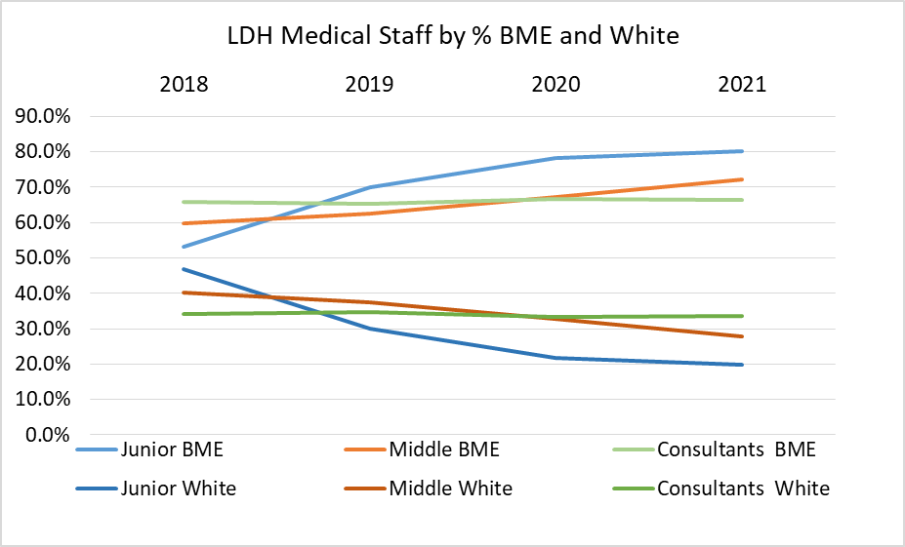

In terms of the workforce being representative of the population it serves the workforce BME is an over representation compared to the population.

- Indicator 2 - Relative likelihood of staff being appointed from shortlisting across all posts

The likelihood of White to BME being appointed by year – (A figure below “1” indicates white are less likely than BME candidates to be appointed from shortlisting) – NB since 2021 calculation requirements changed from using a two-year rolling average to using the year end figure.

From 2015 to 2018 for both BH and LDH, White staff were proportionally more likely to be appointed than BME staff by an average of 1.66 to 1.37 times respectively. The reverse happened in 2019 to 2021 with both sites indicating White staff were less likely to be appointed from shortlisting – BH ratios at 0.87 to 0.59 and at LDH of 0.43 times.

Relative likelihood from shortlist to appointment 2015 to 2020 by Site |  |  |  |  |  |  | BHFT:
YE / ratio | 2015 | 2016 | 2017 | 2018 | 2019 | 2020 | 2021 | 2022
Luton LDH | 1.9 | 1.96 | 1.3 | 1.48 | 0.43 | 0.43 | 1.25 | 1.73
Bedford BH | 1.33 | 1.32 | 1.46 | 1.39 | 0.87 | 0.59 | 1.25 | 1.73

Important to note: The WRES does not ask for the level of numbers across the ethnicities within the recruitment process. Nor to show the proportions that apply, the proportions that once shortlisted attend an interview or those who once they have received an offer accept the post.

For an organisation like the Trust which is seeing a steady increase in BME staff numbers and ratio’s in addition to a circa 10% White Other ethnicity ratio, these are significant performance details.

For example - BHFT recruitment data last year showed circa 72.6% of applicants, 71.9% of shortlisted and 64.7% of new recruits, were of a BME background and this has been a continuing trend.

BHFT RECRUITMENT DATA Y/E 31st March 2021
BHFT | Applied | % | short list | % | offered | %
white | 5235 | 24.9% | 3061 | 25.8% | 199 | 29.1%
BME | 15266 | 72.6% | 8511 | 71.9% | 442 | 64.7%
not known | 537 | 2.6% | 271 | 2.3% | 42 | 6.1%
 | 21038 |  | 11843 |  | 683
BREAKDOWN OF NOT KNOWN DECLARATION
 | Applied | % | short list | % | offered | %
not stated | 46 | 0.2% | 3 | 0.0% | 25 | 3.7%
not wish to disclose | 498 | 2.4% | 268 | 2.3% | 17 | 2.5%
In the unknowns, there is a high ratio of those who do not wish to disclose their ethnic origin e.g. 6.1% or 42 people made an offer had ethnicity unknown. This affects the result e.g. if the 6.1% were BME the offer level for BME would be 70.8% increasing BME likelihood.

Also from the chart that follows BME in 2021 are over represented in the recruitment process which reduces their likelihood in the calculation.

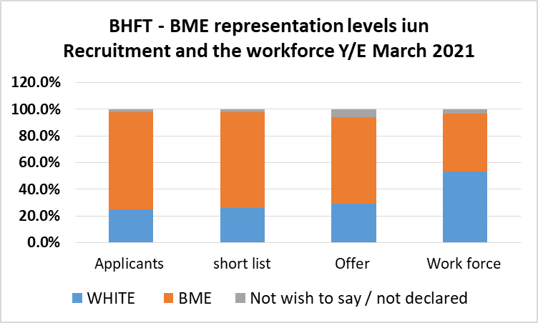

In 2022 compared with 2021 data, the trend for BME ratios to be high in the recruitment process continues at 74.2% of applicants (circa 2% increase), 75.9% of shortlisted (circa 4% increase) and 63% of offers (1.7% decrease). In the unknowns, there is a lower ratio of those have not disclosed their ethnic origin at 4.8% or 48 made an offer with ethnicity unknown. This affects the result e.g. if these 4.8% were BME the offer level for BME would be 67.8% increasing BME likelihood.

BHFT RECRUITMENT DATA Y/E 31st March 2022
BHFT | Applied | % | short list | % | offered | %
white | 7580 | 23.6% | 3842 | 22.4% | 318 | 32.1%
BME | 23841 | 74.2% | 13035 | 75.9% | 624 | 63.0%
not known | 729 | 2.3% | 298 | 1.7% | 48 | 4.8%
 | 32150 |  | 17175 |  | 990
BREAKDOWN OF NOT KNOWN DECLARATION
BHFT | Applied | % | short list | % | offered | %
not stated | 134 | 0.42% | 7 | 0.04% | 32 | 3.23%
not wish to disclose | 595 | 1.85% | 291 | 1.69% | 16 | 1.62%
 | 729 |  | 298 |  | 48
In 2022 BHFT has also looked at interview and recruited stages (in the chart that follows).

Results can really depend on how many clinical and non-clinical roles are being recruited for, as clinical make up circa 77% of the workforce and are 48% BME.

From the chart data it appears proportionally less BME are interviewed and offered but there could be other explanations or reasons E.g. a higher level of BME as applicants and shortlisted for a clinical role would affect the number of BME actually receiving an offer and distort results.

BHFT 2022 | apps | short list | Interviewed | offered
white | 7580 | 3842 | 2240 | 318
BME | 23841 | 13035 | 3921 | 624
not known | 729 | 298 | 207 | 48
TOTAL | 32150 | 17175 | 6368 | 990
BHFT 2022 | apps | short list | Interviewed | offered
white | 23.6% | 22.4% | 35.2% | 32.1%
BME | 74.2% | 75.9% | 61.6% | 63.0%
not known | 2.3% | 1.7% | 3.3% | 4.8%

(NB – Staff are also recruited to the bank of staff including some of whom have not been through a process e.g. employees who are retiring and want to keep a hand in at work. The WRES team are looking at a WRES for bank staff later this year).

The recruitment representation chart that follows shows that a white applicant is more likely to be appointed than a BME applicant - But that BME applicants are over represented in the recruitment process and this will distort the results especially if over represented in the role they have applied for.

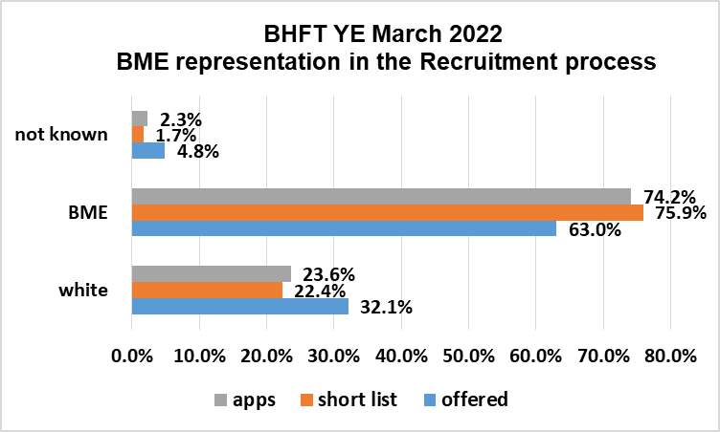

- Indicator 3 - Relative likelihood of staff entering the formal disciplinary process, (by entry into a formal disciplinary investigation).
Note - The calculation requirement has been changed this year from using a two-year rolling average to using the year end figure.
Historically for the LDH and BH sites between 2015 and 2021 results have been:
INDICATOR 3 DISCIPLINARY
by staff numbers in the process at years ending March 31st:
 | 2015 | 2016 | 2017 | 2018 | 2019 | 2020 | 2021
LDH | 24 | 15 | 38 | 37 | 37 | 33 | 19
Ratio | 0.80 | 0.79 | 0.80 | 1.24 | 1.33 | 0.70 | 0.50
BH |  |  |  |  |  |  | 17
Ratio | 1.08 | 1.27 | 1.26 | 1.17 | 1.09 | 1.63 | 0.32

A figure below “1” indicates BME less likely than white to enter a formal disciplinary process.

Relative likelihood of BME entering the process 2015-2020 compared to White Staff:

- LDH - 4 of 6 years - BME less likely to enter a disciplinary process with an average ratio of 0.88.
- BH – for 6 years BME more likely to enter a disciplinary process with an average ratio of 1.25.

In 2021 the figures at each site and Trust wide are below 1 indicating BME less likely than white to enter a formal disciplinary process. This was the best result for both sites for the 7 years in terms of BME. The BHFT result is by 0.41 - less likelihood for BME.

BHFT Indicator 3 – disciplinary results submitted for Y/E March 2021 and 2022

Submitted BHFT results for Indicator 3 disciplinary in 2021 and 2022
At Y/E March 2021 |  | At Y/E March 2022
Number | 36 | Number | 58
Ratio | 0.41 | Ratio | 1.20

Notation at year end 2021 – the result was good for BME Case numbers in all areas (discipline, capability and grievance) fell compared with previous years. It is believed to be partially connected to the Covid-19 pandemic, cases being resolved through informal measures during this time, and the increased number and use of Freedom to Speak up Champions who helped with solutions in some cases.

Notation at year end 2022 – The result was poorer for BME - Case numbers in 2022 increased by 77% (from 36 in 2021 to 64 in 2022 of which 6 were unknown ethnicity). Using the data this

BHFT | Total Employees |  | Total Disciplinary Cases |  | Cases as Proportion of Total Workforce
BHFT | No | % | No. | % | %
White | 4126 | 50.9% | 28 | 48.3% | 0.3%
BAME | 3680 | 45.4% | 30 | 51.7% | 0.4%
 | 7806 |  | 58 |  | 0.7%
Unknown | 300 | 3.7% | 6 | 9.4% | 0.1%
 | 8106 |  | 64 |  | 0.8%

- Indicator 4 - Relative likelihood of staff accessing non-mandatory training and Continued Professional Development (CDP)

A figure below “1” indicates white staff are less likely to access non-mandatory training/ CPD than BME staff.

Indicator 4 results –site specific and for BHFT at March 31st 2022
Y/E March 31st | 2017 | 2018 | 2019 | 2020 | 2021 | 2022
LDH ratio | Neutral | 1.12 | 0.98 | 0.94 | 0.89 | 0.88
BH Ratio | 1.49 | 0.91 | 0.54 | 0.50 | 0.83 | 0.85
 |  |  | BHFT |  | 0.87 | 0.86

In the last 4 years for LDH / BH, and for BHFT in 2021 and 2020, there is less likelihood of White staff to access non-mandatory training and CDP than BME Staff.

Workforce Race Equality Indicators 5-8 in the NHS Staff Survey

Note: The latest staff survey was in late 2021 and the data is in this year-end 2022 WRES report, (as per all years of reporting). This year, added benchmarking details show LDH /BH results for years ending March 2019 and 2020, BHFT results in 2021 and 2022 and the average for all Acute Trusts for those years.

For each of the four staff survey indicators, the outcomes of the responses for White and BME staff are compared. These relate to the percentage differences in experience or treatment between White and BME staff in terms of:
- INDICATOR 5 - (KF 25) - Percentage of staff experiencing harassment, bullying or abuse from patients, relatives or the public in last 12 months. (Lower score better)

BENCHMARKING RESULTS 2019 |  |  |  | BENCHMARKING RESULTS 2020
 | LDH | BH | ACUTE average |  | LDH | BH | ACUTE average
BME | 33.5% | 26.6% | 29.8% | BME | 34.0% | 24.8% | 29.9%
White | 32.1% | 29.1% | 28.4% | White | 33.2% | 30.6% | 28.2%
Gap | 1.4% | -2.5% | 1.4% | Gap | 0.8% | -5.8% | 1.7%

In both 2019 and 2020, the BME results for BH were better than for LDH and better than the national average. For both sites results for White staff have been poorer than the average. Although the results for BH for White staff are marginally better than LDH they are actually showing a higher experience for White than for BME staff of poor conduct at 2.5% in 2019 and 5.8% in 2020.

These results were not good for staff overall - Local and National - The level of poor experience for BME and White staff is still high across the NHS and Trust with scant improvement for the Acute Average, LDH or BH.

Indicator 5 - BHFT Submitted Results 2021 / 2022 - % of staff experiencing abuse harassment or bullying from patients, relatives or public in last 12 months. (Lower score better)
BHFT INDICATOR 5 | 2021 | Acute Average | Difference for BHFT
BME | 29.6% | 28.0% | +1.6%
White | 26.4% | 25.4% | +1%
Gap for BME | +3.2% | +2.6%
BHFT INDICATOR 5 | 2022 | Acute Average | Difference for BHFT
BME | 28.6% | 28.8% | -0.2%
White | 29.6% | 26.5% | +3.1%
Gap for BME | -1.0% | +2.3%

BME result for BHFT 2022 is better than average and better than for BHFT White.
It is 28.6% which compares better than the national average at 28.8%. Compared to 2021 results, this is 1% lower/better and against White results for 2022 it is also 1% lower. The poorer gap for BME in 2021 was 3.2% and has shifted to a poorer gap for White staff in 2022 at -1%. The BHFT White result for 2022 is 3.1% higher than the national average.

- INDICATOR 6 – (KF 26) Percentage of staff experiencing harassment, bullying or abuse from staff in last 12 months. (Lower score better)

BENCHMARKING RESULTS 2019 |  |  |  | BENCHMARKING RESULTS 2020
 | LDH | BH | ACUTE average |  | LDH | BH | ACUTE average
BME | 27.6% | 27.5% | 28.6% | BME | 20.7% | 23.8% | 28.8%
White | 26.7% | 22.6% | 26.4% | White | 23.9% | 27.1% | 25.8%
Gap | 0.9% | 4.9% | 2.2% | Gap | -3.2% | -3.3% | 3.0%

In year end March 2019 and 2020, the results for poor experience from colleagues nationally and locally is marginally better than the poor experience levels seen from the patients and public in indicator 5. In 2020 the difference is significantly lower at LDH by 13% for BME and 9% for White. (For BH 1% and 3.4% respectively). Results at both sites in 2020, show White staff more likely to have had a poor experience from other staff than BME.

In 2021 BHFT BME result at 25.3% is higher than for LDH and BH in 2020. But marginally better than for BHFT White and significantly better than the average. BME result was 4% better than the national average and 0.7% better than for White staff at BHFT. The White result at BHFT was 1.6% higher than the national average.

SUBMITTED - BHFT Result - Indicator 6 -2021 - Percentage of staff experiencing harassment, bullying or abuse from staff in last 12 months. (Lower score better)
BHFT Indicator 6 | 2021 | Acute Average | Difference for BHFT
BME | 25.3% | 29.4% | - 4.1%
White | 26% | 24.4% | +1.6%
Gap for BME | - 0.7% | +5%
BHFT Indicator 6 | 2022 | Acute Average | Difference for BHFT
BME | 24.2% | 28.5% | -4.3%
White | 23.2% | 23.6% | -0.4%
Gap for BME | +1% | +4.9%

In 2022 BHFT results are better than acute averages - for BME this is by 4.3%

For BHFT, the BME result at 24.2% is 1.1% lower in 2021 and White result at 23.3% is 2.8% lower giving a gap in favour of White of 1%.

This result is not good for staff overall - levels nationally and locally are high
Local results have little difference (experience gap) at 24.2% BME: 23.2% White.
This alters the trend of a poorer level experience gap for White to it being BME this year e.g. LDH average gap between BME and White experience over the 6 years to 2020 was 0.4% poorer experience for White Staff.

- Indicator 7 - (KF 21) - Percentage believing that Trust provides equal opportunities for career progression or promotion (Higher score better)

BENCHMARKING RESULTS 2019 |  |  |  | BENCHMARKING RESULTS 2020
 | LDH | BH | ACUTE average |  | LDH | BH | ACUTE average
BME | 83.5% | 75.6% | 72.1% | BME | 78.0% | 75.5% | 74.4%
White | 89.5% | 85.9% | 86.5% | White | 90.3% | 84.5% | 86.7%
Gap | -6.0% | -10.3% | -14.4% | Gap | -12.3% | -9.0% | -12.3%

In 2019 and 2020 the BME Belief results for LDH were significantly better, and for BH marginally better, than the Acute Averages. For both 2019 and 2020; LDH results for White Belief were better than and for BH just below the Acute Averages.

BHFT Result Indicator 7 2021 - Percentage believing the Trust gives equal opportunities for career progression or promotion (Higher score better)

AS REPORTED LAST YEAR:
BHFT RESULTS | 2021 | Acute Average | Difference for BHFT
BME | 72.8% | 72.5% | +0.3%
White | 88% | 87.7% | +0.3%
Gap for BME | -15.2% | -15.2%

Please note - IN 2022 – The calculation formula has changed giving different results with the same data. Before, the % who said ‘Don’t know’ were excluded and are now included.
For example - from 100, if: 50 = yes, 25= no, 15 = don’t know, 10 did not respond:-
- Result before = Yes, divided by Yes or No, = 50 / (50 + 25) = 66.67
- Result now = Yes, divided by Yes, No, don’t know = 50 / (50 + 25 + 15) = 55.56%
This gives different results, even if the data is the same.
For the impact for BHFT see at https://www.nhsstaffsurveys.com/results/local-results/ circa page 129, this indicator result has now been re-calculated for past years using the new method. There are 2 years results for BHFT but the historical data for LDH/BH has been removed.
From a national perspective, the 2021 reports average result from the 2020/21 NHS Staff Survey was 78.2% for Disabled staff. Under recalculation it is now 51.5%. This is the data that will be used from now on and this impacts the WDES also.

BHFT 2021 | BHFT | Acute Average | Difference for BHFT
BME | 45.3% | 45.2% | +0.1%
White | 58.9% | 59.4% | -0.5%
Gap for BME | -13.6% | -14.2%
BHFT 2022 | BHFT | Acute Average | Difference for BHFT
BME | 46.2% | 44.6% | +1.6%
White | 59.5% | 58.6% | +1.1%
Gap for BME | -13.3% | -14.0%

IN 2021 - BHFT BME belief decreased locally and by acute average giving a gap in experience of –13.6% and -14.2% respectively. The possibility of this having been influenced by national events and media in 2021 with regard to BME health and workplace inequalities was considered.

IN 2022 - this gap level continues. In both years the local result is slightly better than national but neither result is good and it needs to be monitored and addressed.

Change to calculation method – This seems to distort the figures and it would be useful to know the number or percentage of “don’t knows”.

This indicator is linked into results in BME Shortlist to appointment (Indicator 2), BME non mandatory training and CPD (Indicator 3), BME representation in Bandings (indicator 1) and Senior / Board levels (indicator 9).

- INDICATOR 8 - Q17. In the last 12 months have you personally experienced discrimination at work from any of the following? Manager/team leader or other colleagues. (Lower score better)

Results pre-merger for the hospitals in 2019 and 2020:
BENCHMARKING RESULTS 2019 |  |  |  | BENCHMARKING RESULTS 2020
 | LDH | BH | ACUTE |  | LDH | BH | ACUTE
BME | 10.7% | 12.1% | 14.6% | BME | 11.2% | 9.8% | 13.8%
White | 5.0% | 7.0% | 6.6% | White | 4.8% | 6.5% | 6.0%
Gap | 5.7% | 5.1% | 8.0% | Gap | 6.4% | 3.3% | 7.8%

For BME experiencing discrimination at work from other staff, in years ending 2019 and 2020, LDH / BH both had better results with lower gaps / percentages than acute averages. However, responses still indicate that a higher percentage of BME responding to the survey have had a poor experience in relation to discrimination locally and nationally compared to White staff.

NB: when the type of discrimination experienced is viewed in the staff survey it is across protected characteristics and so a BME member of staff experiencing this may be reporting this as an instance of age or disability discrimination for instance).

Results for BHFT in 2021 and 2022:

BHFT result Indicator 8 Y/E March 2021 - In the last 12 months have you personally experienced discrimination at work from any of the following? Manager/team leader or other colleagues. (Lower score better)
BHFT RESULTS | 2021 | Acute Average | Difference for BHFT
BME | 14.1% | 16.8% | -2.1%
White | 6.4% | 6.1 | +0.3%
Gap for BME | +7.7% | +10.7%
BHFT RESULTS | 2022 | Acute Average | Difference for BHFT
BME | 17.2% | 17.3% | -0.1%
White | 7.1% | 6.1 | +1.0%
Gap for BME | +10.1% | +11.2%

BME Result –
In 2021 for BHFT the BME result is poorer than in 2020 with a higher level of experience and a wider gap. The BME percentage result is 2.1% better for BHFT than for Acute Averages and 3% better for the gap.

In 2022 the BME result is poorer still for BHFT and Acute Averages with a second year of increased experience for BME staff. There is a closer result to Acute Averages for percentage experience and gap.

The gap in 2022 is 10-11% for BME in terms of poorer experience

White Result – White experience moved 4.8% for LDH / 6.5% for BH to a BHFT result of 6.4% in 2021 and 7.1% in 2022. A smaller increase than for BME

Workforce Race Equality Indicators

- Indicator 9 - Board representation indicator (compares the difference for White/ BME staff).

Percentage difference between the organisations’ Board voting membership and its overall workforce.

Site Workforce BME Ratio and Board Representation:

BH - BME Ratio 2021 was 35.8% – The 2016 ratio was 26.1% so the ratio rose 9.7% in the 6 years. There was no BME board representation at BH in this period.

LDH - BME Ratio 2021 was 48% - The 2016 ratio was 37.7%, so LDH’s BME ratio rose 10.3% in the 6 years with 1 -2 BME board representatives during this period.

LDH’s site BME ratio is 12.2% higher than in BH and with a larger workforce has more BME staff. The increase to BME staff is circa 1.8 to 2% each year, and with the size of the workforce increasing each year, this is even more significant.

For instance: for LDH adding the 10% increase in BME ratio to the 28.8% rise in LDH workforce also equates to a 24.2% increase in BME staff. (Conversely, for White at 58.8% / 2243 in 2016 moving to 49.4%/2426 is only a 4.2% increase in White Staff).

BHFT BME Ratio in 2021 was 43.3% - BHFT BME ratio in 2022 is 45.4% - this is a 2.1% increase - With the trend at both sites for the staff establishment and the ratio of BME staff to increase, this is likely to continue to increase at year end 2023 and annually for the foreseeable future.

Indicator 9 result in 2022 for BME representation on the Board is -39.94%

Trust Workforce = 45.4% BME at March 31st 2022

1 Board voting members BME of 19 members = 5.29%

The difference is 45.4% - 5.29% = -39.94%
BHFT Board @ March 31st 2022
Numbers | White | BME
TOTAL Board | 18 | 1
Voting member | 14 | 1
Non-voting member | 4 | 0
Executive | 7 | 0
Non-Executive | 11 | 1
Workforce BME % | 45.40%
Board BME Representation | 5.29%
The gap in representation | -39.94%
Position on indicator 9 – Board representation in 2021

- A prime consideration is that workforce BME is an over-representation when compared to BME accessing the service (*circa 27% for main services). Both are increasing but the 20% gap will not close significantly anytime soon as the staff BME representation has a higher year on year increase.

- BHFT is one of the more diverse Trusts. The WRES measures BME but not White ethnicities and it is left to the Trust to determine if a course of action is required. For instance LDH had 10% White Other Ethnicities in 2019. In year end 2023 for BHFT, White Ethnicities will be reviewed and analysed.

- The high level of BME in the recruitment process distorts the indicator 2 result. Plus the level of BME new starters continues to increase the ratio of BME to White Employees annually as a continuing trend.

- In 2022 - The Workforce is comprised of 77.4% (6272) Clinical staff. A 2.5% increase in Clinical staff or 264 staff compared to last year’s data with a corresponding decrease in non-clinical staff to 22.6% at -182 staff.
STAFF SPLIT: | SPLIT | BME | White | Unknown | total
CLINICAL | 77.4% | 50.2% | 45.7% | 4.0% | 6272
NON CLINICAL | 22.6% | 28.9% | 68.6% | 2.5% | 1832
Total staff in number |  | 3680 | 4124 | 300 | 8104
Total staff in percentage |  | 45.4% | 50.9% | 3.7%

- BHFT Clinical ratio of BME to White was 48.9% last year and 50.2% this year. Non-declaration for clinical grades has increased from 3.9% to 4%.
Non-declaration for non-clinical remains at 2.5% across the 2 years.

- On the Clinical Data (at 3 times Non–clinical staff numbers) BME staff are over represented and White Staff under-represented –particularly amongst medical and higher role / pay quartiles. On Non clinical BME are underrepresented.

- Non-clinical roles tend to lead to Board positions. With BME over-represented on the Clinical side and under-represented on the Non Clinical side this can cause Board representation issues. However, it is also an issue for White representation on the Clinical side. Consideration needs to be made about career choice determining the route to the board and also of the balance of White and BME across these 2 areas.

- When looking deeper at representation in clinical /non –clinical roles, using the workforce representation ratio of BME: white at 45.4%: 50.9% distorts the in-balance if this is related to chosen career paths and who enters clinical and non- clinical pathways. Also it indicates medical grades need to be handled separately.

- A trial ethnicity pay gap in September 2019 showed that Asian and Other Ethnicity were the highest paid followed by White, then Mixed, then Black ethnicity. Results were similar across male and female except female average hourly pay rates started below the lowest male results.

- Medical and consultants – BME numbers increased by 40 this year whereas White remained the same. It is significant that circa 74% to 82% of junior and middle doctors are from a BME background and 65% of consultants.

2021 | BME | White | Unknown | TOTAL | BME | White | Unknown
junior | 409 | 97 | 32 | 538 | 76.0% | 18.0% | 5.9%
middle | 69 | 18 | 6 | 93 | 74.2% | 19.4% | 6.5%
consultants | 293 | 143 | 15 | 451 | 65.0% | 31.7% | 3.3%
 | 771 | 258 | 53 | 1082
2022 | BME | White | Unknown | TOTAL | BME | White | Unknown
Junior | 289 | 84 | 14 | 387 | 74.7% | 21.7% | 3.6%
Middle | 214 | 25 | 20 | 259 | 82.6% | 9.7% | 7.7%
Consultant | 308 | 149 | 17 | 474 | 65.0% | 31.4% | 3.6%
 | 811 | 258 | 51 | 1120

WRES Report Summary - Recommendations and Action Plan - The WRES requires a detailed Action plan, agreed by the Trust Board, and published on our website, beside this WRES report. The plan will details progress made and set out next steps for expected progress against the WRES indicators. The link to the Action plan 2021-2020 (NB: which will be published before October 31st 2021 will be: https://www.bedfordshirehospitals.nhs.uk/corporate-information/equality-and-diversity/annual-reports-and-relevant-documents/

IN the last staff survey the NHS Staff Survey Team changed the formula / calculation for Metric 5– this is detailed in section 9.2 of the NHS Staff Survey Technical Guidance
National WRES report March 2022 (YE 2021 data) - page 23 still shows the average by the old calculation method (albeit for NHS in general rather than Acute average) https://www.england.nhs.uk/wp-content/uploads/2022/04/Workforce-Race-Equality-Standard-report-2021-.pdf

