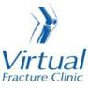

Trauma and Orthopaedics

Calcaneal Fracture - Undisplaced
This is a break to your heel bone.

Healing:
It can take up to 6-12 weeks for this fracture to heal.
Smoking will slow down your healing. We would advise that you stop smoking while your fracture heals. Talk to your GP or go to www.smokefree.nhs.uk for more information.

Pain and swelling:
You may have foot pain and swelling for 3-6 months after your injury. Swelling is often worse at the end of the day.
Taking pain medication, elevating your foot and using ice or cold packs will help. More information is on the next page.
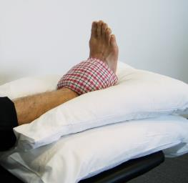

Walking:
You should not put any weight through your injured leg and should use crutches to move around.
The boot protects your foot and will make you more comfortable. You can take it off at night, at rest or when completing the exercises below. You need to wear the boot for at least 6 weeks after your injury. Please inform us if you are diabetic; you may require a specialist boot..
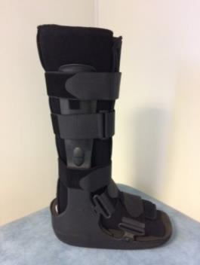

Exercises:
It is important to start exercises as soon as possible. Instructions follow.

Follow up:

You will receive a face to face appointment in the Fracture Clinic 6 weeks after your injury. Contact the Fracture Clinic Receptionists on 01582 497194 if you have not received your appointment letter after one 1 week.

DVT (deep vein thrombosis):
DVT (deep vein thrombosis) is a blood clot in a vein, usually the leg. Because you are non-weight bearing, you may be at higher risk of developing a DVT. You may have been given some blood thinning medication to cover you for this period of time.
Symptoms of DVT in the leg are:
- throbbing or cramping pain in 1 leg (rarely both legs), usually in the calf or thigh
- swelling in 1 leg (rarely both legs)
- warm skin around the painful area
- red or darkened skin around the painful area
- swollen veins that are hard or sore when you touch them
If you notice any of these symptoms, please call 111 immediately and get further advice or attend the Emergency Department.

Any questions:
If you are concerned about your symptoms, are unable to follow this rehabilitation plan or have pain other than at the site of your injury please contact the Virtual Fracture Clinic team.

Caring for your injury
You should not put any weight through your injured leg and should use crutches to move around. You can remove the boot when resting, at night, when doing exercises and to wash and dress. Wear a long sock in your boot. You need to wear the boot for 6 weeks.
Using a cold pack will help with your pain and swelling. You can use an ice pack or bag of frozen peas wrapped in a damp towel. Put this on your foot for up to 15 minutes every few hours. Make sure the ice is not in direct contact with your skin.
Try to rest your foot, especially in the first 24-72 hours. You should not attend school or college. Raise your foot on a stool or cushions to that it is above the level of your hip. This will help to reduce your swelling.

Exercises:
Early movement of the ankle and foot is important to promote circulation and reduce the risk of developing a Deep Vein Thrombosis (blood clot).
Do these exercises 3-4 times a day. Start straight away, you do not need to push into pain

Ankle Exercises
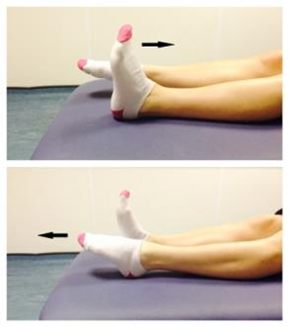
Rest with your leg supported.
Point your foot up and down. Repeat this 10 times.

Frequently Asked Questions
I am struggling with my boot. What do I do?
The boot protects your foot and will make you more comfortable. Wear a long sock in your boot. You can take it off at night, at rest or when completing the exercises. Make sure you wear a supportive shoe or trainer on your uninjured foot. This will reduce stress on other joints.
If you need more advice contact the Virtual Fracture Clinic.
I am diabetic, does this change things?
If you are diabetic, please contact us to discuss your boot. This is particularly important if you have problems with your skin. We may provide you with a specialist diabetic boot.
When can I start driving?
You can return to driving when:
- You are no longer using your boot
- You can walk comfortably
- You can perform an emergency stop pain free
Always test your ability to drive in a safe environment first.
How can I get a certificate for work?
You can get a fitness for work statement from your GP
What do I do with my boot and crutches when I no longer need them?
We are not able to use boots again. These should not be returned to the hospital.
Crutches can be returned to the Fracture Clinic or A&E.
How do I contact the Virtual Fracture Clinic?
Call 01582 718121. Messages will be checked every morning Monday-Friday.
Email VFC@ldh.nhs.uk
Some pictures and content produced by Brighton and Sussex University Hospital and shared with permission.

Bedfordshire Hospitals NHS Foundation Trust
Luton and Dunstable University Hospital
Lewsey Road
Luton, LU4 0DZ
www.bedfordshirehospitals.nhs.uk
@LandDHospital

