Trauma and Orthopaedics

Midshaft ulna Fracture
This means there are signs on your x-ray suggesting a break in your forearm.

Healing:
This normally takes approximately 6 weeks to heal.

Sensation and movement of your hand:

It is important that you are able to wiggle your fingers and are able to have full feeling of your hand. If you lose movement or are unable to feel your hand, then you should go back to A&E immediately for your plaster to be checked.
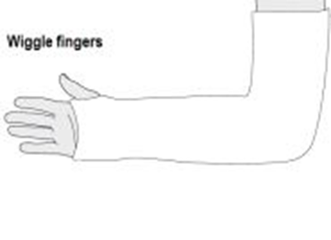
Wearing your sling:
You will have been fitted with a plaster and provided with a sling. Keeping your arm elevated with the sling, or on pillows/cushions, will help reduce the pain and swelling. Take pain relief medication as prescribed.
The plaster needs to be on for 4 weeks. This can then be removed at home. For further advice on removal of backslab casts at home please watch the following video created by the British Society for Children’s Orthopaedic Surgery; https://www.youtube.com/watch?v=5UseusBEqE0
If you need further advice about removing the cast, please contact the Virtual Fracture Clinic.
Your cast:
If you have any of the following please contact the plaster room on 01582 491166 (ext. 2233) Monday to Friday 9am to 5pm (out of hours contact the Emergency Department).
- any new pain unrelated to your existing injury e.g. persistent burning sensation under the casts;
- soreness or rubbing of the cast,
- any offensive smells from the cast
- Staining or leaking through the cast from a wound discharge
- The cast become broken, soft, dented or loose
- The cast becomes wet

Exercise and activity:
It is important to start exercising your hand and fingers as soon as possible. You will find pictures and instructions for your exercises on the next page.
Follow up:
A follow up appointment is not normally needed for this injury. Please contact the Virtual Fracture Clinic if you do not have full movement by 3 weeks after your injury. You may need a physiotherapy referral.

Any questions:
If you are concerned about your symptoms, are unable to follow this rehabilitation plan or notice pain other than at your elbow, please contact the Virtual Fracture Clinic.

Caring for your injury – Week 1 to 4
Try to rest your elbow, especially in the first 24-72 hours.
Elevation, either with your arm resting on a pillow, or by using the sling, will help with the pain and swelling management.
Exercises:
Start these exercises straight away. Bend and straighten your fingers and thumb 10-15 times.
Complete these movements regularly during the day. The cast may restrict your movements.
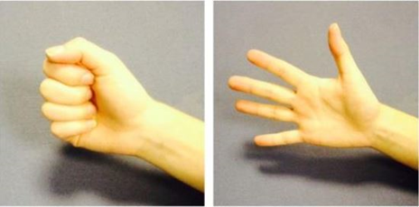

Caring for your injury – Week 5 to 12
Your fracture should now be healed and the cast removed. You can return to light activities but avoid heavy lifting for 6 weeks.
You can gradually increase your day to day activity. Be guided by any pain or discomfort you may still have.
Exercises;
Regular exercise will prevent stiffness and help to recover movement. Try to do these exercises every hour. If this is too painful, start with 3-4 times a day. Repeat each exercise 10 times.
- Open and close your hand.
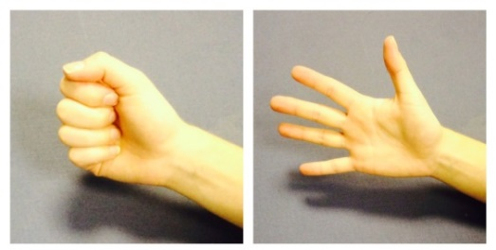
- Move your wrist up and down as far as pain allows – do not push into pain. 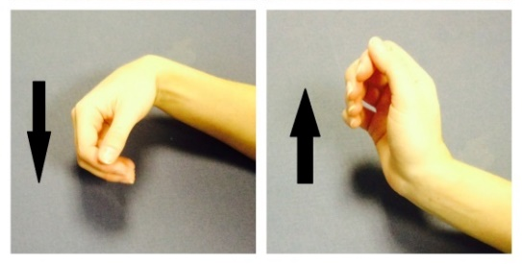
- Bend and straighten your elbow so you feel a mild to moderate stretch. Do not push into pain.
- Bend your elbow to 90 degrees. Slowly turn your palm up and down until you feel a mild to moderate stretch. Do not push into pain.

Contact the Virtual Fracture Clinic if you do not have full movement 3 weeks after cast removal.
It is normal to still have mild discomfort. This may continue for 3-6 months.

Frequently Asked Questions
I’m concerned about my symptoms and/or I am struggling to return to exercise.
Please contact the Virtual Fracture Clinic.
I am struggling with my cast and sling. What do I do?
Contact the Virtual Fracture Clinic. We are happy to give further advice and can refer you to the plaster room if needed.
How do I contact the Virtual Fracture Clinic?
Call 01582 718121. Messages will be checked every morning Monday-Friday.
Email VFC@ldh.nhs.uk

Some pictures and content produced by Brighton and Sussex University Hospital and shared with permission.
Bedfordshire Hospitals NHS Foundation Trust
Luton and Dunstable University Hospital
Lewsey Road
Luton, LU4 0DZ

www.bedfordshirehospitals.nhs.uk
@LandDHospital

