Trauma and Orthopaedics

Metacarpal Neck Undisplaced Fracture
This is a fracture near the knuckle of your hand

Healing:
This normally takes 6 weeks to heal, but symptoms can continue for 3-6 months. As the bone heals a lump may form over the fracture site.
Also, if you have a head/neck fracture, your knuckle may not be as prominent as before. These will not cause any functional problems with your hand.
When forming a fist, if you notice your injured finger crossing another finger, or rotating outwards, please contact the Virtual Fracture Clinic,
Smoking will slow down your healing. We would advise that you stop smoking while your fracture heals. Talk to your GP or go to www.smokefree.nhs.uk for more information.

Pain and Swelling
Painkillers are important to aid your recovery and should be used as required. Stop non-steroidal anti-inflammatory drugs (NSAIDS) e.g. Ibuprofen after 5-7 days as this will slow bone healing. You may find it continues to be a bit achy and swollen for a few months after your injury. You can use an ice pack or bag of frozen peas wrapped in a damp towel. Put this on your wrist for 15 minutes every few hours. Make sure the ice isn’t in direct contact with your skin.

Splint/strapping:
If you have been given a splint this is for comfort and doesn’t affect the rate of healing. You will either have strapping applied or a “Bedford splint”. Both are correct and suitable for your injury. If you have had strapping applied, the following will advise you how to change it. Padding should be placed between the two fingers to prevent rubbing and any breakdown of the skin. Ideally, the padding should extend almost the full length of the shorter finger.
Including the knuckle, each finger has 3 joints (the places where your finger bends). The exception to this is your thumb. Place 1 piece of tape between the first and second joints and another between the second and third. This allows the injured finger to flex or extend and can still be used to grip.
If your finger starts changing colour, or you get pins and needles sensation that wasn’t there before, then the strapping is too tight. Change the strapping daily to allow skin care.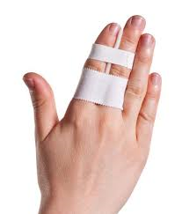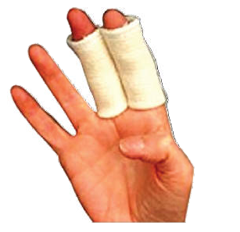

Caring for your injury – week by week plan
Weeks since injury | Plan
0 - 2 | √ Use the strapping and splint for comfort (if you were provided with one). Remove the strapping and splint as soon as you can when pain settles.  √ Move your thumb gently to prevent stiffness – see initial exercises  X Do not drive if you are still using the strapping/splint or you cannot grip the steering wheel fully.
2 - 4 | √ Start doing your normal activities within the limitations of your pain.  √ Progress to additional exercises.  X Avoid heavy lifting tasks and contact sports.
4-6 | √ The injury has healed. Swelling however can last for several months.  √ Heavy lifting could be painful for up to 8 weeks. Increase gradually using pain as a guide.  √ Return to normal activities.
6+ | X if you are still experiencing significant pain and swelling then please contact the Virtual Fracture Clinic for advice.

Initial exercises
It is important to start gentle exercises straight away to prevent stiffness. You will find pictures and instructions for your exercises below. Use your hand as normally as possible within the limitations of pain. This will not cause further damage but failure to do so may lead to ongoing stiffness.
The following exercises should be performed slowly and regularly every day, keeping the strapping on. The purpose of these exercises is to help you regain full movement.
Little and often (a few of each movement every hour) is better that doing lots of repetitions.
Starting with straight fingers, flex them into a loose fist. Initially pain, swelling and bruising will restrict movement. This is perfectly normal and to be expected. Work your way through the movements as shown in the picture above, ending with straight fingers again.
Starting with straight fingers, flex them into a loose fist. Initially pain, swelling and bruising will restrict movement. This is perfectly normal and to be expected. Work your way through the movements as shown in the picture above, ending with straight fingers again.
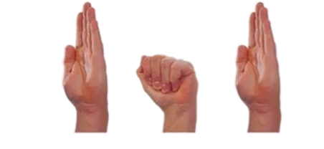
Additional Exercises (from 2-4 weeks)
Movement
As with the initial exercises, the following exercises should be performed slowly and regularly every day. You can now use your other hand to add gentle pressure at the end of movement, but do not force movement. Little and often (a few of each movement every hour) is better that doing lots of repetitions.

Starting with straight fingers, flex them into a loose fist. As the swelling reduces your range of movement will increase. Work your way through the movements as shown in the picture above, ending with straight fingers again.

Strength
You can do some simple exercises to help increase strength.
Use the elastic band around your fingers to strengthen the muscles in the hand.
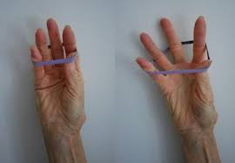
The following pictures show different ball grip exercises. Start with 5 squeezes for each exercise, holding for a couple of seconds. Rest for 2 minutes before completing a further set. Increase the amount of repetitions for each exercise as able.
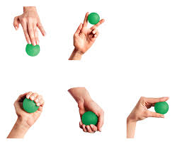
- Extend out
- Side squeeze
- Ball grip (wrist UP)
- Ball grip (wrist DOWN)
- Pinch

Frequently Asked Questions
I’m concerned about my symptoms and/or I am struggling to return to exercise.
Please contact the Virtual Fracture Clinic.
I am struggling with my strapping/splint. What do I do?
Contact the Virtual Fracture Clinic. We can give advice or change your splint if needed.
When can I start driving?
You can return to driving when:
- You can move comfortably.
- You can control the vehicle safely.
- You are no longer using the splint or strapping.
Always test your ability to drive in a safe environment first.
How can I get a certificate for work?
You can get a fitness for work statement from your GP.
How do I contact the Virtual Fracture Clinic?
Call 01582 718121. Messages will be checked every morning Monday-Friday.
Email VFC@ldh.nhs.uk

Some pictures and content produced by Brighton and Sussex University Hospital and shared with permission.
Bedfordshire Hospitals NHS Foundation Trust
Luton and Dunstable University Hospital
Lewsey Road
Luton, LU4 0DZ
www.bedfordshirehospitals.nhs.uk
@LandDHospital

