Trauma and Orthopaedics

Soft Tissue Injury – THUMB

Healing:
It can take up to 6 weeks for this injury to heal. Smoking will slow down your healing. We would advise that you stop smoking while you heal. Talk to your GP or go to www.smokefree.nhs.uk for more information.

Pain and Swelling
Your thumb and hand may be swollen and you will have some pain. Taking pain medication and using ice or cold packs will help. You can use an ice pack or bag of frozen peas wrapped in a damp towel. Put this on your wrist for 15 minutes every few hours. Make sure the ice isn’t in direct contact with your skin.
Try to rest your thumb, especially in the first 24-72 hours, and avoid any aggravating movements.
Exercise and activity:
It is important to start exercising as soon as possible. You will find pictures and instructions for your exercises on the next page. You should avoid lifting anything more than the weight of a cup of tea for the first 2 weeks. You can do light activities when your pain has settled.

Follow up:
A follow up appointment is not normally needed for this injury. Please contact the Virtual Fracture Clinic if you are still experiencing pain and swelling after 6 weeks.

Any questions:
If you are concerned about your symptoms or are unable to follow this rehabilitation plan, please contact the Virtual Fracture Clinic.

Contact us:
If you notice that your thumb cannot fully bend or straighten or it feels unstable after 2 weeks; or if you are concerned about your symptoms or are unable to follow this rehabilitation plan, please contact the Virtual Fracture Clinic.

Splint/strapping:
If you have been given a splint this is for comfort and doesn’t affect the rate of healing. Try to stop using the splint as soon as possible using pain as your guide.
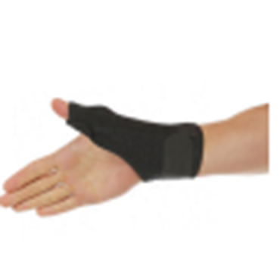

Caring for your injury – week by week plan
Weeks since injury | Plan
0 - 2 | √ Use the strapping and splint for comfort (if you were provided with one). Remove the strapping and splint as soon as you can when pain settles.  √ Move your thumb gently to prevent stiffness – see initial exercises  X Do not drive if you are still using the strapping/splint or you cannot grip the steering wheel fully.
2 - 4 | √ Start doing your normal activities within the limitations of your pain.  √ Progress to additional exercises.  X Avoid heavy lifting tasks and contact sports.
4-6 | √ The injury has healed. Swelling however can last for several months.  √ Heavy lifting could be painful for up to 8 weeks. Increase gradually using pain as a guide.  √ Return to normal activities.
6+ | X if you are still experiencing significant pain and swelling then please contact the Virtual Fracture Clinic for advice.

Caring for your injury – Exercises 0 – 4 weeks
It is important to start gentle exercises straight away to prevent stiffness. You will find pictures and instructions for your exercises below. Use your hand as normally as possible within the limitations of pain. The following exercises should be performed slowly and regularly every day. The purpose of these exercises is to help you regain full movement.
Little and often (a few of each movement every hour) is better that doing lots of repetitions.
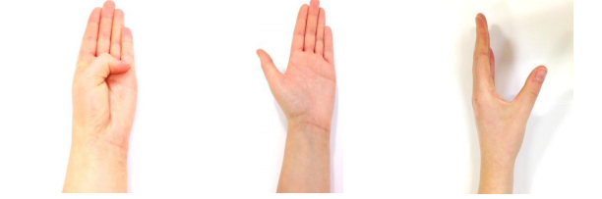
- Move your thumb to your little finger
- Move your thumb out to the side
- Resting your little finger on the table, move you thumb outwards in line with your index finger and back in.
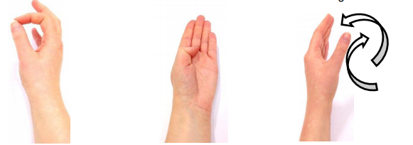
- Make an O shape with your thumb
- Touch the base of each finger with your thumb
- Move you thumb in a circle in one direction then the other.

Caring for your injury – Exercises from 2 weeks

From 2 weeks
As with the initial exercises, the following exercises should be performed slowly and regularly every day.

Strength
You can do some simple exercises gradually after 2 weeks to help increase strength based on the stability of the fracture.
Use the elastic band around your fingers to strengthen the muscles in the hand.
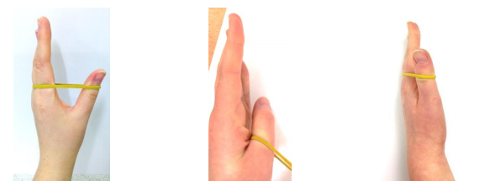

- Move your thumb outwards and hold, return to start position.
- Wrap band around your thumb and hold the other end of the band with your opposite hand, keep the thumb in the same position whilst pulling the band away.
- Wrap the band around your fingers and thumb, with little finger resting on a table, move your thumb upwards and hold for a few seconds.
The following pictures show different ball grip exercises. Start with 5 squeezes for each exercise, holding for a couple of seconds. Rest for 2 minutes before completing a further set. Increase the amount of repetitions for each exercise as able.
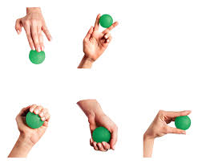

- Extend out
- Side squeeze
- Ball grip (wrist UP)
- Ball grip (wrist DOWN)
- Pinch

Frequently Asked Questions
I’m concerned about my symptoms and/or I am struggling to return to exercise.
Please contact the Virtual Fracture Clinic.
I am struggling with my strapping/splint. What do I do?
Contact the Virtual Fracture Clinic. We can give advice or change your splint if needed.
When can I start driving?
You can return to driving when:
- You can move comfortably.
- You can control the vehicle safely.
- You are no longer using the splint or strapping.
Always test your ability to drive in a safe environment first.
How can I get a certificate for work?
You can get a fitness for work statement from your GP.
How do I contact the Virtual Fracture Clinic?
Call 01582 718121. Messages will be checked every morning Monday-Friday.
Email VFC@ldh.nhs.uk

Some pictures and content produced by Brighton and Sussex University Hospital and shared with permission.
Bedfordshire Hospitals NHS Foundation Trust
Luton and Dunstable University Hospital
Lewsey Road
Luton, LU4 0DZ
www.bedfordshirehospitals.nhs.uk
@LandDHospital

