

Thank you for taking the time to thank your nurse or midwife  
Your Name _______________________

Phone __________________________

Email ______

❒ Please contact me if my nurse is

chosen as a DAISY honoree so that I may attend the celebration if available.

I am (please tick one): ❒Patient

❒ Family/Visitor ❒ RN/RM ❒ Doctor

❒ Staff ❒Volunteer

Date of nomination _________________

If you have any questions, please contact: [daisy.award@ldh.nhs.uk](mailto:daisy.award@ldh.nhs.uk)

We look after nominations for both Bedford Hospital and the L&D at this address.



DAISY Award Coordinators

First Floor

Nova House

Luton & Dunstable Hospital

LU4 0DZ

**Each DAISY Award Honoree is recognised at a special ceremony which is held in their ward / department and will receive a hand carved sculpture ‘A Healers Touch’, an award pin and a personalized certificate of recognition and thanks. The story behind the nomination is read and shared, celebrating the skillful and compassionate care they have provided.**

**Everyone in the ward / department will celebrate with cinnamon rolls, which were a favourite of Patrick’s during his illness. The Barnes Family requests that whenever and wherever nurses and midwives smell that wonderful aroma of cinnamon, they pause for a moment and think about how special they are.**

**Want to Say**

**Thank You**

**To Your Nurse or Midwife?**

**Please share your story with us**

The DAISY (Diseases Attacking the Immune SYstem) Award is an international recognition program that honours and celebrates the skillful, compassionate care nurses and midwives provide every day. The DAISY Foundation was established by the family of J. Patrick Barnes after he died from complications of the auto-immune disease ITP in 1999. During his hospitalization, they deeply appreciated the care and compassion shown to Patrick and his entire family. When he died, they felt compelled to say “thank you” to those who cared for him in a very public way.

To learn more, visit [**DAISYFoundation.org**](http://www.DAISYFoundation.org)

Please say thank you by sharing your story of how a nurse or midwife made a difference you will never forget!

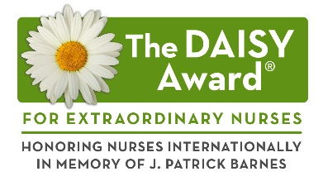



**To Nominate an Extraordinary Nurse or Midwife:**

Anyone may thank a deserving nurse by filling out this form and submitting it to:

DAISY Award Coordinators

First Floor, Nova House

Luton & Dunstable Hospital

LU4 0DZ

daisy.award@ldh.nhs.uk

Name of the nurse or midwife you would like to thank:

Ward / department / service where this nurse or midwife works:

**Please share your story of why your nurse or midwife is so special, providing as much detail as possible.**

© DAISY Foundation 2019

**The DAISY Award for Extraordinary Nurses**