Trauma and Orthopaedics

Volar Dislocation of the PIPJ
This is a type of dislocation of the finger.
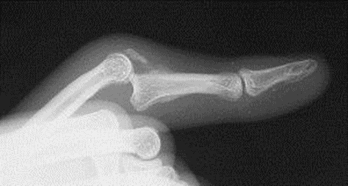
Healing:
This injury can take between 6-12 weeks to heal fully. Smoking will slow down your healing. We would advise that you stop smoking while your injury heals. Talk to your GP or go to www.smokefree.nhs.uk for more information.
Pain and swelling:
It is normal after an injury to have swelling. Swelling can make your finger stiff and make moving your finger more difficult. In the initial stages it is advised not to leave your hand lower than your heart for long periods as this can encourage swelling into this area.
Painkillers are important to aid your recovery and should be used as required. Stop non-steroidal anti-inflammatory drugs (NSAIDS) e.g. Ibuprofen after 5-7 days as this will slow bone healing. You may find it continues to be a bit achy and swollen for a few months after your injury. An ice pack will help initially with pain and swelling (make sure the ice is not in direct contact with the skin).
Follow up:
Normally we do not follow up patients with this type of injury in the Orthopaedic Department as they heal well. You will be referred directly to the Hand Therapy Team who will contact you. If you have not heard anything within 1 week of receiving this information, please contact the Virtual Fracture Clinic.

Contact us
If you are concerned about your symptoms, are unable to follow this rehabilitation plan or notice pain or have any questions other than in your finger, please contact the Virtual Fracture Clinic.

Splint/strapping
A splint is made to place your finger in a fully extended position to protect the injured ligaments keeping the end joint free. This must be worn 24 hours a day for 3-4 weeks. The rest of your hand will be left free for you to use for light activities.
After 3-4 weeks, you will need to continue splinting at night time. A dynamic splint may be issued to you by the hand therapist for use during the day if deemed appropriate. You will be advised by the hand therapist to slowly commence movement after 3-4 weeks.
The aim is to get the finger moving as soon as possible to prevent stiffness. Simple painkillers will help you move the finger.

Caring for your injury:

0 – 4 weeks:
You can use your injured hand, but not the injured finger for light tasks with the splint and within the limitations of pain
No heavy lifting tasks or contact sports

4 – 8 weeks:
Strengthening and lifting heavy items can gradually increase using pain as a guide.
If you are still experiencing significant pain and swelling, then please contact the Virtual Fracture clinic for advice.
Avoid heavy lifting and contact sports for 10-12 weeks.

Do not:
- Remove splint.
- Get your hand wet whilst wearing the splint.
- Grip anything with injured finger.
- You should be able to use your finger for light activities at 4- 6 weeks and you will be able to return to heavy lifting and gripping and sport after 10-12 weeks.

Strength
You can do some simple exercises to help increase strength. Practice up to 3 times a day starting with 5 repetitions, increasing to 10 as able.
Use an elastic band around your fingers to strengthen the muscles in the hand.
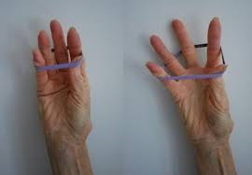
The following pictures show different ball grip exercises. Start with 5 squeezes for each exercise, holding for a couple of seconds. Rest for 2 minutes before completing a further set. Increase the amount of repetitions for each exercise as able.
Extend out and side squeeze
Ball grip (wrist up), ball grip (wrist down) and pinch

Frequently Asked Questions
I’m concerned about my symptoms and/or I am struggling to return to exercise.
Please contact the Virtual Fracture Clinic. If you need more advice contact the Virtual Fracture Clinic.
I am struggling with my strapping/splint. What do I do?
Contact the Virtual Fracture Clinic. You will be referred to the hand therapist who will supervise your rehabilitation.
When can I start driving?
You can return to driving when:
- You can move comfortably and
- You can control the vehicle safely
Always test your ability to drive in a safe environment first.
How can I get a certificate for work?
You can get a fitness for work statement from your GP
How do I contact the Virtual Fracture Clinic?
Call 01582 718786. Our receptionist will arrange for someone to contact you.
Email VFC@ldh.nhs.uk
Some pictures and content produced by Brighton and Sussex University Hospital and shared with permission.
Bedfordshire Hospitals NHS Foundation Trust
Luton and Dunstable University Hospital
Lewsey Road
Luton, LU4 0DZ
www.bedfordshirehospitals.nhs.uk
@LandDHospital

