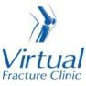

Trauma and Orthopaedics

Salter Harris Un-displaced / Avulsion Fracture of the lateral malleolus (A9)
This is an injury to the growth plate of the fibula bone of the lower leg .

Healing:
This normally takes approximately 4-6 weeks to heal.

Pain and swelling:
Your ankle may be swollen and painful. Swelling is often worse at the end of the day. It is normal to have mild pain and swelling for 3-6 months after your injury.
Taking pain medication and elevating your ankle will help. Raise your ankle on a stool or cushions so that it is above the level of your hip. This will help to reduce your swelling.

Walking and your cast:
You will be in a plaster cast and you are NOT allowed to put weight through your foot for 4 weeks. You will need to use crutches to support you when walking.

Exercises:
Although you cannot exercise your ankle it is important to maintain the strength of the leg where possible. You should continue the exercises throughout your period of non-weight bearing.

Deep Vein Thrombosis (DVT)
Because you are not weight bearing you have a higher risk of developing a blood clot (DVT) however, if you are under 16, you will not be given a blood thinner. If you have any signs of a blood clot such as swelling or redness in the calf then please contact 111 or the Emergency Department ASAP.

Follow up:
You will attend fracture clinic and see an Orthopaedic Doctor approximately 4 weeks after your injury. The specialist will explain the results and the next stage of your care.

Any questions

If you are concerned about your symptoms, unable to follow this rehabilitation plan or have not received your appointment letter please contact us.

Caring for your injury – Weeks 1-4

Walking and your cast
Your elbow crutches will be adjusted to the correct height, your forearms should sit within the cuff and hand grips point forward.

To stand:
- Hold the crutches in one hand by the grips
- Push up on the arm of the chair with the other hand, stand on your good leg.
- Slip your arms through the arm cuffs.

To sit:
- Make sure you are close to the chair so you can feel it at the back of your legs
- Get your balance on your good leg so your injured leg is off the floor
- Take your crutches off your arms
- Hold your crutches by the arm grips or lean them against the chair
- Reach back for the arms of the chair and lower yourself into the chair
- Never stand or sit with your arms in the crutches.

Walking -Non Weight Bearing with elbow crutches:

- Keep your elbows into your sides
- Place the crutches forwards shoulder width apart to ensure your whole body can fit through the gap
- Lean on the crutches to take weight onto your arms and the crutches
- Step through with your good leg
- When you have your balance, repeat the above steps.

Stairs - If you feel unsafe or unsteady, go up and down on your bottom.

If a handrail is available, use it and put your walking aid in the opposite hand. If you have a second crutch, hold it horizontally in the same hand.

- To go up stairs, raise your good leg up first and put your weight on it, then raise your operated leg to the same step, followed by the walking aid. Remember this when going up stairs: Good leg, operated leg, crutch, repeat.
- If going down stairs, move the crutch onto the lower step first, put your weight on the crutch as you move your operated leg onto the step alongside it. Bring your good leg onto the same step. Remember this when going down stairs: Crutch, operated leg, good leg, repeat.

Your cast
If you have any of the following please contact the plaster room on 01582 491166 (ext. 2233) Monday to Friday 9am to 5pm (out of hours contact the Emergency Department).
- any new pain unrelated to your existing injury e.g. persistent burning sensation under the casts;
- soreness or rubbing of the cast,
- any offensive smells from the cast
- Staining or leaking through the cast from a wound discharge
- The cast become broken, soft, dented or loose
- The cast becomes wet
Try to rest your ankle where possible, raise your ankle on a stool or cushions so that it is above the level of your hip. This will help to reduce your swelling.

Exercises:
It is important to exercise your knee, hip and bottom muscles of your injured leg to maintain as much muscle strength and encourage blood flow to prevent DVTs. You should also check you can move your toes regularly. These exercises must be done without putting any weight through your injured leg. Here are some examples:
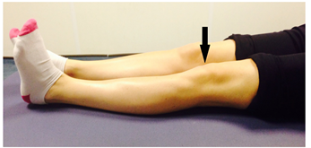
Static Quadriceps Exercise
Rest with your leg supported and straight. Gently tense the muscles in your thigh and try to straighten your knee further. Hold for 5 seconds and repeat 7-10 times.

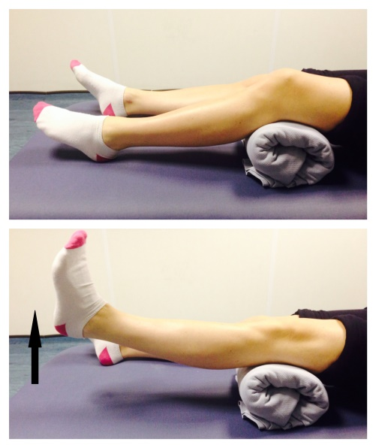
Inner Range Quads Exercise
Place a rolled up towel or small pillow under your injured knee.

Tense your thigh muscle and try to straighten your knee. Keep the back of your knee in contact with the towel/pillow.

Repeat 10 times. If you can, try to hold your knee straight for 5 seconds.

Knee Flexion and Extension:
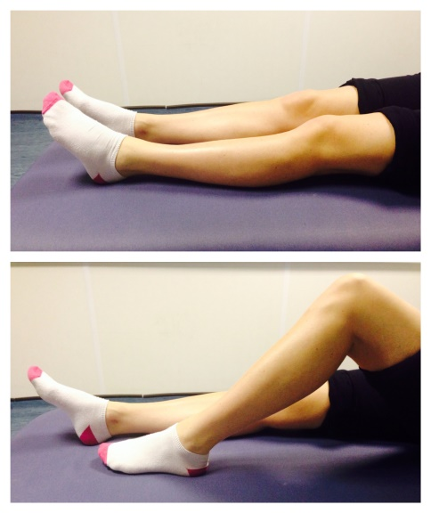
Sit or lie with your legs out stretched.

Bend and straighten your injured leg. Go as far as you feel comfortable.

Repeat 7-10 times.

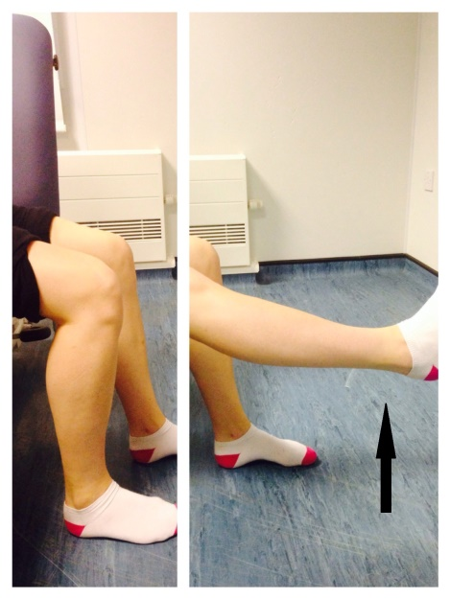
Seated knee flexion and extension:
When you can do the first knee bending exercise easily, you can progress to this exercise.
Sit on a chair or on the edge of your bed. Bend and straighten your knee, lifting your heel off the floor.
Repeat this 10 times.
If you can, try holding your knee straight for 5 seconds.

Frequently Asked Questions
What do I do with my crutches when I no longer need them?
Crutches can be returned to the Fracture Clinic or A&E.
I haven’t received my appointment letter. What do I do?
If you have not received your appointment letter within two weeks please contact Fracture Clinic Reception on 01582 497194.
How do I contact the Virtual Fracture Clinic?
Call 01582 718121. Messages will be checked every morning Monday-Friday. Email VFC@ldh.nhs.uk
Some pictures and content produced by Brighton and Sussex University Hospital and shared with permission.

Bedfordshire Hospitals NHS Foundation Trust
Luton and Dunstable University Hospital
Lewsey Road
Luton, LU4 0DZ

www.bedfordshirehospitals.nhs.uk
@LandDHospital

