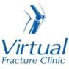

Trauma and Orthopaedics

Salter Harris Un-displaced / Avulsion Fracture of the lateral malleolus (A9)
This is an injury to the growth plate of the fibula bone of the lower leg .

Healing:
This normally takes approximately 4-6 weeks to heal.

Pain and swelling:
Your ankle may be swollen and painful. Swelling is often worse at the end of the day. It is normal to have mild pain and swelling for 3-6 months after your injury.
Taking pain medication and elevating your ankle will help. Raise your ankle on a stool or cushions so that it is above the level of your hip. This will help to reduce your swelling.

Walking and your boot:
You will be in a walking boot and you are allowed to put weight through your foot as much as you can tolerate for 4 weeks. You can use crutches to support you when walking if required. You can remove the boot at rest/at night if comfortable.

Follow up:
A follow up appointment is not normally needed for this injury. Please contact the Virtual Fracture Clinic if you are still experiencing pain and swelling after 4 weeks.
Any questions: If you are concerned about your symptoms, unable to follow this rehabilitation plan or have not received your appointment letter please contact us.

Caring for your injury: Week 1-4
Try to rest your ankle where possible, raise your ankle on a stool or cushions so that it is above the level of your hip. This will help to reduce your swelling.

Exercises:
It is important to exercise your ankle, knee, hip and bottom muscles of your injured leg to maintain as much muscle strength and encourage blood flow to prevent DVTs. You should also check you can move your toes regularly. Here are some examples:

Inner Range Quads Exercise
Place a rolled up towel or small pillow under your injured knee.
Tense your thigh muscle and try to straighten your knee. Keep the back of your knee in contact with the towel/pillow.
Repeat 10 times. If you can, try to hold your knee straight for 5 seconds.
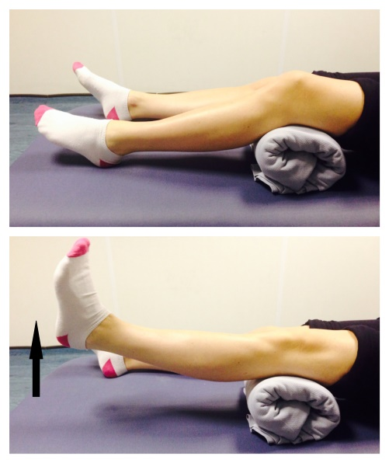
Seated knee flexion and extension:
Sit on a chair or on the edge of your bed. Bend and straighten your knee, lifting your heel off the floor.
Repeat this 10 times.
If you can, try holding your knee straight for 5 seconds.
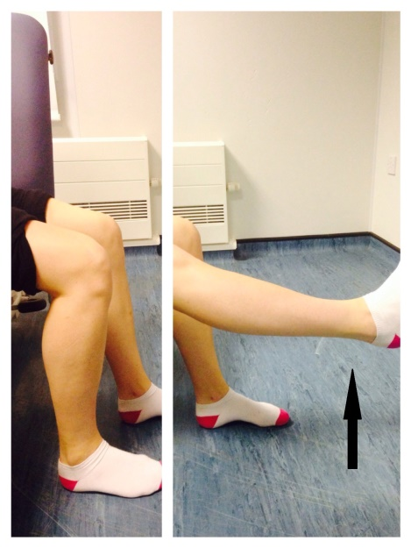
Do these exercises 3-4 times a day to improve movement at the ankle. Start straight away, you do not need to push into pain.

- Point your foot up and down. Repeat this 10 times.
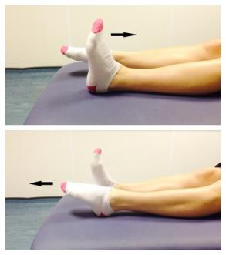
- With your heels together, move your toes apart to turn the foot outwards. Repeat this 10 times. Do this movement gently within comfort.
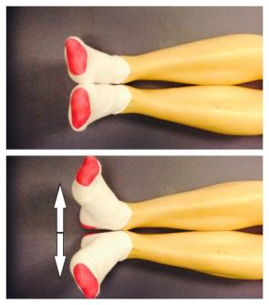
- Make gentle circles with your foot in one direction and then the other direction. Repeat this 10 times.
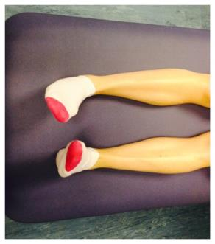
Frequently Asked Questions
What do I do with my crutches when I no longer need them?
Crutches can be returned to the Fracture Clinic or A&E.
How do I contact the Virtual Fracture Clinic?
Call 01582 718121. Messages will be checked every morning Monday-Friday. Email VFC@ldh.nhs.uk

Some pictures and content produced by Brighton and Sussex University Hospital and shared with permission.

Bedfordshire Hospitals NHS Foundation Trust
Luton and Dunstable University Hospital
Lewsey Road
Luton, LU4 0DZ

www.bedfordshirehospitals.nhs.uk
@LandDHospital

