Enhanced Recovery Programme for
Total Knee Replacements

Patient information booklet

ENHANCED RECOVERY PROGRAMME FOR TOTAL KNEE REPLACEMENTS

The aim of this booklet is to provide you with some general information about our Enhanced Recovery Programme. It is important that you are aware of what to expect before and after your orthopaedic surgery in terms of how to prepare for your operation and for your recovery.
Enhanced Recovery is a modern, evidence-based approach that can help people recover more quickly after surgery.
Having an operation can be both physically and emotionally stressful. Enhanced Recovery Programmes try to get you back to full health as quickly as possible.
Research has shown that the earlier a person gets out of bed and starts walking, eating and drinking after having an operation, and getting home helps to reduce complications with a shorter recovery time.

You have a very important part to play in your recovery so it is essential to follow the advice that is given to you.

ENHANCED RECOVERY PROGRAMME FOR TOTAL KNEE REPLACEMENTS

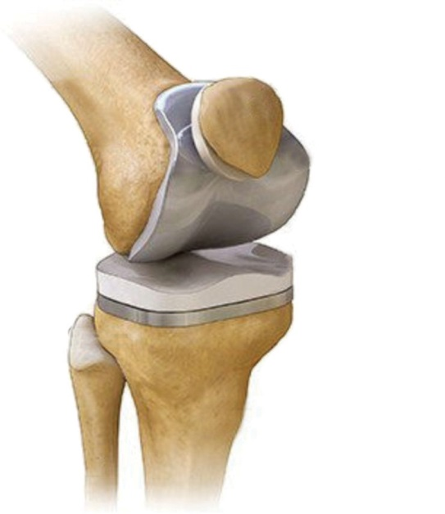
What is a total knee replacement?
Patella
Femur
Knee joint
Prosthesis
Fibula
Tibia
In a total knee replacement (TKR), both sides of your knee joint are replaced, the worn ends of the bones in your knee joint are removed and replaced with metal and plastic parts (a prosthesis) which are measured to fit.
This new joint can last for years however through time and wear and tear it may need to be replaced or revised.

The benefits of a total knee replacement
The main benefits are:-
- To relieve severe pain and stiffness
- To improve mobility
- To do everyday activities more easily
- To improve the quality of life

In the problem/arthritic knee there is often considerable disability in the form of pain, stiffness and restricted movement. A new artificial knee joint can help you to carry our normal activities of daily living again, and most patients will regain near normal movement.

ENHANCED RECOVERY PROGRAMME FOR TOTAL KNEE REPLACEMENTS

Before your surgery…
You will be given a drink high in carbohydrates to have prior to your surgery with instructions on when to take. (Unless you are a patient with diabetes).
Undergoing surgery can put a strain on your body and your energy needs may increase at a time when you are not able to eat and drink normally. These drinks can help prepare your body for the strain of surgery and keep you well hydrated at the same time.

Patients with diabetes
Morning admission - we would encourage you to drink
500mls/half a litre of any fluids the evening before surgery and 500mls/half a litre of clear fluids on the morning of surgery before 06:30 (Nothing containing milk)
Afternoon admission we would encourage you to drink 1 litre of fluid in the morning (Nothing containing milk after 7:30am), clear fluids up until 11am

It is important to eat and drink well before your surgery as this helps you to recover quicker. Being well nourished and hydrated is essential for healing and minimising your chances of getting an infection.

Other things you can do to help improve your recovery...
- If you smoke, try to reduce or cease prior to your surgery
- Limit your alcohol intake (at least for 48 hours prior to surgery)
- If you are overweight, any weight loss can help reduce the stress on your new joint
- An increase on your daily exercise by 10% (which can include walking, gardening, or using the stairs) can significantly improve your recovery
If support needed please contact your GP or you can find useful websites
to visit at the back of this booklet.
ENHANCED RECOVERY PROGRAMME FOR TOTAL KNEE REPLACEMENTS

Pre-op counselling: Patient information videos (website)

There are Enhanced Recovery patient information videos available
on the hospital web page. You are required to watch all of the videos
the videos prior to your admission to hospital, each video will explain what is required of yourself both pre and post-surgery.
To access the videos:
- Please go to the Bedfordshire hospitals website. https://www.bedfordshirehospitals.nhs.uk/
- Search for – Enhanced Recovery after Surgery
- Click link - Enhanced Recovery After Surgery (ERAS)
- Click link – Luton and Dunstable Hospital
- Click link – before surgery – video 1 can be found here
- Click link – Orthopaedics – Primary Hip and Knee replacement
- Please watch all videos

The Pre-assessment clinic
Before your operation you will be asked to attend a pre-operative assessment clinic to check if you are medically fit to have your surgery.
You will also be given information about your operation, Anaesthetic and pain management.
You may also be given the Carbohydrate Loading drinks at this appointment (unless you are a patient with Diabetes)
Remaining fit for surgery
It is very important that on the day of surgery you still remain fit and well, so if you are suffering from any of the following ailments you must make an appointment to see your GP or dentist to make them aware that you are going to be having orthopaedic surgery.
- Currently taking antibiotics
- Symptoms of water works infection (UTI)
- Dental or gum concerns to include infections
- Signs of cold/flu/chest infection
- Open wound, grazes, pressure sores, to the skin on the leg to be operated on

ENHANCED RECOVERY PROGRAMME FOR TOTAL KNEE REPLACEMENTS

- High Temperature
- Ear infection
- Cold sores
- Uncontrolled diabetes
- Uncontrolled low/high blood pressure
If you need to delay your surgery, contact pre-assessment hotline number 01582 718980 as soon as possible, and contact them again when you are fit to proceed. Please check with pre-assessment if you need to inform the waiting list office

Preparation for your hospital stay
- Stock up your fridge and/or freezer with easily prepared meals for when you come home
  - Long life milk
  - Bread
  - Microwave/oven meals
  - Remove any clutter (e.g. including any trip hazards such as carpet edges and rugs)
- Organise your kitchen e.g. consider moving things you use frequently to avoid bending and twisting

Shopping list
We recommend you have a few things in the house ready for your discharge from hospital:
- Fresh orange juice; will help with constipation relief
- X2 bags of cheap frozen peas, wrapped in a damp tea towel; helps to reduce pain and swelling
- Water based cream (E45/Aqueous)

ENHANCED RECOVERY PROGRAMME FOR TOTAL KNEE REPLACEMENTS

Coming into hospital
Before you come in please have a bath/shower as normal and pay extra attention to the knee you are having operated. A clean operation site can help reduce the risk of infection post operatively. Please also put a clean set of clothes on. Do not apply cream or shave your legs on the day of surgery

You should bring into hospital with you:-
  - This booklet!
  - Loose fitting nightdress or pyjamas (or shorts are equally acceptable).
  - Slippers (supportive, not mules) - if buying a new pair buy a size larger because of swelling after the operation.
  - Loose, comfortable clothes for daytime on the ward
  - Personal hygiene items (shaving, washing, mouth care etc..)
  - If appropriate, any walking aids you currently use.
  - A 3 day supply of any medications you are taking (please hand these in to the nurse on the ward)
  - A mobile phone (if you have one) and family/friends contact details
  - Laptops / iPad / books / Magazines
  - Non-perishable snacks/drinks

Please arrange your transportation home, you could achieve the criteria needed for discharge the day after your surgery and this is when you will go home. If you have any issues regarding transport arrangements you should discuss this with the ward staff as soon as possible.

ENHANCED RECOVERY PROGRAMME FOR TOTAL KNEE REPLACEMENTS

You MUST NOT eat anything for 6 hours prior to your operation. You may drink clear fluids up until 2 hours before your surgery.
!
Try not to starve any longer than need be, your admission letter will give you details of when to stop eating and drinking

On arrival at the hospital
- Please report to the admission location as stated on your letter
- You will be given a pair of anti-embolism stockings to help prevent a Deep Vein Thrombosis (DVT). One will be put on before your surgery to the non-operated leg; the other should go onto your operated leg immediately after your surgery.
- Before your surgery the surgeon will see you to explain the operation. Your Anaesthetist will discuss with you the type of anaesthetic that you are having. Please ask any questions you want.
- Your leg will be marked with a marker pen at the site of your operation.
- You will be given a hospital gown and 2 identity bands, one around your wrist and one around your ankle.
- Any dentures can be removed at the last minute (please advise staff of any capped or crowned teeth)
- You will be escorted to theatre walking unless you require a wheelchair.
ENHANCED RECOVERY PROGRAMME FOR TOTAL KNEE REPLACEMENTS

The Operation
You will have a spinal anaesthetic, which numbs you from the waist down with/without sedation depending on how sleepy or awake you wish to be. Or you may have a general anaesthetic for medical reasons. This will be decided between you and your anaesthetist

The surgeon will make an incision down the front of the knee. The damaged joint is replaced with a total artificial one.

The wound will be closed using clips, stitches or glue and covered with a waterproof dressing.

Sometimes you may have a drip (a fine tube) inserted into a vein in your arm to give you fluids and painkillers directly into the bloodstream.

After your operation you will be in recovery on your bed until your bed area is available, this can take some hours.

If you had a spinal anaesthetic or local nerve block, you will experience a degree of numbness in the lower body. This will be monitored and will gradually return to normal.

Once fully recovered from the sedation/anaesthetic you can eat and drink as normal.

The team will encourage you to be active and mobile, you will get up on the day of your surgery with assistance providing your observations are stable, the sensation has returned to your legs and it is safe to do so.

To prevent infection please ensure that you, the hospital staff and your visitors all wash/clean their hands before and after touching you, your dressing or wound site.

ENHANCED RECOVERY PROGRAMME FOR TOTAL KNEE REPLACEMENTS

Risks and Complications
General anaesthetic – there is a small risk of a reaction, please ask your pre-assessment nurse for a leaflet on anaestheics or speak with your anaesthetist for details.

A Deep Vein Thrombosis – (DVT) – this can occur after any operation but with a particular risk following lower limb surgery. In a few cases a clot can travel from the veins in your leg to your lungs (Pulmonary Embolism) which can be fatal.

Urinary retention – occasionally some patients experience difficulty in passing urine after surgery. You may find that standing up or sitting on a toilet will help with this. But if not it may be necessary to pass a fine tube (a catheter) into your bladder temporarily to allow you to pass urine. This will be medically reviewed and removed as soon as possible. If you have had difficulty in passing urine after surgery previously please make the nursing staff aware of this.

For some patients the risks may be greater; please speak to your surgeon before your operation if you have any concerns about these risks or other complications.

The most important person in your recovery is you! You can make a difference to the speed of your recovery and to increasing your independence and mobility by following the advice and exercises given by the physiotherapist, Enhanced Recovery team , nursing staff on the wards and the Hospital and Home team.

ENHANCED RECOVERY PROGRAMME FOR TOTAL KNEE REPLACEMENTS

Pain Management after your Surgery
You will experience some degree of pain and or/discomfort after your surgery, which we will try to reasonably manage on oral analgesia. You will have regular pain relief prescribed. If you feel pain is stopping you from walking or doing your exercises, you must let the ward nurses know as soon as possible.
Stiffness also causes pain, putting weight through the joint and
frequent movement is crucial.

How is my pain assessed?
Your pain will be regularly assessed by the team and will be assessed on a scale of 0 (no pain) to 10 (extremely severe pain).

Pain Score | Description
0 (none) | No pain at rest or on movement
1-3 (mild) | No pain at rest but slight pain on movement
4-7 (moderate) | Intermittent pain at rest or moderate pain on movement
8-10 (severe) | Continuous pain at rest or severe pain on movement

You should assess your pain levels on movement in the bed and if need be you can have additional pain relief - please ask you nurse if you feel you need additional pain relief.

Please refer to pages 22-23 for further information.

ENHANCED RECOVERY PROGRAMME FOR TOTAL KNEE REPLACEMENTS

Day 0 - After your surgery

In the Recovery area
As soon as you have sensation and feeling back in your legs and you are able to follow verbal instructions from your healthcare professional you can start to;
- You can start to eat and drink (if you feel sick please let your nurse/doctor know asap) you will be prescribed an anti-sickness medication prescribed
- Do your bed exercises and move the operated leg, including bending the knee. These can be found on pages 15-16. You will have a bulky bandage applied to the operated leg which will remain in place for 24 hours, but this shouldn't stop you bending your knee!
- Assess your pain levels on movement in the bed and if you need additional pain relief you can request this.
On the Ward
The nurses will check your blood pressure and sensation in your legs (if had spinal anaesthetic) to see if you are safe to get out of bed. Initially ask for help to get up and walk - do not attempt this on your own until you have been told you can do it alone.
Your joint has been replaced, you should now;
- Start using your Enhanced Recovery Goal Chart
- Complete your bed exercises (see pages 15-16)
- Get out of bed and try to take a few steps, with assistance at first until you are told you can walk alone putting full weight through the joint
- Sit in the chair and continue exercises as instructed on pages 15-16
- Re-assess your pain regularly on movement, if you require additional pain relief please ask your nurse.

ENHANCED RECOVERY PROGRAMME FOR TOTAL KNEE REPLACEMENTS

- It is important to pass urine after your surgery - this is easier when you are mobile! Men may stand and use a bottle at the bedside, both men and women can use a commode or if near a toilet then can walk there with assistance. Gravity helps!
- Eat well and drink lots! You might not fancy eating, but it is important to be well nourished after your operation, so a ‘little and often’ type diet may be more appropriate initially.
- Consider having 30 minute mid-morning and mid- afternoon naps as you will feel tired, we do however encourage you to be up most of the day. This is all aimed at helping to reduce chest infections and blood clots as well as strengthen the muscles and ligaments surrounding your new knee joint.

Day 1 to the day you are discharged
- Use your Enhanced Recovery daily Goal Chart - aim for 4 walks a day - this can be with ANY healthcare professional. Therapists will provide you with the most appropriate walking aid and progress you as able.
- You will have a routine x-ray on the way back from recovery area to the ward, and a blood test the morning after - please let your nurse know if either has not happened.
- Get yourself washed and dressed into your own day clothes. Ask for assistance if required. This is to assess your ability to wash and dress before you go home.
- Eat and drink a well-balanced diet, little and often if your appetite is reduced.
- Continue with your exercise programme (pages 15-16).
- Re-assess your pain regularly on movement, if you require additional pain relief please ask your nurse.
- The bulky bandage should be removed from your operated leg and replaced with the other anti-embolism stocking. These stockings should be removed daily with assistance and your legs washed, creamed and stockings reapplied. They may need to be re-measured if too tight, Please do not leave off for any longer than half an hour.
- The dressing on your wound is showerproof and should remain for up to 7 days (unless saturated) this can help reduce the risk of infection. The dressing is applied in a sterile environment and removing it frequently can disturb the healing process.
- If you have stairs at home, the physiotherapist will assess you going up and down prior to discharge (unless indicated otherwise)

When do I go Home?
When you safely meet the following discharge criteria:

- Medically fit (x-ray and bloods taken and the x-ray reviewed))
- Discharged by the Physiotherapist
- Eating and drinking
- Pain levels are reasonably well controlled on oral medication
Once all discharge criteria has been achieved it is time to go home
On discharge

- You will be sent an appointment for approximately 6 weeks after your surgery, to be reviewed by one of the Orthopaedic team.
- You will be given your discharge letter and medication - please make sure you understand the medications you have to take and when, please go through this with your nurse. Also please ask for any of your own medication to be returned to you.
- You will be provided with two pairs of anti-embolism support stockings. You should continue to wear them until you are fully mobile or as you were before your surgery.
See Frequently Asked Questions on pages 24-28 for further information.

ENHANCED RECOVERY PROGRAMME FOR TOTAL KNEE REPLACEMENTS

Exercises
Complete each exercise 10 times and repeat them 3-4 times per day
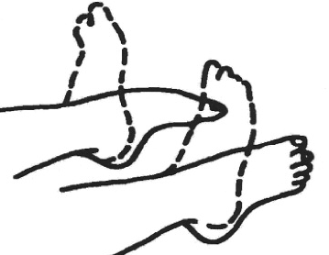
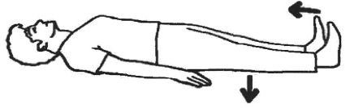
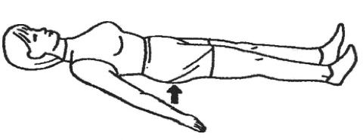
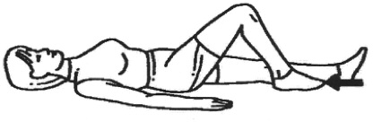

E X E R C I S E 1
Move your foot up and down and circle feet

E X E R C I S E 2
Pull your toes up and press the back of your knee into the bed
Hold for 5 seconds

E X E R C I S E 3
Squeeze buttocks together
Hold for 5 seconds

E X E R C I S E 4
Bend your knee up as far as you can and then straighten it so that the back of your knee is pressed down on the bed.

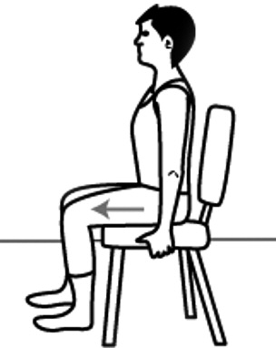

You can commence these exercises prior to your surgery to help strengthen the muscles that will be affected. Please do not do this if it causes you to be in pain.

Bed exercises should be commenced post operatively in the recovery area, please follow this guidance!

E X E R C I S E 6
Sitting on a chair, push your foot into the floor and hold for 5 seconds, contracting the muscle at the back of the thigh.
ENHANCED RECOVERY PROGRAMME FOR TOTAL KNEE REPLACEMENTS
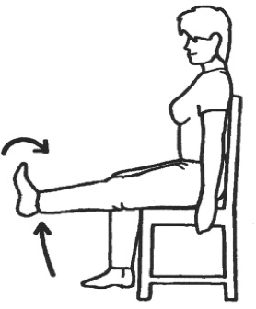

E X E R C I S E 5
Sitting in a chair or on the edge of the bed, lift your leg to straighten the knee
Hold for 5 seconds

ENHANCED RECOVERY PROGRAMME FOR TOTAL KNEE REPLACEMENTS

Physiotherapy advice

Getting washed and dressed
You shouldn't require any long handled aids, however if you feel they would be beneficial you can purchase these from us at a small cost.

Alternatively, you can purchase these privately. The aids can be seen below.

- Helping Hand/Grabber (or helping hand) for underwear, tights, trousers and for picking up anything out of reach

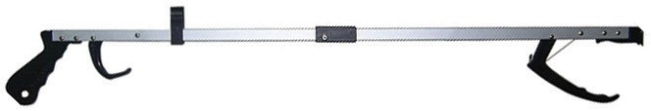

- Long handled shoehorn for footwear

- Long handled sponge for washing

Price list on request

ENHANCED RECOVERY PROGRAMME FOR TOTAL KNEE REPLACEMENTS

Sitting down
- Feel the chair with the back of your legs
- Reach your hands back to feel for the arms of the chair
- Place the operated leg forward and take the weight on your un-operated leg
- Gently lower yourself down to the chair

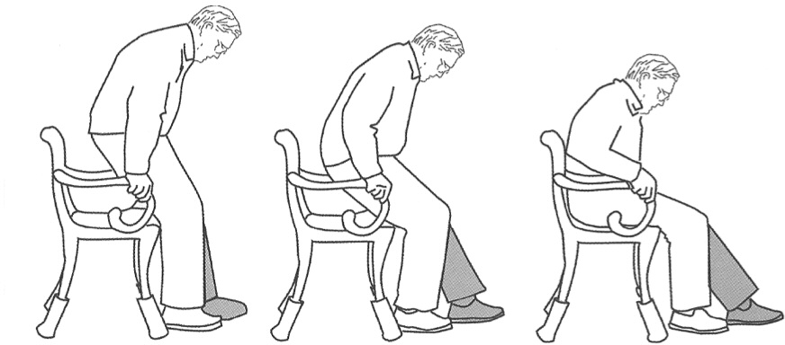

Standing up
- Put your operated leg straight out in front
- Keep your un-operated leg bent
- Slide your bottom forward and push up through the arms of the chair
- Push yourself into a standing position
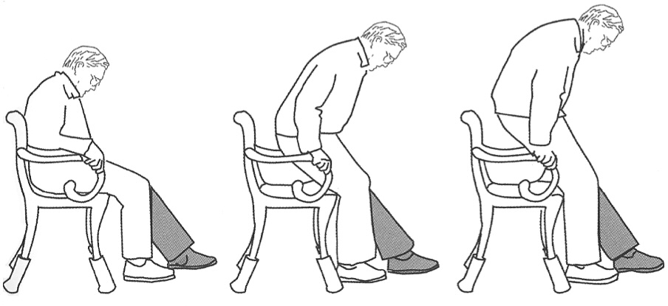

ENHANCED RECOVERY PROGRAMME FOR TOTAL KNEE REPLACEMENTS

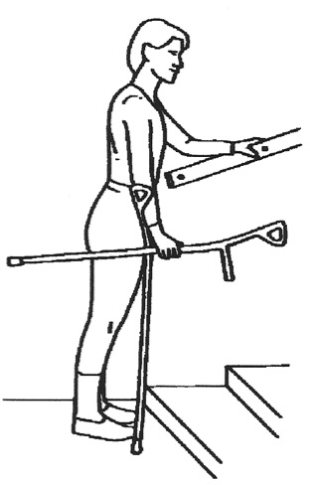
Walking UP stairs
  - Stand close to the stairs
  - Hold onto the handrail with one hand
  - Hold the stick / crutch in the other hand

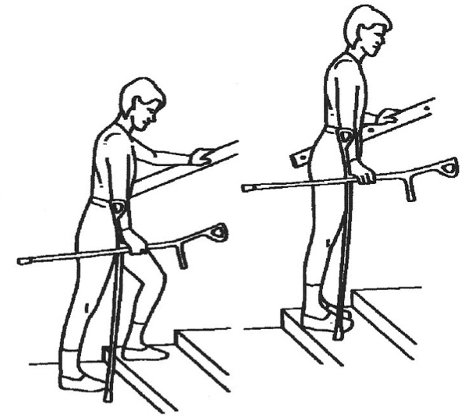
  - Step up with your good / un-operated leg
  - Then step up with your bad / operated leg
  - Bring the stick / crutch up to the same step

ENHANCED RECOVERY PROGRAMME FOR TOTAL KNEE REPLACEMENTS

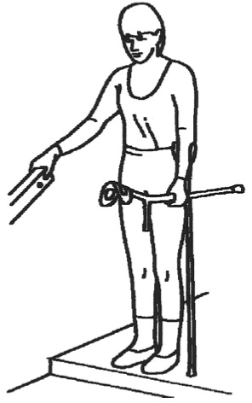
Walking DOWN stairs
  - Stand close to the stairs
- Hold onto the handrail with one hand
- Hold the stick / crutch in other hand

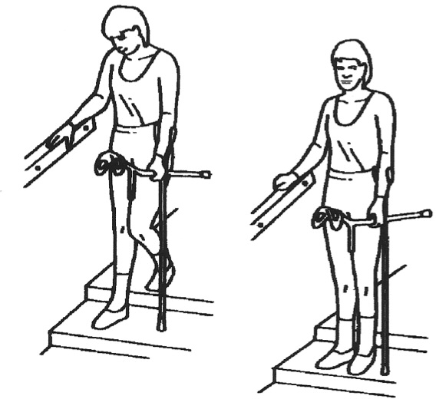
- Put the stick / crutch down one step
- Step down onto your bad
/ operated leg
- Then step down with your good / un-operated leg onto the same step

ENHANCED RECOVERY PROGRAMME FOR TOTAL KNEE REPLACEMENTS

Getting into a car
- Move the passenger seat as far back as it will go
- Carefully move back towards the passenger seat until you feel the door sill against the back of your legs
- Support yourself by holding the back of the seat and the dashboard or door frame
- Gently lower your bottom onto the seat
- Slide your bottom backwards towards the driver’s seat
- Using your arms to support you, slowly lift your legs into the car
- if required ask someone to assist in lifting your legs into the car

Getting out of a car
- Move your bottom closer to the driver’s seat
- Lift your legs out of the car and slide your bottom forward to the edge of the seat
- Place one hand on the dashboard and one on the back of the seat or door frame
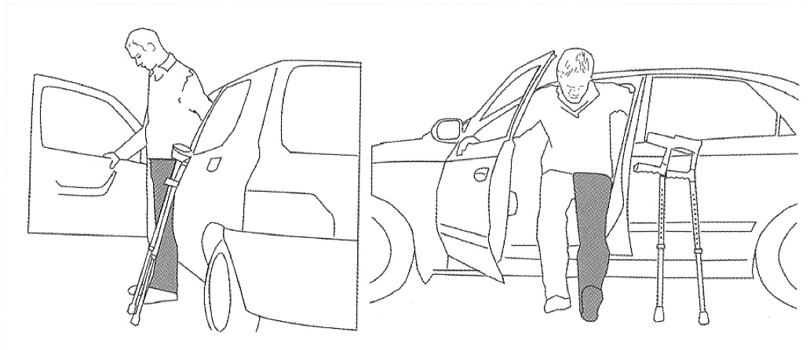
- Push up to standing position

ENHANCED RECOVERY PROGRAMME FOR TOTAL KNEE REPLACEMENTS

The Hospital @ Home Service
This allows for you to be cared for at home by the ‘Hospital at Home Team’ – the team consists of nurse and physiotherapists.
All the team members are multi-skilled in this particular service and can provide a high standard of care in your home.
Provided you have not had an extended length of stay (over 7 days) or live outside of the catchment area then you will be seen by the Hospital @ Home team.
They can assist with;
- Medication management
- Going through exercises and progressing mobility at home
- Wound care
- Further advice on how to manage daily activities at home

Medication Information

Which medications will I be prescribed for pain and how long should I expect to take them?

PARACETAMOL
If you are able to take this then these can be taken regularly, 2 x 500mgs tablets 4 times a day. Taking these make your stronger painkillers work more effectively.
When weaning back off your painkillers, these should be the last ones you stop.

ENHANCED RECOVERY PROGRAMME FOR TOTAL KNEE REPLACEMENTS

OXYCODONE MODIFIED RELEASE (MR) TABLETS
This is the standard, strong painkiller you will be given in hospital. It releases slowly over 12 hours so you will have 1 dose - twice a day. This will usually be prescribed for maximum 3 days.

OXYCODONE IMMEDIATE RELEASE (IR) LIQUID/ CAPSULES
Also called ‘Top-up’ or ‘As required’ medication. This should be used if you need extra pain relief during the day. It works quickly - usually within half an hour. Please ask your nurse for this if required.

GABAPENTIN
This medication is used to help prevent neuropathic (nerve) pain.
If you are able to take this medication you will be given a short course, one dose of 300mg is given pre-operatively and then up to 3 days.

IBUPROFEN
If you can take this medication safely then you will have 400mg, three times a day for a maximum of 5 days only. To be taken with or after food.

OMEPRAZOLE
If you are prescribed ibuprofen, you will be given this to take alongside to protect your stomach and reduce the risk of any stomach pain or upsets.

LAXATIVES
The painkillers we have prescribed you may cause some constipation. We will supply you with some gentle laxatives which will help prevent this.

ANTI-COAGULATION MEDICATION
You will generally be prescribed a 14 day course of blood thinning medication from the day of your surgery which can help to reduce the risk of developing a blood clot (DVT) after surgery.

If you are on analgesia for chronic pain then you may be put back on your own medications, this will be discussed with you.
……………………………………………………………………………..

ENHANCED RECOVERY PROGRAMME FOR TOTAL KNEE REPLACEMENTS
Aspirin 75mg (most commonly given post op and given in tablet form).
Or
ENOXAPARIN/TINZAPARIN an injection which goes into your stomach. If you are on warfarin you will require bridging Tinzaparin injections as well as your warfarin to start with, this will continue until your INR is within therapeutic range at which time the injections will stop. Hospital at Home team can help to manage this once you are home if needed.

Frequently Asked Questions (FAQ’s)

Why have I still got swelling?
It is normal for healing tissues to be swollen and it can last several months. Putting full weight through your leg uses the calf muscle to help pump the blood back to the heart and so can decrease swelling. When you are sat down/resting, elevate your operated leg onto a foot stool so that your feet are at waist height, this will encourage the fluid to work its way up your leg. Ice packs (or frozen peas wrapped in a damp tea towel) and place on the swollen areas for 15-20 minutes, do not leave on for longer than 20 minutes as you will become more at risk of Ice burns.

Why is my scar warm?
As your body heals it is a natural response to produce heat. This may also last for a few months. However, if your knee is significantly more red/hot/weeping please contact the Hospital @ Home team if you were under their care on discharge or the Enhanced Recovery team. Contact numbers can be found on page 31.

How long will I experience pain?
You may experience some degree of discomfort for several weeks following your surgery. If need be you can discuss with the Hospital @ Home Team or the Enhanced Recovery Team. Please see phone numbers listed on page 31.

Why do I get pain lower down my leg or in my back?
While everything is settling and you are adjusting to walking in a normal way again you may experience some referred pain in the shin, behind the knee or in your back.

ENHANCED RECOVERY PROGRAMME FOR TOTAL KNEE REPLACEMENTS

How long will I need to use walking aids (i.e. Crutches or walking sticks)

Unless you have been informed of any weight baring restrictions, there is no fixed length of time that walking aids are required as everyone is different, there are a few things to remember when trying to progress your mobility:
- Ensure you feel steady and safe – if you feel unsteady or do not feel confident using one crutch for example then please continue using two.
- Be careful not to limp – if you are trying to progress from two crutches onto one and when you try this you notice you are limping, again, please continue to use two crutches. Limping is a sign that your knee muscles are not yet ready to be supporting your full weight
- Trial and error – there is no harm in trying to progress your mobility. You can try a few steps, and can have a family member/friend stand with you if you prefer. If you feel unsafe, or feel you are limping, then continue with your previous level of walking aids. You can always try again in another couple of days.
- Outside is different to inside – You may have managed to progress onto using one crutch or walking stick indoors, but may still need to use 1-2 crutches outdoors. This is because of uneven surfaces, the distance you are walking, and the weather. It is ok to still require a walking aid outdoors for some time after your surgery.

Why does my joint stiffen up?
It is not the joint that is stiffening, you have a brand new joint, it is the muscles, tendons, ligaments and nerves that are now involved and causing stiffness. Movement will help, aim to walk every hour during the daytime.

How far do I need to bend my knee?
Aim to bend your knee to a minimum of 90 degrees ( a right angle)
Ideally you would be able to achieve a further bend as the weeks go on (100-110 degrees), the further you are able to bend your knee the more functional it will become. It is also important to be able to bend your knee fully, in order to have a normal walking pattern.

How long should I wear my anti-embolism stockings?
Until your mobility is back to what it was before your surgery. You should have 2 pairs at home and they MUST fit correctly i.e. not cutting in or too tight. Take them off daily to wash and put them back
on after no longer than 30 minutes. If the stockings begin to cut in please remove and do not replace, continue to drink 1-1.5L of fluid a day and walk around regularly (every hour during the day).

Is it normal to have disturbed nights?
Yes. This is due to the muscles, tendons, ligaments and nerves stiffening up overnight. The following may help;
- Movement - bed exercises or getting up and walking around for a short time
- Take your quick acting pain relief during the night
- Ice therapy - bag of frozen peas!

When can I start driving again?
You must not drive until you can perform an emergency stop safely, please check the small print of your car insurance policy. We recommend that you wait until you have had your Consultant review around approximately 6 weeks’ time.

When can I shower/bath?
You have a shower proof dressing in place so you can shower when as you are able. Just be mindful if your shower is over the bath as getting in and out of the bath might be a struggle to start with.
Bath: avoid baths until clips have been removed from your wound area and ensure you feel you can safely get in and out of your bathtub.
Any queries regarding showering/bathing can be answered by the Hospital @ Home team or the Enhanced Recovery Team.

When can I go swimming?
Not until after you have had your 6 week follow up with your consultant surgeon or one of the orthopaedic team.

ENHANCED RECOVERY PROGRAMME FOR TOTAL KNEE REPLACEMENTS

Will I set off the security monitors at the airport? Do I need a doctor’s letter?
You will probably set off the alarm as you progress through the security checkpoint. Be proactive and inform the security personnel that you have had a knee replacement and will most likely set off the alarm. Wear clothing that will allow you to show them your knee incision without difficulty

Can I kneel down?
After several months you may try to kneel. It may be painful at first, but will not harm or damage your knee replacement. Much of the discomfort comes from healing on your recent incision and the healing local tissues. Kneeling generally becomes more comfortable as time passes. Always use a pad under your knee.

When can I have sex after my surgery?
There is no concrete answer for when you should first engage in sexual activity. It’s important that you listen to your body, level of desire, and take note of any pain. Please avoid positions that are uncomfortable, cause pain and involve kneeling or deep knee bending is a must.

ENHANCED RECOVERY PROGRAMME FOR TOTAL KNEE REPLACEMENTS

I think I will need some help at home - what do I do?
When you are in hospital you will be assessed to make sure you can carry out the following tasks prior to discharge;

- Getting in and out of bed
- Getting on and off the toilet

Most patients can manage very well at home with the good preparation beforehand.

However, if you are currently struggling with most of these tasks before you come in for your surgery and feel you may need some extra help at home, then please contact your local social services this can be done via your GP.

Poor preparation beforehand may lead to increased anxiety and delayed discharge from hospital.

If you have any more questions please write them down and ask a nurse, therapist or doctor these when you come in to hospital, or contact the Enhanced Recovery telephone number listed at the back of the booklet.
!
ENHANCED RECOVERY PROGRAMME FOR TOTAL KNEE REPLACEMENTS

Discharge information for managing pain relief for Enhanced Recovery patients after knee replacement surgery
- Everyone is different, but generally pain is worst in the first few days after surgery, then day by day the pain improves meaning pain relief medication can also be reduced.
- Please consider other methods to manage your post-operative pain. To ease any discomfort try: ice therapy (bag of peas), heat therapy, frequent movement, changing positions, distraction techniques.
- You will go home on the pain relieving medication you have been using in hospital to manage any post-operative surgical discomfort. This should be reduced as your pain improves.
- You need to ensure you understand the information given to you by the nurses regarding your medication on discharge.
- Information regarding your hospital stay and medications will be in your GP letter.
- You are unlikely to become addicted to the pain relief medications as you will only be taking them for a limited period of time.
- If you take pain relief medication for chronic pain, then continue this medication, until you have been fully assessed by your GP. Remembering that if you were suffering with pain in the joint that has been operated on, the pain from your osteoarthritis has now been removed, however if you have osteoarthritis in other joints you may still need pain relieving medication for that.
- You will be given the appropriate amount of pain relief medication for your post-operative pain. However, everyone is different; if you experience pain and you are unable to perform your exercises then you will need to contact either the Hospital @ Home (H@H) team if you are under their care, otherwise the Enhanced Recovery Team, both contact details are at the back of this book.
- It is likely you will experience some level of pain or discomfort after your surgery

ENHANCED RECOVERY PROGRAMME FOR TOTAL KNEE REPLACEMENTS

Notes

ENHANCED RECOVERY PROGRAMME FOR TOTAL KNEE REPLACEMENTS

Notes

Useful Contact Details
Below are some useful telephone numbers to have to call for advice before or after your surgery or also whilst in hospital.
To call a bleep, dial the main hospital number and ask operator to bleep the number stated below. Otherwise you can call one of the numbers listed below.
Main hospital no:
01582 491166

Enhanced Recovery Team:

Clinical Lead: Irene Fitt
Senior Sister: Rosie McGrandles
Sister (Orthopaedics): Aimee Ford
Sister (Orthopaedics): Hima Nair
Sister: Reema Dsouza
Contact number: 01582 718169
To bleep us 01582 491166 and ask for them to bleep 398
We are usually available 7-4pm Mon-Sun (Answer phone service available)
Hospital @ Home (9-5pm):
Lead Nurse: Rita Patel
07534 960 143

Emergency Surgical Unit (ESU)
If after 5pm and you need to speak to someone before the morning then contact the Emergency surgical unit number 01582 497496
Hospital @ Home Physiotherapist (9-5pm):
07807 089 236

Waiting List Office: 01582 497379
All information correct at the time of going to print
Code: LDH/ER/TKR/2018 Review 2021

