Enhanced Recovery Programme for
Total Hip Replacements

Patient information booklet

ENHANCED RECOVERY PROGRAMME FOR TOTAL HIP REPLACEMENTS

The aim of this booklet is to provide you with some general information about our Enhanced Recovery Programme. It is important that you are aware of what to expect before and after your orthopaedic surgery in terms of how to prepare for your operation and for your recovery.
Enhanced Recovery is a modern, evidence-based approach that can help people recover more quickly after surgery.
Having an operation can be both physically and emotionally stressful. Enhanced Recovery Programmes try to get you back to full health as quickly as possible.
Research has shown that the earlier a person gets out of bed and starts walking, eating and drinking after having an operation, and getting home helps to reduce complications with a shorter recovery time.
You have a very important part to play in your recovery so it is essential to follow the advice that is given to you.

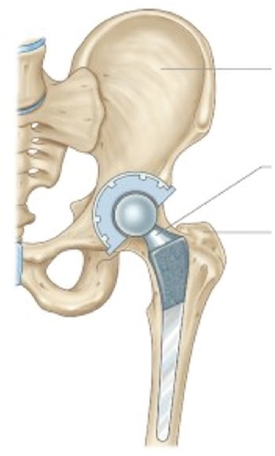
What is a total hip replacement?

Pelvis

Artificial hip joint
Femur
During the operation your surgeon will replace the worn or damaged joint with an artificial one. The hip is a ball and socket, articulated (movable) joint with the top end of the thigh bone (femur) sitting within the pelvis.
This new joint can last for years however through time and wear and tear it may need to be replaced or revised.

The benefits of a total hip replacement
The main benefits are:-
- To relieve severe pain and stiffness
- To improve mobility
- To do everyday activities more easily
- To improve the quality of life

In the problem/arthritic hip there is often considerable disability in the form of pain, stiffness and restricted movement. A new artificial hip joint can help you to carry our normal activities of daily living again, and most patients will regain near normal movement.

ENHANCED RECOVERY PROGRAMME FOR TOTAL HIP REPLACEMENTS

Before your surgery…
You will be given a drink high in carbohydrates to have prior to your surgery with instructions on when to take. (Unless you are a patient with diabetes).
Undergoing surgery can put a strain on your body and your energy needs may increase at a time when you are not able to eat and drink normally. These drinks can help prepare your body for the strain of surgery and keep you well hydrated at the same time.

Patients with diabetes
Morning admission - we would encourage you to drink
500mls/half a litre of any fluids the evening before surgery and
500mls/half a litre of clear fluids on the morning of surgery before 06:30 (Nothing containing milk)
Afternoon admission we would encourage you to drink 1 litre of fluid in the morning (Nothing containing milk after 7:30am), clear fluids up until 11am

It is important to eat and drink well before your surgery as this helps you to recover quicker. Being well nourished and hydrated is essential for healing and minimising your chances of getting an infection.
Other things you can do to help improve your recovery...
- If you smoke, try to reduce or cease prior to your surgery
- Limit your alcohol intake (at least for 48 hours prior to surgery)
- If you are overweight, any weight loss can help reduce the stress on your new joint
- An increase on your daily exercise by 10% (which can include walking, gardening, or using the stairs) can significantly improve your recovery

If support is needed please contact your GP prior to your surgery

Pre-op counselling: Hip School
You will be asked to attend a Hip school ran by the Enhanced Recovery Team which is a mandatory condition of your surgery. This is a 1 hour 15 minute educational session shown to benefit you as a patient and is aimed to give you the information you require in order to be an active participant in your own recovery. This will include;
- How to prepare for coming in for your surgery
- Post-operative advice “The important role you play in your own recovery”
- Discharge Criteria ...how quickly you may go home?
Other healthcare professionals may attend; these include Hospital @ Home, Physio & Occupational therapists.

The Pre-assessment clinic
Before your operation you will be asked to attend a pre-operative assessment clinic to check if you are medically fit to have your surgery.
You will also be given information about your operation, anaesthetic and pain management.
You may also be given the Carbohydrate Loading drinks at this appointment (unless you are a patient with Diabetes)

Pre-op Occupational Therapist (OT) appointment
The OT will aim to assess you prior to your operation. During this appointment the OT will discuss your home setup and assess whether you will require any equipment. This may be provided at the appointment.

ENHANCED RECOVERY PROGRAMME FOR TOTAL HIP REPLACEMENTS

Remaining fit for surgery
It is very important that on the day of surgery you still remain fit and well, so if you are suffering from any of the following ailments you must make an appointment to see your GP or dentist to make them aware that you are going to be having orthopaedic surgery.
- Currently taking antibiotics
- A high temperature
- Symptoms of water works infection (UTI)
- Dental or gum concerns to include infections
- Signs of cold/flu/chest infection
- Open wound, grazes, pressure sores, to the skin on the leg to be operated on
- Ear infection
- Cold sores
- Uncontrolled diabetes
- Uncontrolled low/high blood pressure
If you need to delay your surgery, contact pre-assessment hotline number 01582 718980 as soon as possible, and contact them again when you are fit to proceed. Please check with pre-assessment if you need to inform the waiting list office.

Preparation for your hospital stay
- Stock up your fridge and/or freezer with easily prepared meals for when you come home
  - Long life milk
  - Bread
  - Microwave/oven meals
  - Remove any clutter (e.g. including any trip hazards such as carpet edges and rugs)

- Organise your kitchen e.g. consider moving things you use frequently to avoid bending and twisting
- Consider which side of the bed you get in and out of as it is preferable to get out of bed leading with the leg you have had operated. For example if you have had your right hip replaced, get out of bed on the right side

Coming into hospital
Before you come in please have a bath/shower as normal and pay extra attention to the hip you are having operated. A clean operation site can help reduce the risk of infection post operatively. Also do not apply cream or shave your legs on the day of surgery and put on a clean set of clothes

You should bring into hospital with you:-
- This booklet!
- Loose fitting nightdress or pyjamas for night time
- Slippers (supportive, not mules) - if buying a new pair buy a size larger because of swelling after the operation.
- Loose, comfortable clothes for daytime on the ward
- Personal hygiene items (shaving, washing etc..)
- If appropriate, any walking aids you currently use.
- A 3 day supply of any medications you are taking in their original boxes (please hand these in to the nurse on the ward)
- A mobile phone (if you have one) and family/friends contact details
- Books, magazines, pens, paper, crosswords (ideas for things to do during your stay)
- Non-perishable snacks/drinks

Please arrange your transportation home, you could achieve the criteria needed for discharge the day after your surgery and this is when you will go home. If you have any issues regarding transport arrangements you should discuss this with the ward staff as soon as possible.

ENHANCED RECOVERY PROGRAMME FOR TOTAL HIP REPLACEMENTS

!
You MUST NOT eat anything for 6 hours prior to your operation. You may drink clear fluids up until 2 hours before your surgery.
Try not to starve any longer than need be, your admission letter will give you details of when to stop eating and drinking

On arrival at the hospital
- Please report to the admission location as stated on your letter
- You will be given a pair of anti-embolism stockings to help prevent a Deep Vein Thrombosis (DVT). One will be put on before your surgery to the non-operated leg, the other should go on immediately after your surgery.
- Before your surgery the surgeon will see you to explain the operation. Your Anaesthetist will discuss with you the type of anaesthetic that you are having. Please ask any questions you want.
- Your leg will be marked with a marker pen at the site of your operation.
- You will be given a hospital gown and 2 identity bands, one around your wrist and one around your ankle.
- Any dentures can be removed at the last minute (please advise staff of any capped or crowned teeth)
- You will be escorted to theatre walking unless you require a wheelchair.

The Operation
You will have a spinal anaesthetic, which numbs you from the waist down with/without sedation depending on how sleepy or awake you wish to be. Or you may have a general anaesthetic for medical reasons. This will be decided between you and your Anaesthetist

The surgeon will make an incision down the side of the hip. The damaged joint is replaced with a total artificial one.

The wound will be closed using clips, stitches or glue and covered with a waterproof dressing.

Sometimes you may have a drip (a fine tube) inserted into a vein in your arm to give you fluids and painkillers directly into the bloodstream. This will be removed quite quickly if you are drinking adequately.

After your operation you will be in recovery on your bed until your bed area is available, this can take some hours.

If you had a spinal anaesthetic or local nerve block, you will experience a degree of numbness in the lower body. This will be monitored and will gradually return to normal.

Once fully recovered from the sedation/anaesthetic you can eat and drink as normal.

To prevent infection please ensure that you, the hospital staff and your visitors all wash/clean their hands before and after touching you, your dressing or wound site.

ENHANCED RECOVERY PROGRAMME FOR TOTAL HIP REPLACEMENTS

Risks and Complications
General anaesthetic – there is a small risk of a reaction, please ask your pre-assessment nurse for a booklet on anaesthetics or speak with your anaesthetist for details.

A Deep Vein Thrombosis – (DVT) – this can occur after any operation but with a particular risk following lower limb surgery. In a few cases a clot can travel from the veins in your leg to your lungs (Pulmonary Embolism) which can be fatal.
Things we do to help prevent DVT: blood thinning medication, anti-embolism stockings, early and frequent walking & drink a variety of fluids (aim for 1.5L per day)

Change of leg length – there is a risk that following the surgery there may be a difference in your leg length which may require a raised shoe.

Dislocation – you will be advised by your physiotherapist and occupational therapist how to help prevent this. (See hip precautions on page 18).

Urinary retention – occasionally some patients experience difficulty in passing urine after surgery. You may find that standing up or sitting on a toilet will help with this. But if not it may be necessary to pass a fine tube (a urinary catheter) into your bladder temporarily to allow you to pass urine. If you have had difficulty passing urine previously please make the nursing staff aware.

For some patients the risks may be greater; please speak to your surgeon before your operation if you have any concerns about these risks or other complications.

The most important person in your recovery is you!
You can make a difference to the speed of your recovery and to increasing your independence and mobility by following the advice and exercises given by the physiotherapist, occupational therapists, Enhanced Recovery team and nursing staff on the ward.

Pain Management after your Surgery
You will experience some degree of pain and or/discomfort after you surgery, which we will try to reasonably manage on oral analgesia that will be prescribed for you. If you feel pain is stopping you from walking or doing your exercises, you must let the ward nurses know as soon as possible.
Stiffness also causes pain, putting weight through the joint and
frequent movement is crucial.

How is my pain assessed?
Your pain will be regularly assessed by the team and will be assessed on a scale of 0 (no pain) to 10 (extremely severe pain).

Pain Score | Description
0 (none) | No pain at rest or on movement
1-3 (mild) | No pain at rest but slight pain on movement
4-7 (moderate) | Intermittent pain at rest or moderate pain on movement
8-10 (severe) | Continuous pain at rest or severe pain on movement

You should assess your pain levels on movement in the bed and you need added pain relief you can request this.
Please refer to page 25-26 for further information.

ENHANCED RECOVERY PROGRAMME FOR TOTAL HIP REPLACEMENTS

Day 0 - After your surgery

In the Recovery area
As soon as you have sensation and feeling back in your legs and can follow verbal instructions from your healthcare professional;
- Ask for the wedge shaped cushion between your legs to be removed – this is only there to prevent you crossing your legs
- You should now have an anti-embolism stocking applied to your operated leg by Nursing staff
- You can start to eat and drink (if you feel sick please let your nurse/doctor know asap, as you will be prescribed anti sickness medication)
- You should start to attempt your bed exercises and to move the operated leg. These can be found on pages 16 & 17.

On the Ward
The nurses will check your observations to see if you are safe to get out of bed. Initially ask for help to get up and mobilise - do not attempt on your own! You will be advised as to when you are able to walk without assistance/supervision.
Your joint is fully weight bearing so now you should;

- Complete bed exercises
- Aim to get out of bed and try to take a few steps & then to
sit in the chair and continue exercises (page 16 and 17)
- Start using your Enhanced Recovery Goal Chart
- Re-assess your pain regularly on movement, if you require additional pain relief please ask your nurse
- It is important to pass urine after your surgery - this is easier when you are mobile! Men may stand and use a bottle at the bedside, both men and women can use a commode or if near a toilet then can walk there with assistance. Gravity helps!

ENHANCED RECOVERY PROGRAMME FOR TOTAL HIP REPLACEMENTS

- Drink a variety of fluids
- Your appetite may be low, however, it is important to maintain a well-balanced diet little and often

- The team will encourage you to be active and mobile, you will get up on the day of your surgery with assistance providing your observations are stable, the sensation has returned to your legs and it is safe to do so.

Day 1 to the day you are discharged
- Use your Enhanced Recovery daily Goal Chart to help guide you
- Aim for 4 walks a day (or more if able) gradually building up the distance you walk - this can be with ANY healthcare professional until advised you are safe to walk without assistance/supervision. Therapists will provide you with the most appropriate walking aid and progress you as able.
- You will have a routine x-ray and blood test- please let your nurse know if this has not happened.
- Get yourself washed and dressed into your own day clothes. Ask for assistance if required. This is to assess your ability to wash and dress before you go home.
- Continue with your exercise programme (pages 16 & 17).
- Re-assess your pain regularly on movement, if you require additional pain relief please ask your nurse.
- Your anti-embolism stockings should be removed daily by nursing staff and your legs washed, creamed with water based moisturiser and stockings reapplied. They may need to be re-measured if too tight, please do not leave off for any longer than half an hour.

ENHANCED RECOVERY PROGRAMME FOR TOTAL HIP REPLACEMENTS

- Your dressing is showerproof and should remain in place for up to 7 days (unless leaking outside of the dressing boarder) this can help reduce the risk of infection as it is applied in a sterile environment in theatres.
- If you have stairs at home, the physiotherapist will assess you going up and down with the walking aid you have been provided with prior to discharge (unless indicated otherwise)
- If equipment was not provided prior to admission, this assessment will take place on the ward. Please be aware that equipment will need to be collected from the hospital. Please discuss any concerns with the Occupational Therapist.

When do I go Home?
Criteria for discharge – Quite often this is achieved the very next day

- Medically fit (x-ray and bloods taken and the x-ray has been reviewed)
- Discharged by the Physiotherapist
- Discharged by the Occupational Therapist
- Eating
- Drinking adequately (around 1.5L in 24 hours)
- Pain reasonably well controlled on oral medication
You will have the support of the Hospital @ Home Team on discharge from hospital, unless for some reason your stay in hospital is longer than 7 days or you live outside of the catchment area in which case other arrangements will be made i.e. Practice Nurse or District Nurse referral.

ENHANCED RECOVERY PROGRAMME FOR TOTAL HIP REPLACEMENTS

On discharge

- You will be sent an appointment to see a member of your surgical team in approximately 6-8 weeks’ time at which time you will have a repeat X-ray.
- You will be given your discharge letter and medication - please make sure you understand the medications you have to take and when and go through this with your nurse. Also ask for any of your own medication to be returned to you.
- You will be provided with two pairs of anti-embolism support stockings and if under the care of the Hospital at Home team they will assess when these should be removed. If you are not receiving Hospital at Home the stockings will be removed on discharge.
- Any equipment that you have been provided with should be taken home with you (if this has not already been collected)

See Frequently Asked Questions section on pages 27-29 for further information.

ENHANCED RECOVERY PROGRAMME FOR TOTAL HIP REPLACEMENTS

Exercises
Complete each exercise 10 times and repeat them 3-4 times per day
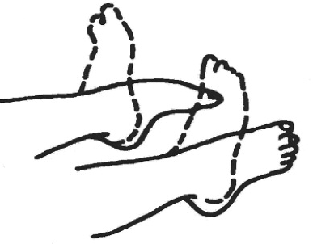
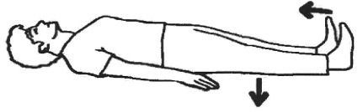
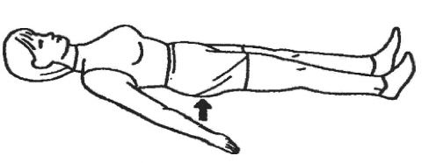
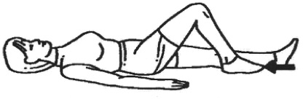

E X E R C I S E 1
Move your foot up and down

E X E R C I S E 2
Pull your toes up and press the back of your knee into the bed
Hold for 5 seconds

E X E R C I S E 3
Squeeze buttocks together
Hold for 5 seconds

E X E R C I S E 4
Gently bend and straighten your leg
Remember DO NOT go beyond
90 degrees

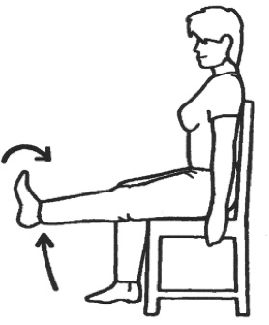
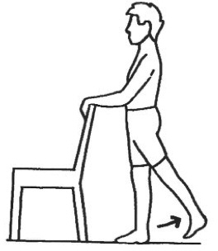

E X E R C I S E 6
Sitting in a chair or on the edge of the bed, lift your leg to straighten the knee
Hold for 5 seconds

E X E R C I S E 7
Stand holding onto a supportive surface

Lift your leg behind you keeping the leg straight, and then gently return to the centre

ENHANCED RECOVERY PROGRAMME FOR TOTAL HIP REPLACEMENTS

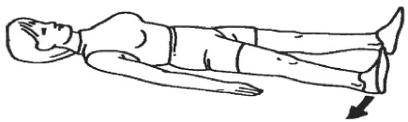

E X E R C I S E 5
Keep your toes pointing up. Slide your leg out to the side then back

Only do this exercise when advised by the Physiotherapist or OT

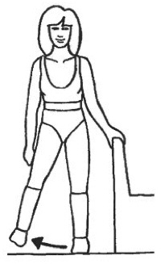

E X E R C I S E 8
Stand holding onto a supportive surface Lift your leg out to the side and back to the centre. Maintain good posture and keep the toes pointing forward
Only do this exercise when advised by the Physiotherapist or OT

ENHANCED RECOVERY PROGRAMME FOR TOTAL HIP REPLACEMENTS

Occupational Therapy and Physiotherapy advice

Hip precautions
Following a Total Hip replacement the surrounding muscles and tissues need time to heal and strengthen. It is therefore important that you avoid the movements shown below after the operation to reduce the risks of dislocating the hip. Your surgeon will review your hip precautions at your follow up appointment 6-8 weeks post-surgery and let you know if these need to continue beyond this time.

- DO NOT cross your legs
- DO NOT twist - take small steps when turning
- DO NOT bend past 90 degrees - e.g. no bending over to pick things off the floor or sitting on low seats
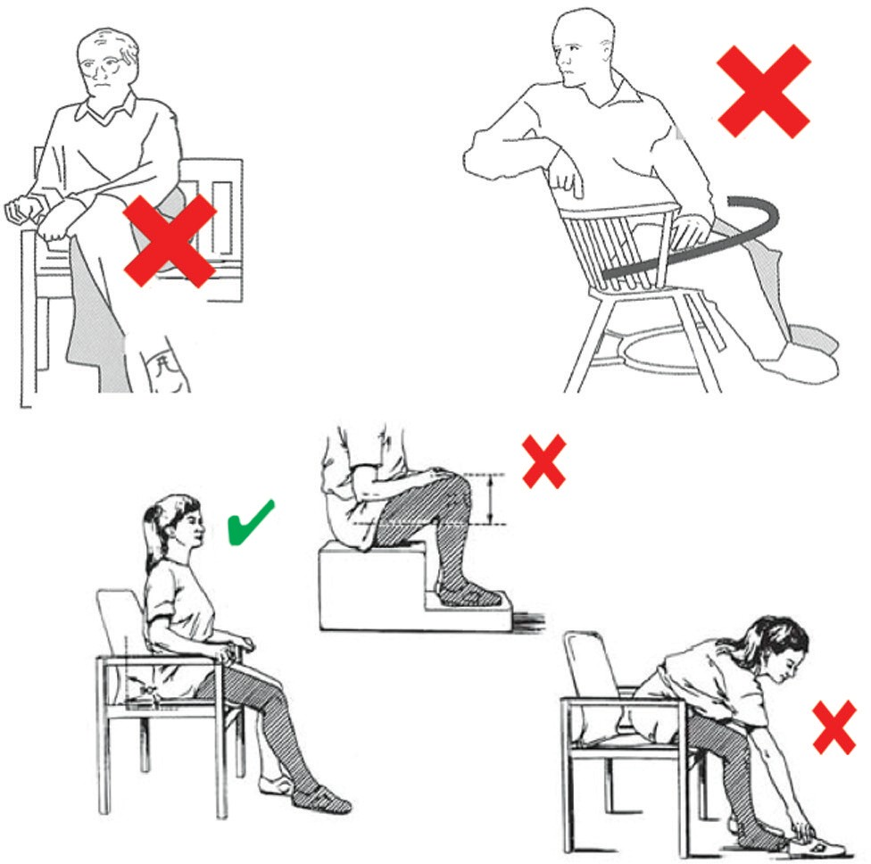

Getting washed and dressed
The important thing to remember is DO NOT BEND OR TWIST
when you are washing and dressing the lower half of your body.

You can purchase long handled aids from us for a small cost. Alternatively, you can purchase these privately. These aids can be seen below.

We recommend you do not use a bath for the duration of your hip precautions

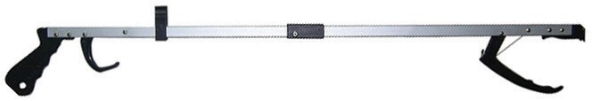
- Helping Hand/Grabber
- Sock aid - for socks and stockings

- Long handled shoehorn for footwear

- Long handled sponge for washing

ENHANCED RECOVERY PROGRAMME FOR TOTAL HIP REPLACEMENTS

Getting out of bed
- Always get out of bed on the operated side
- Walk your legs to the edge of the bed
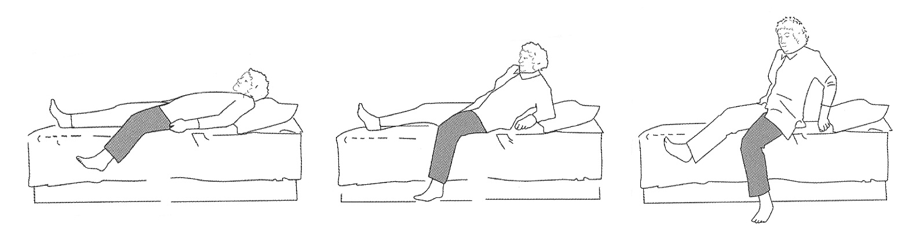
- Gently move to a sitting position on the edge of the bed

Getting into bed
- Always get into bed leading with your un-operated leg
- Shuffle your bottom to the middle of the bed
- Slowly lift the operated leg onto the bed
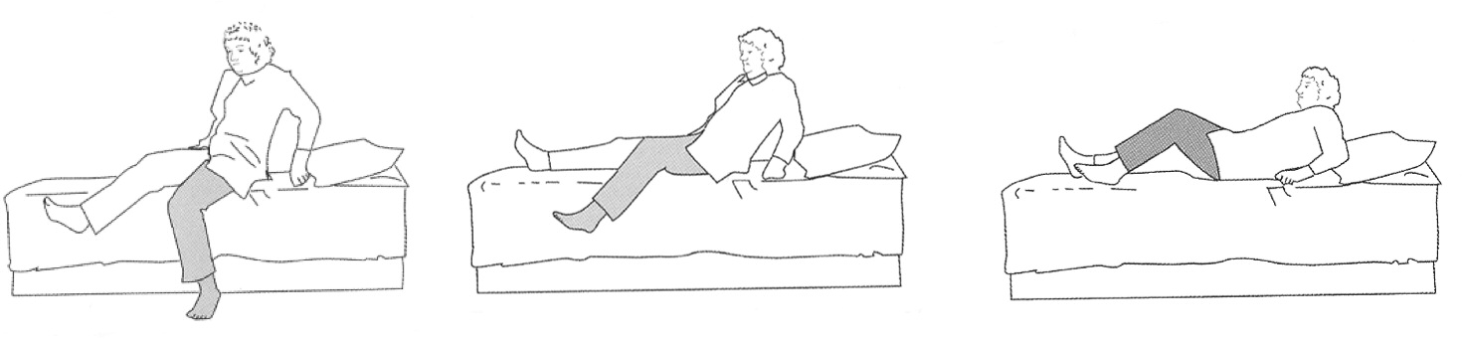

For Example:
If RIGHT Total Hip replacement – get in & out on the right side of the bed
If LEFT Total Hip replacement – get in & out on the left side of the bed

ENHANCED RECOVERY PROGRAMME FOR TOTAL HIP REPLACEMENTS

Sitting down
- Feel the chair with the back of your legs
- Reach your hands back to feel for the arms of the chair
- Place the operated leg forward and take the weight on your un-operated leg
- Gently lower yourself down to the chair

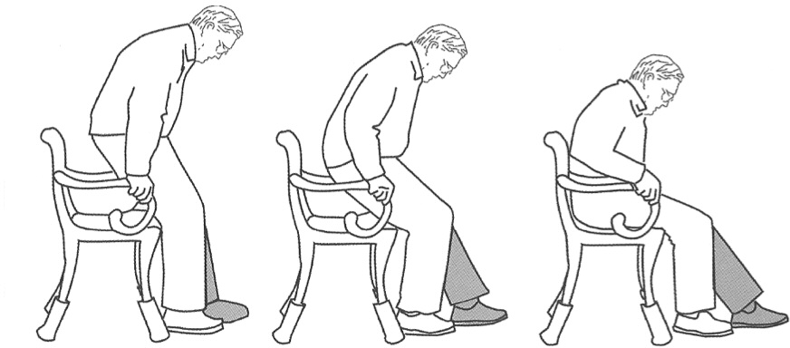

Standing up
- Put your operated leg straight out in front
- Keep your un-operated leg bent
- Slide your bottom forward and push up through the arms of the chair
- Push yourself into a standing position
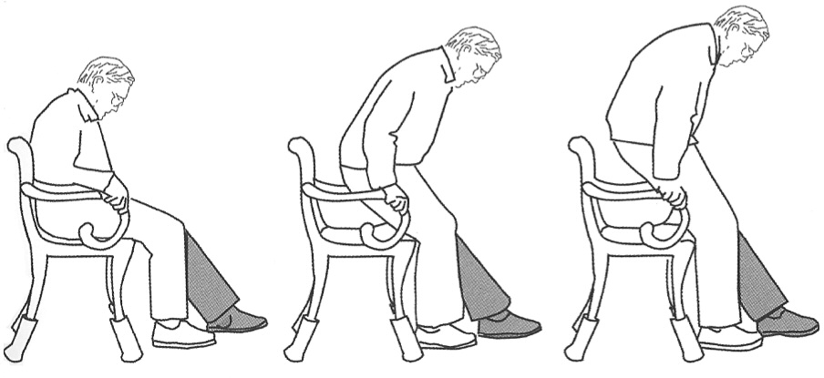

ENHANCED RECOVERY PROGRAMME FOR TOTAL HIP REPLACEMENTS

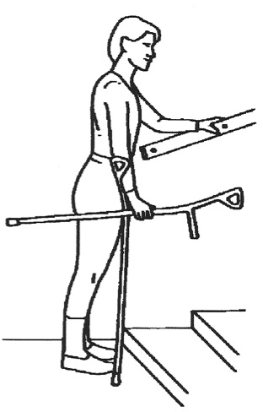
Walking UP stairs
- Stand close to the stairs
- Hold onto the handrail with one hand
- Hold the stick / crutch in the other hand

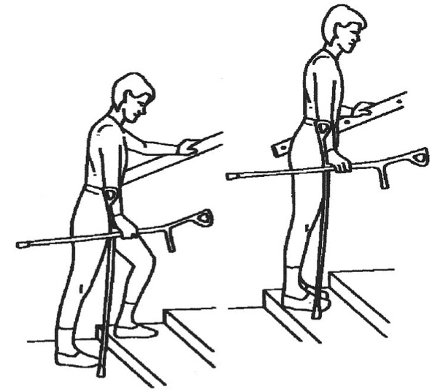
- Step up with your good / un-operated leg
- Then step up with your bad / operated leg
- Bring the stick / crutch up to the same step

ENHANCED RECOVERY PROGRAMME FOR TOTAL HIP REPLACEMENTS

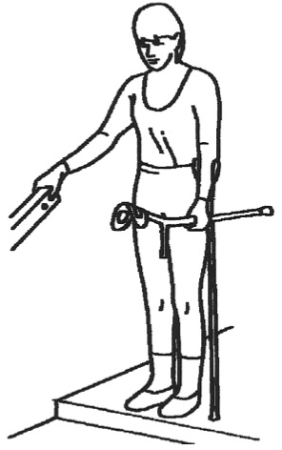
Walking DOWN stairs
- Stand close to the stairs
- Hold onto the handrail with one hand
- Hold the stick / crutch in other hand

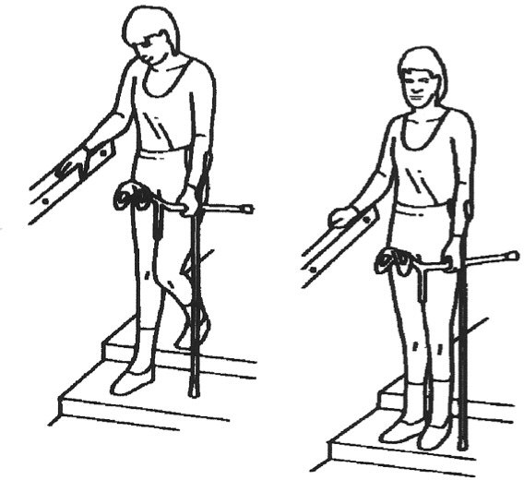
- Put the stick / crutch down one step
- Step down onto your bad
/ operated leg
- Then step down with your good / un-operated leg onto the same step

ENHANCED RECOVERY PROGRAMME FOR TOTAL HIP REPLACEMENTS

Getting into a car
- Move the passenger seat as far back as it will go
- Carefully move back towards the passenger seat until you feel the door sill against the back of your legs
- Support yourself by holding the back of the seat and the dashboard or door frame
- Gently lower your bottom onto the seat
- Slide your bottom backwards towards the drivers seat
- Using your arms to support you, slowly lift your legs into the car
- if required ask someone to assist in lifting your legs into the car

Getting out of a car
- Move your bottom closer to the drivers seat
- Lift your legs out of the car and slide your bottom forward to the edge of the seat
- Place one hand on the dashboard and one on the back of the seat or door frame and stand up
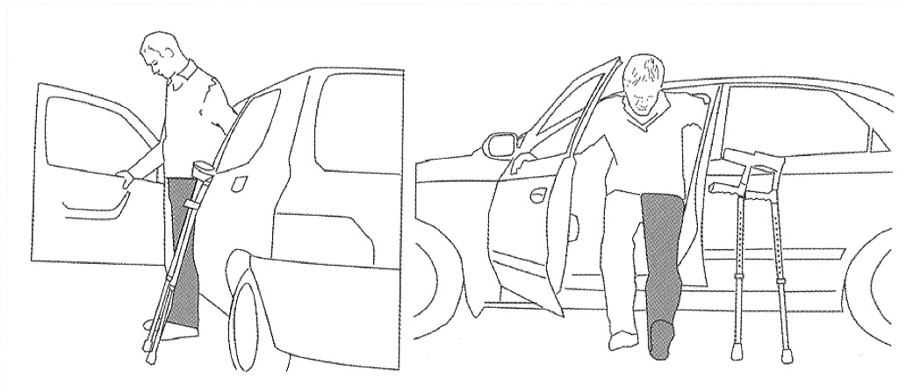

ENHANCED RECOVERY PROGRAMME FOR TOTAL HIP REPLACEMENTS

The Hospital @ Home Service
This allows for you to be cared for at home by the ‘Hospital at Home Team’ – the team consists of Nurses and Physiotherapists.
All the team members are multi- skilled in this particular service and can provide a high standard of care in your home.
Provided you have not had an extended length of stay (over 7 days) or live outside of the catchment area then you will be seen by the Hospital @ Home team.
They can assist with;
- Medication management
- Going through exercises and progressing mobility at home
- Wound care
- Further advice on how to manage daily activities at home

Medication Information

Which medications will I be prescribed for pain and how long should I expect to take them?

PARACETAMOL
If you are able to take this then these can be taken regularly, 2 x 500mgs tablets 4 times a day. Taking these make your stronger painkillers work more effectively.
When weaning back off your painkillers, these should be the last ones you stop.

ENHANCED RECOVERY PROGRAMME FOR TOTAL HIP REPLACEMENTS

OXYCODONE MODIFIED RELEASE (MR) TABLETS
This is the standard, strong painkiller you will be given in hospital. It releases slowly over 12 hours so you will have 1 dose - twice a day. This will usually be prescribed for maximum 3 days.

OXYCODONE IMMEDIATE RELEASE (IR) LIQUID/CAPSULES
Also called ‘Top-up’ or ‘as required’ medication. This should be used if you need extra pain relief during the day. It works quickly - usually within half an hour. Please ask your nurse for this if required.

GABAPENTIN
This medication is used to help prevent neuropathic (nerve) pain.
It is a short course and one dose of 100mg or 300mg is given pre-operatively (depending on age and any existing medical conditions). This is then continued for 3 days post-operatively (100mg-300mg three times daily).

IBUPROFEN
If you can take this medication safely then you will have 400mg, three times a day for a maximum of 5 days. To be taken with or after food.

OMEPRAZOLE
If you are prescribed ibuprofen, you will be given this to take alongside to protect your stomach and reduce the risk of any stomach pain or upsets.

LAXATIVES
The painkillers we have prescribed you may cause some constipation. We will supply you with some gentle laxatives which will help prevent this.

ANTI- COAGULATION MEDICATION
You will be prescribed a 10 day course of blood thinning injections to start on the evening of surgery, this will be followed by 4 week course of Aspirin 75mg once daily, this will be from the day of your surgery which can help to reduce the risk of developing a blood clot (DVT) after surgery this may be:

If you are on warfarin you will require bridging Tinzaparin injections as well as your warfarin to start with, this will continue until your INR is within therapeutic range at which time the injections will stop. Hospital at Home team can help to manage this once you are home if needed.

If you are on analgesia for chronic pain then you may be put back on your own medications, this will be discussed with you.

Frequently Asked Questions (FAQ’s)

Why have I still got swelling?
It is normal for healing tissues to be swollen and it can last several months. Putting full weight through your leg uses the calf muscle to help pump the blood back to the heart and so can decrease swelling. When you are sat down/resting, elevate your operated leg onto a foot stool so that your feet are at waist height, this will encourage the fluid to work its way up your leg. Ice packs (or frozen peas wrapped in a damp tea towel) and place on the swollen areas for 15-20 minutes, do not leave on for longer than 20 minutes as you will become more at risk of Ice burns.

How long will I need to use walking aids (i.e. Crutches or walking sticks)
Unless you have been informed of any weight baring restrictions, there is no fixed length of time that walking aids are required as everyone is different, there are a few things to remember when trying to progress your mobility:

- Ensure you feel steady and safe – if you feel unsteady or do not feel confident using one crutch for example then please continue using two.
- Be careful not to limp – if you are trying to progress from two crutches onto one and when you try this you notice you are limping, again, please continue to use two crutches. Limping is a sign that your knee muscles are not yet ready to be supporting your full weight
- Trial and error – there is no harm in trying to progress your mobility. You can try a few steps, and can have a family member/friend stand with you if you prefer. If you feel unsafe , or feel you are limping, then continue with your previous level of walking aids. You can always try again in another couple of days.
- Outside is different to inside – You may have managed to progress onto using one crutch or walking stick indoors, but may still need to use 1-2 crutches outdoors. This is because of uneven surfaces, the distance you are walking, and the weather. It is ok to still require a walking aid outdoors for some time after your surgery.

Why is my scar warm?
As your body heals it is a natural response to produce heat. This may also last for a few months.

How long will I experience pain?
You may experience some degree of discomfort for several weeks following your surgery. If you are still under the care of the Hospital @ Home team then discuss with them or the Enhanced Recovery Team.

Why do I get pain lower down my leg or in my back?
While everything is settling and you are adjusting to walking in a normal way again you may experience some referred pain in the shin, behind the knee or in your back.

Why does my joint stiffen up?
After sitting or lying down for a while, you may feel stiff when you try to move. Taking a few steps should loosen this or doing some of your exercises before you move can also help.

How long should I wear my anti-embolism stockings?
Until your mobility is back to what it was before your surgery. You should have 2 pairs at home and they MUST fit correctly i.e. not cutting in or too tight. Take them off daily to wash and put them back on after no longer than 30 minutes. If the stockings begin to cut in please remove and do not replace, continue to drink 1-1.5L of fluid a day and walk around regularly (every hour during the day).

ENHANCED RECOVERY PROGRAMME FOR TOTAL HIP REPLACEMENTS

Is it normal to have disturbed nights?
Yes. This is due to the joint and muscles stiffening up overnight. The following may help;
- Movement - bed exercises or getting up and walking around for a short time
- Take your quick acting pain relief during the night
- Ice therapy – Ice packs or a bag of frozen peas wrapped in a damp tea towel and apply to swollen/painful area.

I have concerns about my wound?
Please contact the Hospital @ Home in the first instance, or the Enhanced Recovery Team (Contact numbers can be found at the back of this booklet)

When can I start driving again?
You must not drive until you can perform an emergency stop safely and also that your insurance company is happy. We recommend that you wait until you have had your consultant review around approximately 6-8 weeks’ time.

When can I go swimming?
Not until after you have your 6-8 week follow up with your surgical team.

ENHANCED RECOVERY PROGRAMME FOR TOTAL HIP REPLACEMENTS

If you have any more questions please write them down and ask a nurse, therapist or doctor these when you come in to hospital.
!

I think I will need some help at home - what do I do?
When you are in hospital you will be assessed to make sure you can carry out the following tasks prior to discharge;
- Washing & dressing
- Getting in and out of bed
- Getting on and off the toilet

The Occupational Therapists will discuss meal preparation with you also and how to manage this at home.

Most patients can manage very well at home with the good preparation beforehand and the correct equipment. However, if you are currently struggling with most of these tasks before you come in for your surgery and feel you may need some extra help at home, then please contact your GP prior to admission for an assessment.

Poor preparation beforehand may lead to increased anxiety.

ENHANCED RECOVERY PROGRAMME FOR TOTAL HIP REPLACEMENTS

Discharge information for managing pain relief for Enhanced Recovery patients after total hip and knee surgery
- Everyone is different, but generally pain is worst in the first few days after surgery, then day by day the pain improves meaning pain relief medication can be reduced also.
- Please consider other methods to manage your post-operative pain. To ease your discomfort try: ice therapy (ice pack or bag of peas), movement, changing positions, distraction.
- You will probably go home on the pain relieving medication you have been using in hospital to manage any post-operative surgical discomfort. This should be reduced as your pain improves.
- You need to ensure you understand the information given to you by the nurses regarding your medication on discharge.
- Information regarding your hospital stay and medications will be in your GP letter.
- You are unlikely to become addicted to the pain relief medications as you will only be taking them for a limited period of time. However you will need to reduce them down gradually.
- If you take pain relief medication for chronic pain, then continue this medication, until you have been fully assessed by your GP. Remembering that if you were suffering with pain in the joint that has been operated on, the pain from your osteoarthritis will be improved.
- You will be given the appropriate amount of pain relief medication for your post-operative pain. However, everyone is different; if you experience pain and you are unable to perform your exercises then you will need to contact either the Hospital @ Home (H@H) team if you are under their care, otherwise the Enhanced Recovery Team, both contact details are at the back of this book.

Useful Contact Details
Below are some useful telephone numbers to have to call for advice before or after your surgery or also whilst in hospital.
To call a bleep, dial the main hospital number and ask operator to bleep the number stated below. Otherwise you can call one of the numbers listed below.
Main hospital no:
01582 491166

Enhanced Recovery Team:
We are usually available 7-4pm Mon-Sun (Answer phone service available)

Clinical Lead: Irene Fitt
Senior Sister: Rosie McGrandles
Sister (Orthopaedics): Aimee Ford
Sister (Orthopaedics): Hima Nair
Sister: Reema Dsouza
Contact number: 01582 71816 To bleep us 01582 491166 and ask for them to bleep: 398
Hospital @ Home (9-5pm):
Lead Nurse: Rita Patel
07534 960 143

Surgical Assessment Unit (SAU)
if after 5 and you need to speak to someone before the morning then contact the surgical assessment unit number 01582 497496

Waiting List Office: 01582 497379

Code: LDH/ER/THR/2018 Review 2021

