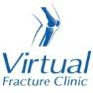

Trauma and Orthopaedics

Lateral Clavicle Fracture
This is a break to the end of your collar bone.

Healing:
This normally takes approximately 3-6 weeks to heal, but symptoms can continue for 3-6 months.
Smoking will slow down your healing. We would advise that you stop smoking while your fracture heals. Talk to your GP or go to www.smokefree.nhs.uk for more information.

Pain and swelling:
Your shoulder may be swollen and you will have some pain. Taking pain medication and using ice or cold packs will help.

Wearing your sling:
Use your sling for 2-3 weeks. You can take it off to wash, dress and do your exercises. It does not need to be worn at night.
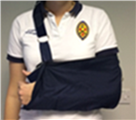

Exercises:
It is important to start gentle exercises straight away to prevent stiffness. You will find pictures and instructions for your exercises below.
You should not do any heavy lifting or overhead movement for the first 6 weeks.

Follow up:
Normally we do not follow up patients with this type of injury as they heal well. If after 6 weeks your child still has significant pain or swelling please contact us using the details listed above. A lump (callus) may appear at the fracture site as it is healing; this is quite normal and will disappear over a few months after the fracture has healed.

Any questions:
If you are concerned about your symptoms, unable to follow this rehabilitation plan or have pain other than at your knee, please contact the Virtual Fracture Clinic team.

Caring for your injury – Week 1-3
Remember to use your sling for the first 3 weeks. Take it off to wash, dress and do your exercises. You don’t have to wear your sling at night. You may find it more comfortable to sleep propped up on pillows
Using a cold pack will help with your pain and swelling. You can use an ice pack or bag of frozen peas wrapped in a damp towel. Put this on your shoulder for 15 minutes every few hours. Make sure the ice isn’t in direct contact with your skin.
Try to rest your arm, especially in the first 24-72 hours.
Exercises:
Start these exercises straight away. Hand, wrist and elbow exercises are only needed while you are wearing a sling. You can stop these once they become easy and you have full movement. Try to do these exercises 4-5 times a day. Repeat each exercise 10 times.
Hand, wrist and elbow exercises:
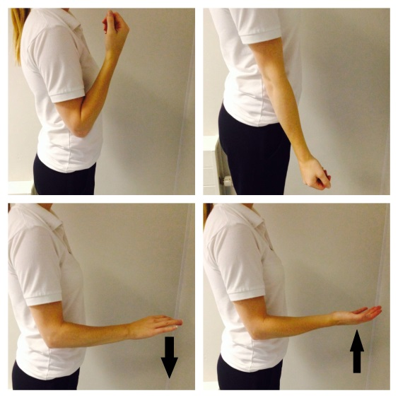
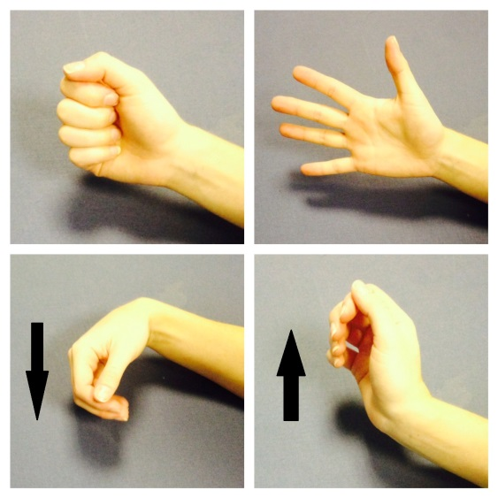

Open and close your hand. Next, move your wrist up and down. Repeat 10 times.
After a few days, hold a soft ball or rolled up socks. Squeeze the ball and hold for 5 seconds. Repeat 5 times.
Bend and straighten your elbow. Repeat 10 times.
Bend your elbow to a right angle. Slowly turn your palm up to the ceiling and down to the ground. Repeat 10 times.

Posture Exercise:

Bring your shoulders back and gently squeeze your shoulder blades together. Hold for 20-30 seconds. Repeat 5 times.
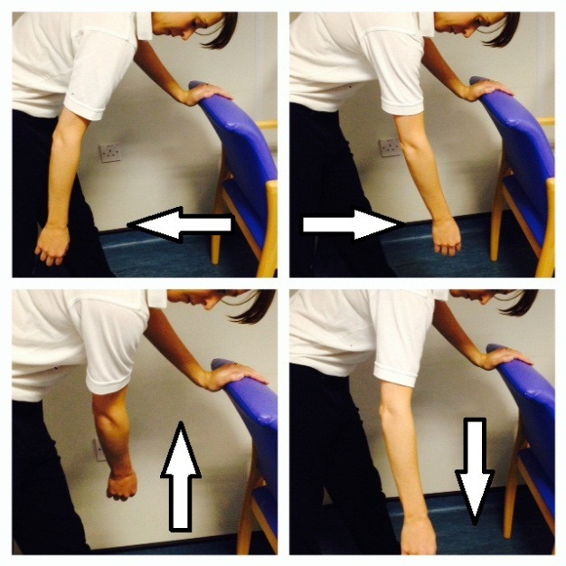
Shoulder Pendulum Exercise:

Stand next to a firm surface. Support yourself with your un-injured arm and lean forwards. Let your injured arm relax and hang down to the ground.
Gently swing your arm, making a small movement. Try to do this forward and backward, side to side and in small circles.
Aim to do this for 1-2 minutes in total. You do not need to push into pain. Remember to keep your arm relaxed.

Caring for your injury – Week 3-6
You can now stop using your sling.
You can now return to light activities. Remember, you should not do any heavy lifting or overhead activity for 6 weeks.
Exercises: Start these exercises 3 weeks after your injury. Try to do them 4-5 times a day. Repeat each exercise 10 times.

Active Assisted Flexion
Use your other hand to lift your injured arm up in front of you, as shown in these pictures.
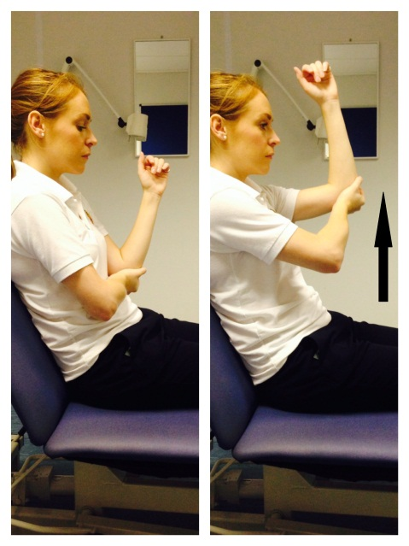
Active Assisted External Rotation
Keep the elbow of your injured arm tucked into your side and your elbow bent. Hold onto a stick, umbrella or something similar.
Use your good arm to push your injured hand outwards. Remember to keep your elbow tucked in.
If you don’t have a stick, hold your injured arm at the wrist, guide it outwards with your good hand.
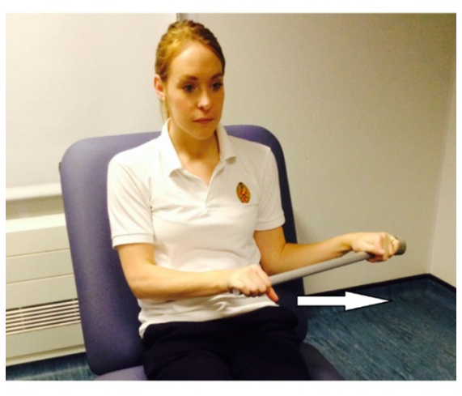
Your injury should be healed.
You can return to normal activities. Do this in gradually and be guided by any pain or discomfort you experience. Some heavier tasks may still be uncomfortable.

Caring for your injury – Week 6-12
Exercises:
Start these exercises 6 weeks after your injury. Try to do these exercises 4-5 times a day. Repeat each exercise 10 times.
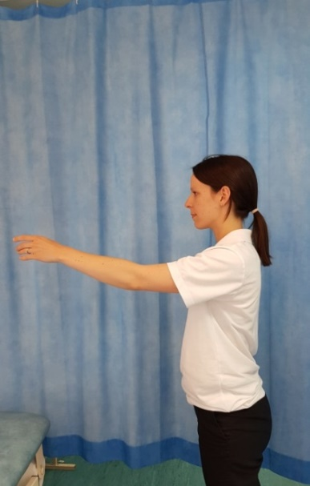
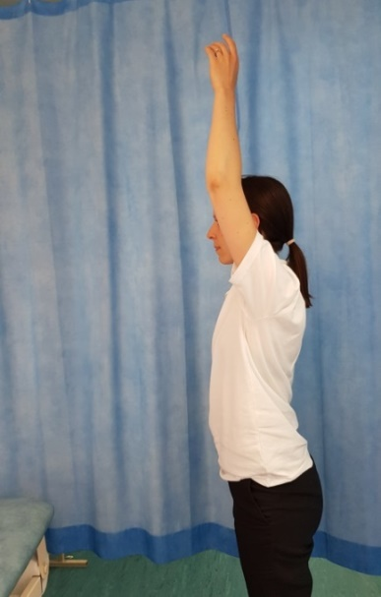
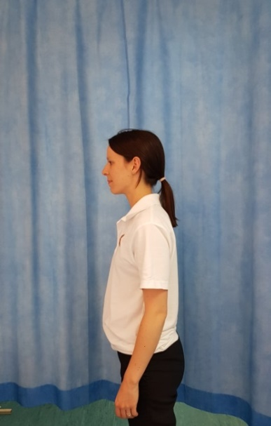
Active Flexion
Lift your arm forwards in front of you. Try to raise the arm as high as you can. You do not need to push into pain. If this is too difficult, try the same movement with a bent elbow.

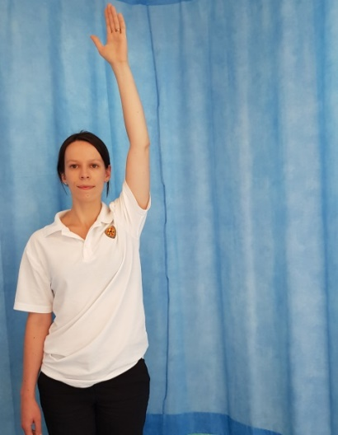
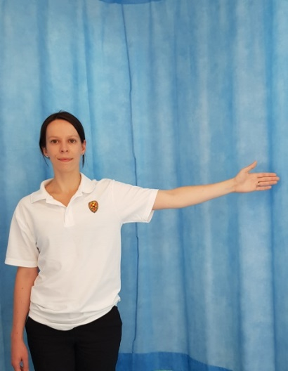
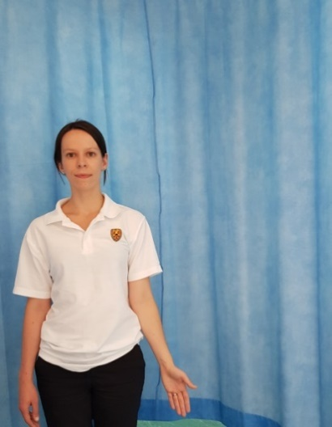
Active Abduction
With your palm facing forwards, move your arm out to the side in a big arc. Try to raise the arm as high as you can. You do not need to push into pain. If this is too difficult, try the same movement with a bent elbow.
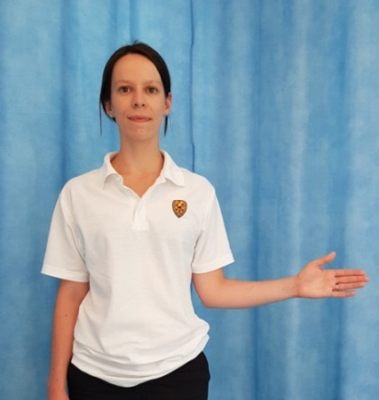
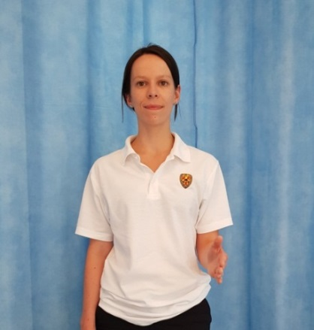
Active External Rotation
Start with your elbow bent by your side. Move your forearm out to the side, keeping your elbow bent and near your waist.

Frequently Asked Questions
I’m concerned about my symptoms and/or I am struggling to return to exercise.
Please contact the Virtual Fracture Clinic
I am struggling with my sling. What do I do?
Contact the Virtual Fracture Clinic. We can give advice or change your sling if needed.
When can I start driving?
You can return to driving when:
- You are no longer using a sling,
- You can move comfortably and
- You can control the vehicle safely.
Always test your ability to drive in a safe environment first.
How can I get a certificate for work?
You can get a fitness for work statement from your GP or the doctor at your Fracture Clinic appointment.
How do I contact the Virtual Fracture Clinic?
Call 01582 718121. Messages will be checked every morning Monday-Friday.
Email VFC@ldh.nhs.uk

Some pictures and content produced by Brighton and Sussex University Hospital and shared with permission.
Bedfordshire Hospitals NHS Foundation Trust
Luton and Dunstable University Hospital
Lewsey Road
Luton, LU4 0DZ

www.bedfordshirehospitals.nhs.uk
@LandDHospital

