

**Creating an ‘email signature’**

In order to add to your Outlook email signature, please follow the steps below. This can also be adapted to add any other key topical NHS campaign signatures (for e.g. Seasonal Flu, Smoking cessation, NHS Birthday etc.) However the Trust logo and your contact information should always remain the same as demonstrated below if you choose to include the logo in your signature. You can choose to have a simple email signature without the logo and campaign banner but the bullet points under Important Considerations must be adhered to.

**How:**

Open Outlook and choose **‘new message’**

Select the **‘signature’** tab and scroll down to **‘Signatures…’**

In the menu box select **‘New’** and name the signature appropriately, for example **‘Values’**

Copy the below template and paste into the content area, then populate with your details.

**Save** the signature.

To the right of the menu box you will see **‘choose default signature’**

Ensure this is set to your preferred signature using the drop down menu to make your selection.

Click **‘Ok’** and you’re all done!

**Copy:**

**­**

|  |  |
| --- | --- |
|  | **Name Name**  **Job Title, Department**  Bedfordshire Hospitals NHS Foundation Trust  **Tel: 01528 497458**  **Mobile: 07777 370428**  Visit: www.bedfordshirehospitals.nhs.uk |
|  |

**Signature with a promotional banner**

If you would prefer to use an email signature with a campaign banner underneath then the format of the below example should be applied:

**Your name**

**Your job title**

Bedfordshire Hospitals NHS Foundations Trust

**Tel: 01582 xxxxxx In Ext:xxxx** | **Mob: xxxxx xxxxxx**

**Visit**: [www.bedfordshirehospitals.nhs.uk](http://www.bedfordshirehospitals.nhs.uk/)

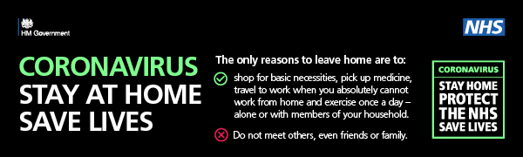

**Important considerations:**

We are aware that email signatures do vary throughout the Trust but it is important that if you’re incorporating the Trust logo then the above correct logo **must be used in all variations.**

In order to ensure information we are emailing out is as accessible as possible we encourage you to follow national guidance around Accessible Information which takes into consideration people accessing such info with learning disabilities and/or minor visual impairments. Below are quick tips for you to consider and adopt when selecting your email signature.

* Use Arial font with a **minimum 11pt** in size
* No background colours on emails should be used
* Italic fonts should be avoided
* No clip art unless it is part of a national digital package for a campaign (for e.g. NHS Birthday)