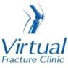

Trauma and Orthopaedics

Recurrent Shoulder Dislocation - High Trauma
This is when your shoulder comes out of joint after high energy injury.

Healing:
Multiple shoulder dislocations can cause damage to the soft tissues of the shoulder joints. It takes approximately 6 weeks for this to settle.
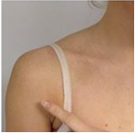

Pain, swelling and pins and needles:
Your shoulder may be swollen and you will have some pain. Taking pain medication and using ice or cold packs will help. More information is on the next page.
You may have a small patch of numbness on the outside of the shoulder. This will improve with time. Please contact us if you have any of the following symptoms:
- Pins and needles or numbness of the arm or in your hand
- If you are struggling to move the hand or arm at all
- You have pain or symptoms anywhere other than your shoulder

Wearing your sling:
Use your sling for comfort only and no more than 1 week. You can take it off to wash, dress and do your exercises.

Exercise and activity:
It is important to start gentle exercises straight away to prevent stiffness. You will find pictures and instructions for your exercises below.
You should not lift the arm over shoulder height for 3 weeks or do heavy lifting for 6 weeks.

Follow up:
You will have a face to face appointment 3 weeks after your injury. The Specialist will assess your shoulder and discuss the best management plan with you. We have discussed a referral to physiotherapy and will refer if required.

Caring for your injury – Week 1 to 3
Wear your sling for comfort in the first week, including in bed at night. You may find it more comfortable to sleep propped up on pillows. Remove the sling for washing, dressing and exercises.
Using a cold pack will help with your pain and swelling. You can use an ice pack or bag of frozen peas wrapped in a damp towel. Put this on your shoulder for 15 minutes every few hours. Make sure the ice isn’t in direct contact with your skin.
Try to rest your arm, especially in the first 24-72 hours.
Exercises
Start these exercises straight away. Try to do these exercises 4-5 times a day. Repeat each exercise 10 times.
Hand, wrist and elbow exercises:
Open and close your hand. Next, move your wrist up and down. Repeat 10 times.
After a few days, hold a soft ball or rolled up socks. Squeeze the ball and hold for 5 seconds. Repeat 5 times.
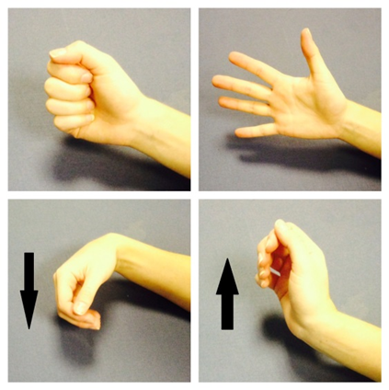

Bend and straighten your elbow. Repeat 10 times.
Bend your elbow to a right angle. Slowly turn your palm up to the ceiling and down to the ground. Repeat 10 times.
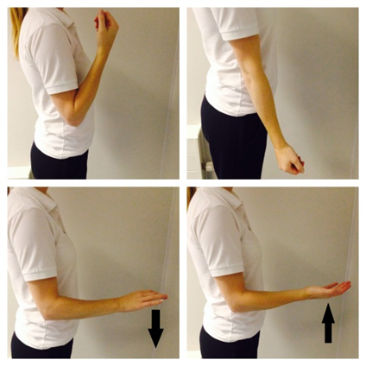
Posture exercises:
Bring your shoulders back and gently squeeze your shoulder blades together. Hold for 20-30 seconds. Repeat 5 times.
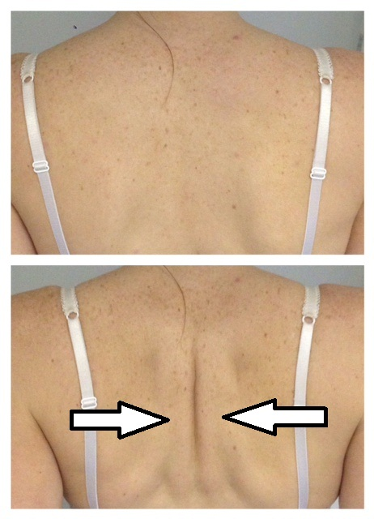
Shoulder pendulum exercises:
Stand next to a firm surface. Support yourself with your un-injured arm and lean forwards. Let your injured arm relax and hang down to the ground.
Gently swing your arm, making a small movement. Try to do this forward and backward, side to side and in small circles.
Aim to do this for 1-2 minutes in total. You do not need to push into pain. Remember to keep your arm relaxed.
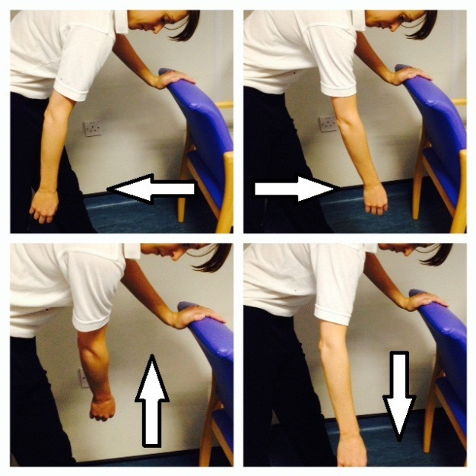

Caring for your injury – Week 3 to 6
You will have a face to face appointment.
Remember to keep using your sling. You can take it off to wash, dress and do your exercises.
Exercises:
Start these exercises 3 weeks after your injury. Try to do them 4-5 times a day. Repeat each exercise 10 times.
Active Assisted Flexion
Use your other hand to lift your injured arm up in front of you, as shown in these pictures.
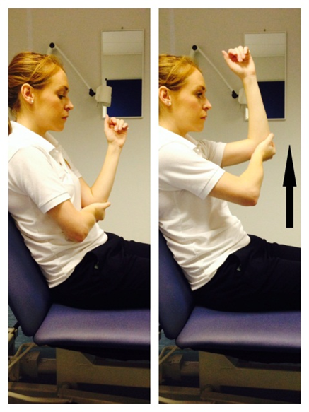
Active Assisted External Rotation
Keep the elbow of your injured arm tucked into your side and your elbow bent. Hold onto a stick, umbrella or something similar.
Use your good arm to push your injured hand outwards. Remember to keep your elbow tucked in.
If you don’t have a stick, hold your injured arm at the wrist, guide it outwards with your good hand.
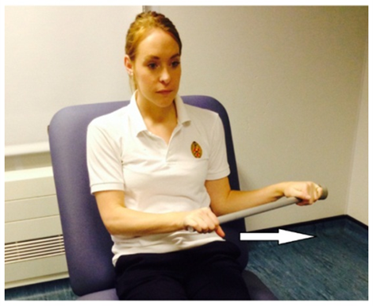

Caring for your injury – Week 6 to 12
You should be back to most of your normal activities. Take care with heavier or overhead tasks which may still be uncomfortable.
Exercises:
Start these exercises 6 weeks after your injury. Try to do these exercises 4-5 times a day. Repeat each exercise 10 times.
Active Flexion
Lift your arm forwards in front of you. Try to raise the arm as high as you can. You do not need to push into pain. If this is too difficult, try the same movement with a bent elbow.
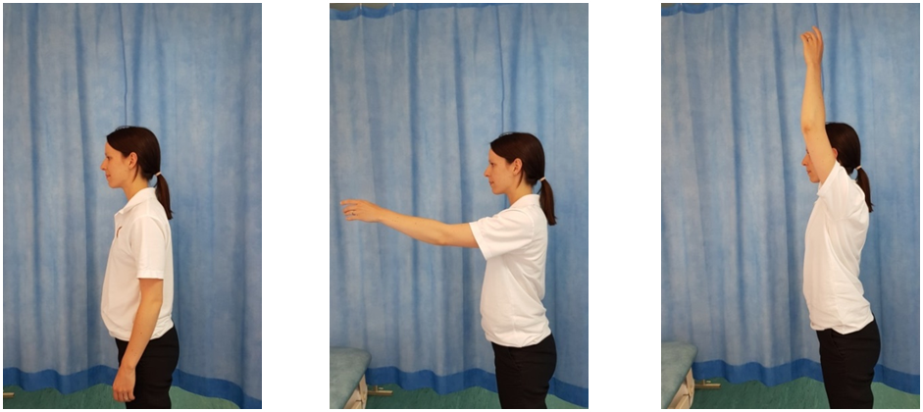
Active Abduction
With your palm facing forwards, move your arm out to the side in a big arc. Try to raise the arm as high as you can. You do not need to push into pain. If this is too difficult, try the same movement with a bent elbow.
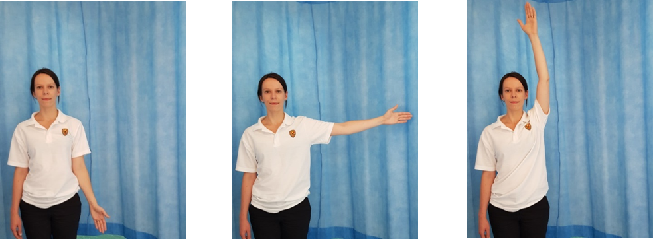
Active External Rotation
Start with your elbow bent by your side. Move your forearm out to the side, keeping your elbow bent and near your waist.
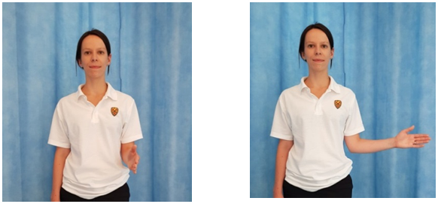

Frequently Asked Questions
I’m concerned about my symptoms and/or I am struggling to return to exercise.
Please contact the Virtual Fracture Clinic/your Physiotherapist if you have started treatment.
I am struggling with my sling. What do I do?
Contact the Virtual Fracture Clinic. We can give further advice.
When can I start driving?
You can return to driving when:
- You are no longer using a sling,
- You can move comfortably and
- You can control the vehicle safely.
Always test your ability to drive in a safe environment first.
How can I get a certificate for work?
You can get a fitness for work statement from your GP
How do I contact the Virtual Fracture Clinic?
Call 01582 718121. Messages will be checked every morning Monday-Friday.
Email VFC@ldh.nhs.uk
Some pictures and content produced by Brighton and Sussex University Hospital and shared with permission.
Bedfordshire Hospitals NHS Foundation Trust
Luton and Dunstable University Hospital
Lewsey Road
Luton, LU4 0DZ
www.bedfordshirehospitals.nhs.uk
@LandDHospital

