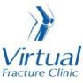

Trauma and Orthopaedics

Midshaft Clavicle Fracture
This is a break to the middle of your collar bone.

Healing:
It normally takes 6-12 weeks to heal, but symptoms can continue for 3-6 months.
Smoking will slow down your healing. We would advise that you stop smoking while your fracture heals. Talk to your GP or go to www.smokefree.nhs.uk for more information
Pain, swelling and pins and needles:
Your shoulder may be swollen and you will have some pain. Taking pain medication and using ice or cold packs will help. More information is on the next page.

Wearing your sling:
Use your sling for 3 weeks. You can take it off to wash, dress and do your exercises. It does not need to be worn at night.
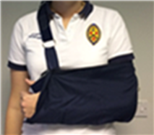

Exercise and activity:
It is important to start gentle exercises straight away to prevent stiffness. You will find pictures and instructions for your exercises below.
You should not do any heavy lifting or overhead movement for the first 6 weeks

Follow up:
You will have a face to face appointment 3 weeks after your injury. They may do another x-ray to check the position of your fracture. They will explain the next stage of your rehabilitation.
If you have not received your appointment letter within 1 week, please contact us.

Follow up:
If you are concerned about your symptoms, are unable to follow this rehabilitation plan or notice pain other than at your shoulder, please contact the Virtual Fracture Clinic.

Caring for your injury – Week 1 to 3
Remember to use your sling for the first 3 weeks. Take it off to wash, dress and do your exercises. You may find it more comfortable to sleep propped up on pillows.
Using a cold pack will help with your pain and swelling. You can use an ice pack or bag of frozen peas wrapped in a damp towel. Put this on your shoulder for 15 minutes every few hours. Make sure the ice isn’t in direct contact with your skin.
Try to rest your arm, especially in the first 24-72 hours.
Exercises
Hand, wrist and elbow exercises:
Open and close your hand. Next, move your wrist up and down. Repeat 10 times.
After a few days, hold a soft ball or rolled up socks. Squeeze the ball and hold for 5 seconds. Repeat 5 times.
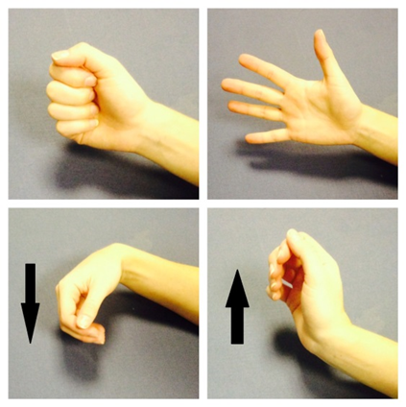
Bend and straighten your elbow. Repeat 10 times.
Bend your elbow to a right angle. Slowly turn your palm up to the ceiling and down to the ground. Repeat 10 times.
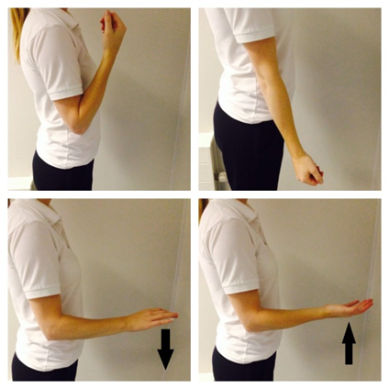
Posture exercises:
Bring your shoulders back and gently squeeze your shoulder blades together. Hold for 20-30 seconds. Repeat 5 times.
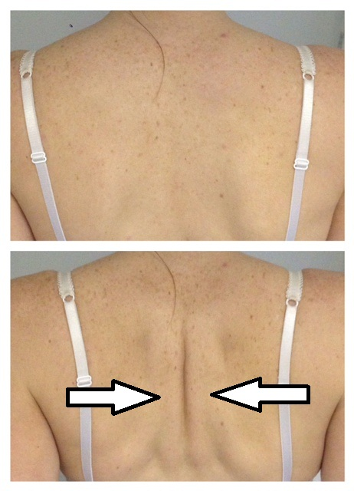
Shoulder pendulum exercises:
Stand next to a firm surface. Support yourself with your un-injured arm and lean forwards. Let your injured arm relax and hang down to the ground.
Gently swing your arm, making a small movement. Try to do this forward and backward, side to side and in small circles.
Aim to do this for 1-2 minutes in total. You do not need to push into pain. Remember to keep your arm relaxed.
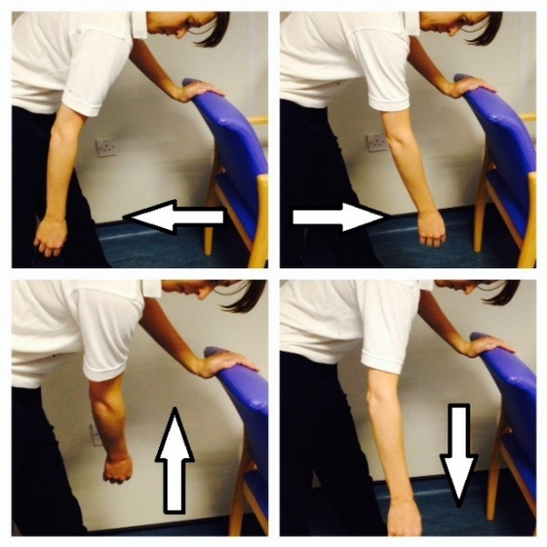

Caring for your injury – Week 3 to 6
You can now stop using your sling.
You can now return to light activities. Remember, you should not do any heavy lifting for 6 weeks.
Start these exercises 3 weeks after your injury. Try to do them 4-5 times a day. Repeat each exercise 10 times.
Active Assisted Flexion
Use your other hand to lift your injured arm up in front of you, as shown in these pictures.
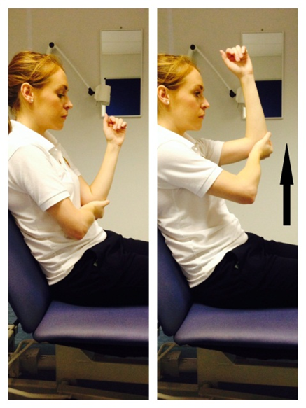
Active Assisted External Rotation
Keep the elbow of your injured arm tucked into your side and your elbow bent. Hold onto a stick, umbrella or something similar.
Use your good arm to push your injured hand outwards. Remember to keep your elbow tucked in.
If you don’t have a stick, hold your injured arm at the wrist, guide it outwards with your good hand.
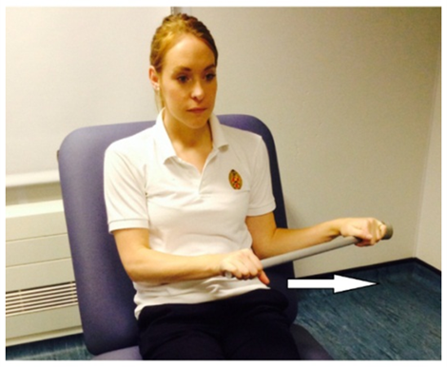

Caring for your injury – Week 6 to 12
Your injury should be healed.
You can return to normal activities. Do this gradually and be guided by any pain or discomfort you experience. Sme heavier tasks may still be uncomfortable.
Start these exercises 6 weeks after your injury. Try to do these exercises 4-5 times a day. Repeat each exercise 10 times.
Active Flexion
Lift your arm forwards in front of you. Try to raise the arm as high as you can. You do not need to push into pain. If this is too difficult, try the same movement with a bent elbow.
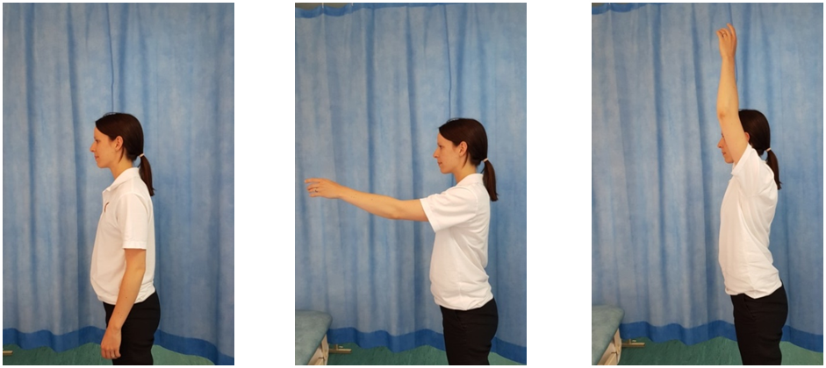
Active Abduction
With your palm facing forwards, move your arm out to the side in a big arc. Try to raise the arm as high as you can. You do not need to push into pain. If this is too difficult, try the same movement with a bent elbow.
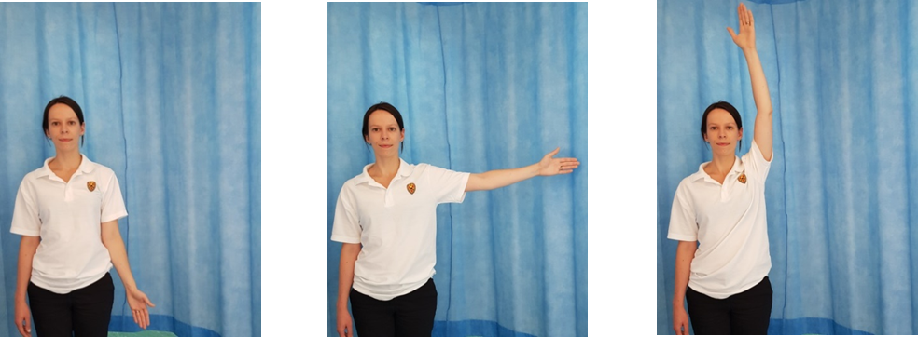
Active External Rotation
Start with your elbow bent by your side. Move your forearm out to the side, keeping your elbow bent and near your waist.
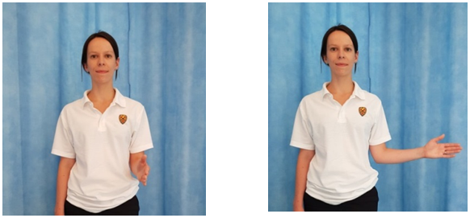

Frequently Asked Questions
I’m concerned about my symptoms and/or I am struggling to return to exercise.
Please contact the Virtual Fracture Clinic.
I am struggling with my sling. What do I do?
Contact the Virtual Fracture Clinic. We can give advice or change your sling if needed
When can I start driving?
You can return to driving when:
- You are no longer using a sling,
- You can move comfortably and
- You can control the vehicle safely.
Always test your ability to drive in a safe environment first.
How can I get a certificate for work?
You can get a fitness for work statement from your GP
How do I contact the Virtual Fracture Clinic?
Call 01582 718121. Messages will be checked every morning Monday-Friday.
Email VFC@ldh.nhs.uk
Some pictures and content produced by Brighton and Sussex University Hospital and shared with permission.
Bedfordshire Hospitals NHS Foundation Trust
Luton and Dunstable University Hospital
Lewsey Road
Luton, LU4 0DZ
www.bedfordshirehospitals.nhs.uk
@LandDHospital

