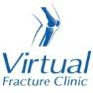

Trauma and Orthopaedics

Long head of biceps injury
This is an injury to the biceps tendon that inserts into the shoulder.

Healing:
It normally takes 6 weeks to heal, but symptoms can continue for 3 months. In some circumstances this injury may need surgical repair.
Pain, swelling and pins and needles:
Your shoulder may be swollen and you will have some pain. Take pain medication as prescribed.
You can use an ice pack or bag of frozen peas wrapped in a damp towel to help with your pain. Put this on your shoulder for up to 15 minutes every few hours. Make sure the ice is not in direct contact with your skin.
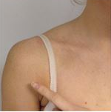

Wearing your sling:
Your sling can be worn for comfort. You should stop using your sling as soon as possible.
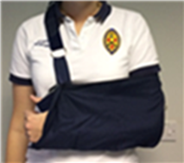

Exercise and activity:
Try to rest your shoulder for the first 24-72 hours.
It is important to keep your shoulder moving to prevent stiffness. You will find pictures and instructions for your exercises below.

Follow up:
You will have a face to face appointment 3 weeks after your injury. They will assess your shoulder and decide if further treatment or scans are required.
If you have not received your appointment within 1 week please contact our team
Contact us:
If you have any questions, are concerned about your symptoms or have pain other than at your shoulder please contact us.
Stage 1 Exercises
Hand, wrist and elbow exercises are only needed while you are wearing a sling. You can stop these once they become easy and you have full movement. Try to do these exercises 4-5 times a day. Repeat each exercise 10 times.
Hand, wrist and elbow exercises:
Open and close your hand. Next, move your wrist up and down. Repeat 10 times.
After a few days, hold a soft ball or rolled up socks. Squeeze the ball and hold for 5 seconds. Repeat 5 times.
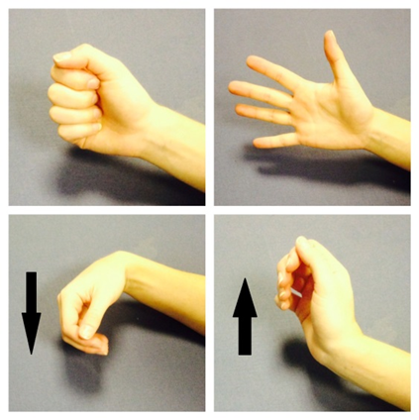
Bend and straighten your elbow. Repeat 10 times.
Bend your elbow to a right angle. Slowly turn your palm up to the ceiling and down to the ground. Repeat 10 times.
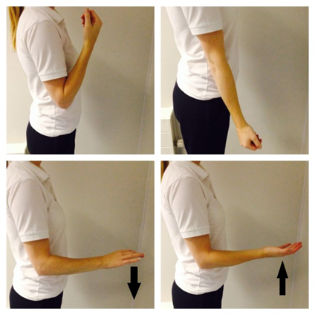
Posture exercises:
Bring your shoulders back and gently squeeze your shoulder blades together. Hold for 20-30 seconds. Repeat 5 times.
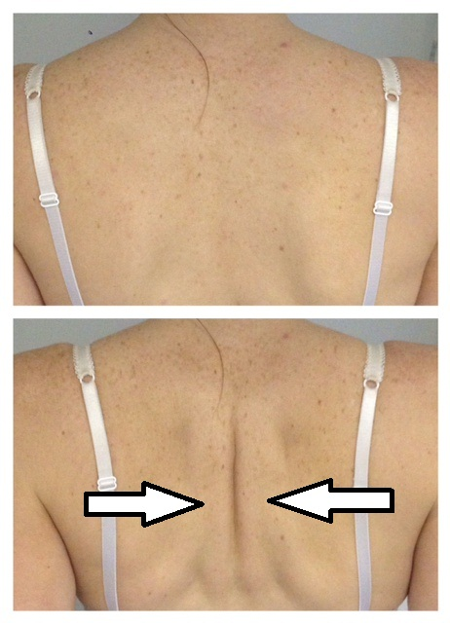
Shoulder pendulum exercises:
Stand next to a firm surface. Support yourself with your un-injured arm and lean forwards. Let your injured arm relax and hang down to the ground.
Gently swing your arm, making a small movement. Try to do this forward and backward, side to side and in small circles.
Aim to do this for 1-2 minutes in total. You do not need to push into pain. Remember to keep your arm relaxed.
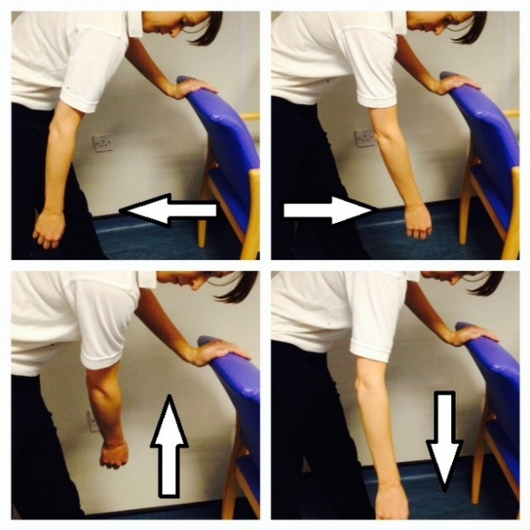
Stage 2 Exercises
You can start these exercises as soon as you are able to. Try to do these exercises 4-5 times a day. Repeat each exercise 10 times.
Exercise 1 - Active Assisted Flexion
Use your other hand to lift your injured arm up in front of you, as shown in these pictures.
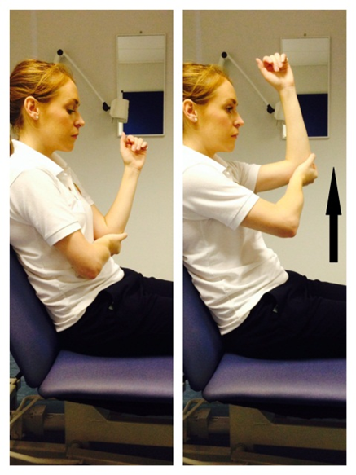
Exercise 2 - Active Assisted External Rotation
Keep the elbow of your injured arm tucked into your side and your elbow bent. Hold onto a stick, umbrella or something similar.
Use your good arm to push your injured hand outwards. Remember to keep your elbow tucked in.
If you don’t have a stick, hold your injured arm at the wrist, guide it outwards with your good hand.
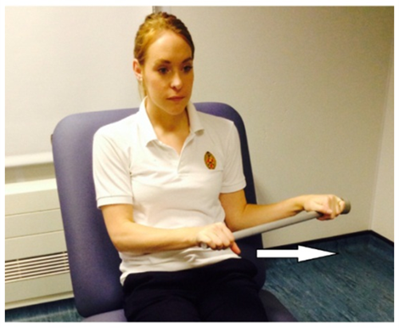

Stage 3 Exercises
You can start these exercises as soon as you are able to do Stage 2 Exercises comfortably. Try to do these exercises 4-5 times a day. Repeat each exercise 10 times.
Exercise 1 - Active Flexion
Lift your arm forwards in front of you. Try to raise the arm as high as you can. You do not need to push into pain. If this is too difficult, try the same movement with a bent elbow.
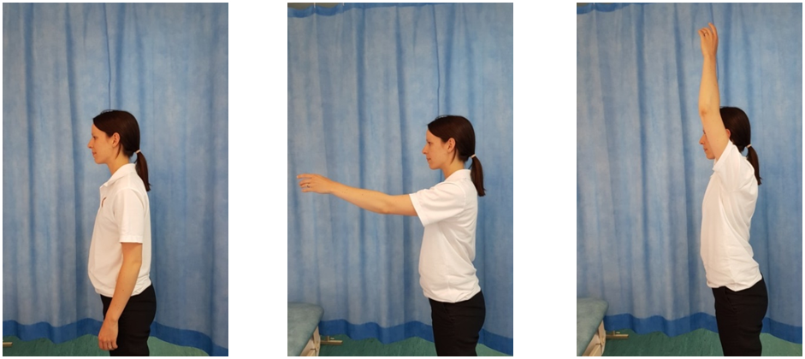
Exercise 2 - Active Abduction
With your palm facing forwards, move your arm out to the side in a big arc. Try to raise the arm as high as you can. You do not need to push into pain. If this is too difficult, try the same movement with a bent elbow.
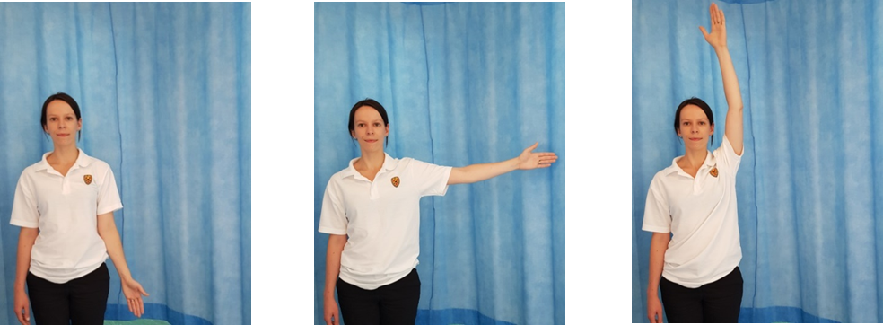
Exercise 3 - Active External Rotation
Start with your elbow bent by your side. Move your forearm out to the side, keeping your elbow bent and near your waist.
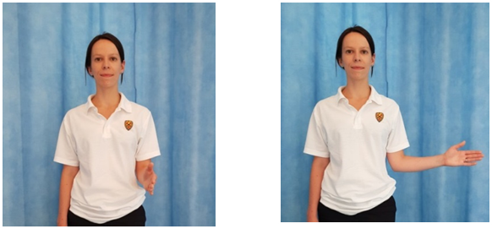

Frequently Asked Questions
When can I start driving?
You can return to driving when:
- You are no longer using a sling,
- You can move comfortably and
- You can control the vehicle safely.
Always test your ability to drive in a safe environment first.
How can I get a certificate for work?
You can get a fitness for work statement from your GP
How do I contact the Virtual Fracture Clinic?
Call 01582 718121. Messages will be checked every morning Monday-Friday.
Email VFC@ldh.nhs.uk
Some pictures and content produced by Brighton and Sussex University Hospital and shared with permission.
Bedfordshire Hospitals NHS Foundation Trust
Luton and Dunstable University Hospital
Lewsey Road
Luton, LU4 0DZ
www.bedfordshirehospitals.nhs.uk
@LandDHospital

