Trauma and Orthopaedics

Midshaft Humerus Fracture
This is a break to the middle of your upper arm bone.

About your injury:
It is important that you can always feel your hand and wiggle your fingers. If you can’t, please contact the Virtual Fracture Clinic. If it is out of hours please re-attend A&E.

Healing:
This normally takes 9-12 weeks to heal. Smoking will slow down your healing. We would advise that you stop smoking while your fracture heals. Talk to your GP or go to www.smokefree.nhs.uk for more information.
Pain, swelling and pins and needles:
Your shoulder may be swollen and you will have some pain. Taking pain medication and using ice or cold packs will help. More information is on the next page.

Wearing your brace and sling:
Wear your humeral brace and sling all the time, even in bed at night. Your hand can be removed from the sling to do your exercises and wash and dress. More advice about your brace is on the next page.
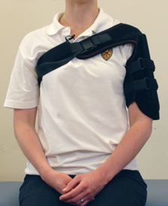

Exercise and activity:
It is important to start gentle exercises straight away to prevent stiffness. You will find pictures and instructions for your exercises below. You should not do any heavy lifting or overhead movement for the first 6 weeks.

Follow up:
You will have a face to face appointment 2-3 weeks after your injury. They will do another x-ray to check the position of your fracture and explain the next stage of your rehabilitation.
If you have not received your appointment letter within 1 week, please contact us.
If you are concerned about your symptoms, are unable to follow this rehabilitation plan or notice pain other than at your shoulder, please contact the Virtual Fracture Clinic.
Caring for your injury
Your brace should fit like this picture. This video will also help: https://vimeo.com/386673228.
Please contact the plaster room if you have any concerns such as pinching of skin, a rash or irritation, or difficulty washing.
Try to rest your arm, especially in the first 24-72 hours.
Exercises
Start these exercises straight away. Keep your brace on while doing these exercises. Try to do them 4-5 times a day. Repeat each exercise 10 times.
Hand, wrist and elbow exercises:
Open and close your hand. Next, move your wrist up and down. Repeat 10 times.
After a few days, hold a soft ball or rolled up socks. Squeeze the ball and hold for 5 seconds. Repeat 5 times.
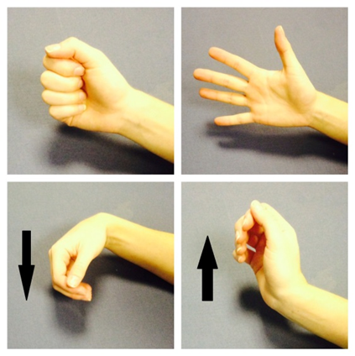

Bend and straighten your elbow. Repeat 10 times.
Bend your elbow to a right angle. Slowly turn your palm up to the ceiling and down to the ground. Repeat 10 times.
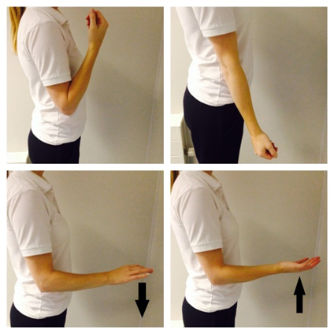
Posture exercises:
Bring your shoulders back and gently squeeze your shoulder blades together. Hold for 20-30 seconds. Repeat 5 times.
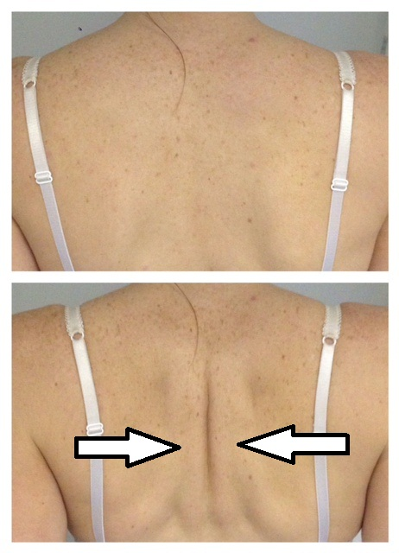
Shoulder pendulum exercises:
Stand next to a firm surface. Support yourself with your un-injured arm and lean forwards. Let your injured arm relax and hang down to the ground.
Gently swing your arm, making a small movement. Try to do this forward and backward, side to side and in small circles.
Aim to do this for 1-2 minutes in total. You do not need to push into pain. Remember to keep your arm relaxed.
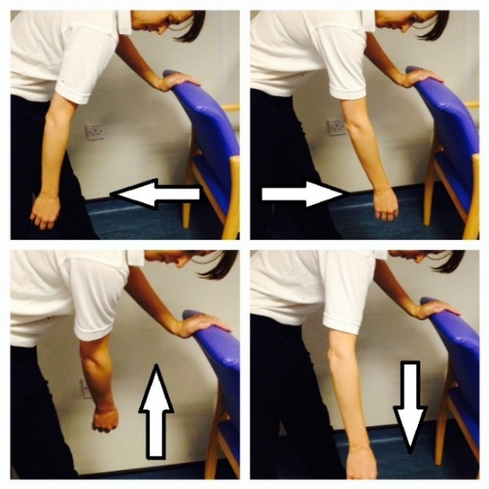

Frequently Asked Questions
I’m concerned about my symptoms and/or I am struggling to return to exercise.
Please contact the Virtual Fracture Clinic. If it is out of hours and you are unable to feel or move you hand please attend A&E.
I am struggling with my brace. What do I do?
Contact the Virtual Fracture Clinic. We can give further advice.
When can I start driving?
You can return to driving when:
- You are no longer using a sling,
- You can move comfortably and
- You can control the vehicle safely.
Always test your ability to drive in a safe environment first.
How can I get a certificate for work?
You can get a fitness for work statement from your GP
How do I contact the Virtual Fracture Clinic?
Call 01582 718121. Messages will be checked every morning Monday-Friday.
Email VFC@ldh.nhs.uk
Some pictures and content produced by Brighton and Sussex University Hospital and shared with permission.
Bedfordshire Hospitals NHS Foundation Trust
Luton and Dunstable University Hospital
Lewsey Road
Luton, LU4 0DZ
www.bedfordshirehospitals.nhs.uk
@LandDHospital

