Tongue Tie in Babies

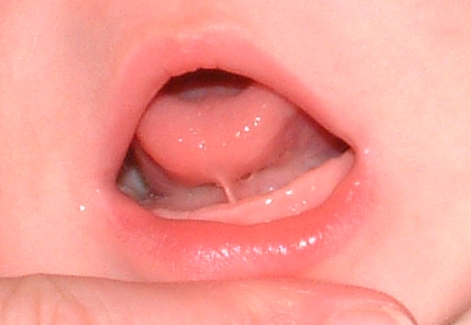
C.Westcott

Introduction
A tongue tie (also known as ankyloglossia) consists of a piece of tissue (called a frenulum) which bridges the gap between the underside of the tongue and the floor of the mouth. The frenulum may be attached near the tip of the tongue, which will give the tongue a heart shaped appearance, or may be joined a little further back. In this case, if tight, it may tether the tongue and restrict movement of the tongue. In some cases it may be hereditary.
Some babies with tongue tie can breastfeed well, others have difficulty with breastfeeding, and a few have difficulty with bottle feeding.

The effects of artificial formula milk on breastfeeding
Babies with a tongue tie who are having difficulties with breastfeeding initially need help with optimal positioning and attachment of the baby to the breast. Where difficulties persist, dividing the tongue tie and allowing increased tongue movement will assist the baby to attach effectively to the breast.
The baby with tongue tie who compresses the nipple, not the breast, fails to get sufficient milk and causes nipple pain and trauma.
Some bottle feeding babies also have difficulty when feeding with a tongue-tie, as they have difficulty forming a good seal around the teat (leading to slow feeds, dribbling or irritability with feeds). If you are experiencing any of these symptoms, please contact your midwife or health visitor for further support.

Signs and symptoms of tongue tie affecting feeding
Mother | Baby
- Sore or damaged nipples | - Difficulty with attachment or maintaining attachment
- Nipple pain whilst feeding | - Clicking noises whilst feeding
- Mastitis/breast infections (from poor drainage) | - Fussiness at the breast
- Diminished milk supply | - Frequent or prolonged feeding
- Exhaustion from frequent feeding | - Prolonged physiological jaundice
- Psychological effects from failure to establish breastfeeding | - Excessive early weight loss/failure to gain weight

Treatment
In order to free the tongue so that the baby can then feed effectively, a simple procedure is carried out to divide the frenulum. This is called a frenulotomy, but is often referred to as dividing or snipping the tongue tie. Consent to perform the division will be gained from the parent.
A trained health professional will simply wrap your baby, divide the tongue tie with sterile scissors (which will then allow free movement of the tongue) and then return baby to the mother quickly so that the baby can be fed straight away.
There is usually minimal bleeding, a few drops perhaps. The infant appears to feel little pain (some babies remain asleep during the procedure; some may cry for a few seconds, some cry because they don’t like being wrapped!).
The first breastfeed after division will usually be supported by a breastfeeding specialist who will assist the mother with good positioning and attachment to prevent further problems.
Opportunities will be offered to continue support from a breastfeeding specialist.
Some babies develop a small white patch where the division was performed a day or two later. Aftercare will be discussed at the time of the procedure.
It is important to note that not all tongue ties need to be divided and in some situations breastfeeding problems can be prevented or resolved by the mother receiving the correct support right from the beginning.
Please see our website for more information about feeding your baby:
www.bedfordshirehospitals.nhs.uk/infantfeeding

June 2021

