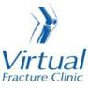

Trauma and Orthopaedics

Tibial Spine Avulsion Fracture
This is a break to the bone at the top of the shin bone.

Healing:
It can take 6 weeks for this fracture to heal.
Smoking will slow down your healing. We would advise that you stop smoking while your fracture heals. Talk to your GP or go to www.smokefree.nhs.uk for more information.

Pain and swelling:
Your knee will be swollen and you will have some pain. Swelling is often worse at the end of the day. Taking pain medication, elevating your knee and using ice or cold packs will help. More information is on the next page.
It is normal to have mild pain and swelling for 3-6 months.

Walking:
You should not put any weight through your injured leg and should use crutches to move around.
Please tell the Virtual Fracture Clinic team if you are diabetic, especially if you have problems with your sensation or skin. You may need a special boot.

Exercises:
It is important to start exercises as soon as possible. Instructions are on the next page.

Follow up:
A Routine follow up will be sent to you for 2-3 weeks from the date of your injury.

Any questions:
If you are concerned about your symptoms, unable to follow this rehabilitation plan or have pain other than at your knee, please contact the Virtual Fracture Clinic team.

Caring for your injury
Using a cold pack will help with your pain and swelling. You can use an ice pack or bag of frozen peas wrapped in a damp towel. Put this on your knee for up to 15 minutes every few hours. Make sure the ice is not in direct contact with your skin.
Try to rest your knee, especially in the first 24-72 hours. Raise your leg on a stool or cushions to that it is above the level of your hip. This will help to reduce your swelling.
Exercises:
Early exercise is important to recover movement and promote circulation. This will reduce the risk of developing a Deep Vein Thrombosis (blood clot). If you notice any swelling or redness in the calf, please attend A&E.
Do these exercises 3-4 times a day. Start straight away, you do not need to push into pain.
Ankle Exercises
Rest with your leg supported.
Point your foot up and down. Repeat this 10 times.
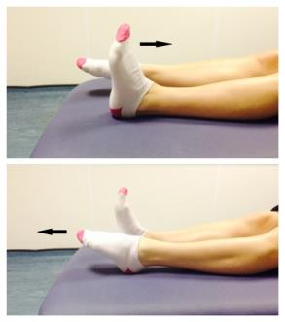

Frequently Asked Questions

I am struggling with my brace. What do I do?
Please contact the Virtual Fracture Clinic.
When can I start driving?
You can return to driving when:
- You are no longer using your brace,
- You can walk comfortably
- You can perform an emergency stop pain free.
Always test your ability to drive in a safe environment first.
How can I get a certificate for work?
You can get a fitness for work statement from your GP or the doctor at your Fracture Clinic appointment.
What do I do with my brace and crutches when I no longer need them?
We are not able to use brace again. These should not be return to the hospital.
Crutches can be returned to the Fracture Clinic or A&E.
I haven’t received my appointment letter. What do I do?
Your first appointment will be made by the Virtual Fracture Clinic team. If you have not received your appointment letter please contact us.
How do I contact the Virtual Fracture Clinic?
Call 01582 718121. Messages will be checked every morning Monday-Friday.
Email VFC@ldh.nhs.uk

Some pictures and content produced by Brighton and Sussex University Hospital and shared with permission.

Bedfordshire Hospitals NHS Foundation Trust
Luton and Dunstable University Hospital
Lewsey Road
Luton, LU4 0DZ

www.bedfordshirehospitals.nhs.uk
@LandDHospital

