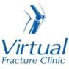

Trauma and Orthopaedics

Proximal Fibula Fracture
This is a break to your knee cap.

Healing:
It can take 6 weeks for this fracture to heal.
Smoking will slow down your healing. We would advise that you stop smoking while your fracture heals. Talk to your GP or go to www.smokefree.nhs.uk for more information.

Pain and swelling:
Your knee will be swollen and you will have some pain. Swelling is often worse at the end of the day. Taking pain medication, elevating your knee and using ice or cold packs will help. More information is on the next page.
It is normal to have mild pain and swelling for 3-6 months.

Walking and your boot:
You are allowed to put weight through your leg. You may find it easier to use crutches in the early stages. You will need to pace your activity until your pain and movement is better.
You may have been given a boot in A&E. This is for comfort only. 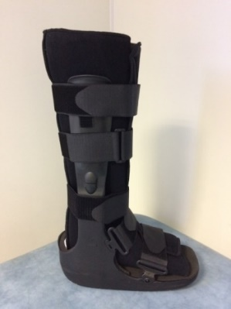
Try to stop using it as soon as you can.
Please tell the Virtual Fracture Clinic team if you are diabetic, especially if you have problems with your sensation or skin. You may need a special boot.

Exercises:
It is important to start exercises as soon as possible. Instructions are on the next page.

Follow up:
Routine follow up appointments are not normally needed after this injury. If you still have significant pain or swelling after 6 weeks, please contact the Virtual Fracture Clinic.

Any questions:
If you are concerned about your symptoms, unable to follow this rehabilitation plan or have pain other than at your knee, please contact the Virtual Fracture Clinic team.

Caring for your injury
If provided, use your boot for comfort. This video provides you with a guide for fitting your boot: https://vimeo.com/386673062.
Try to stop using the boot and crutches as soon as you can. You should have stopped using them by 6 weeks after your injury, at the latest. Practice walking without you boot and crutches around your home first. Build up to longer walks outside.
Remove your boot to wash, dress and do your exercises.
Using a cold pack will help with your pain and swelling. You can use an ice pack or bag of frozen peas wrapped in a damp towel. Put this on your knee for up to 15 minutes every few hours. Make sure the ice is not in direct contact with your skin.
Try to rest your knee, especially in the first 24-72 hours. Raise your leg on a stool or cushions to that it is above the level of your hip. This will help to reduce your swelling.
stool or cushions to that it is above the level of your hip. This will help to reduce your swelling.
Exercises:
Early exercise is important to recover movement and promote circulation. This will reduce the risk of developing a Deep Vein Thrombosis (blood clot). If you notice any swelling or redness in the calf, please attend A&E.
Do these exercises 3-4 times a day. Start straight away, you do not need to push into pain.
Ankle Exercises
Rest with your leg supported.
Point your foot up and down. Repeat this 10 times.
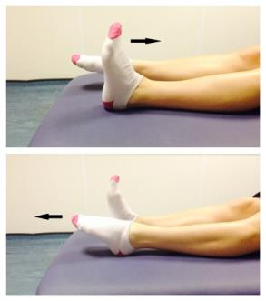

Static Quadriceps Exercise
Rest with your leg supported and straight. Gently tense the muscles in your thigh and try to straighten your knee further. Hold for 5 seconds and repeat 7-10 times.
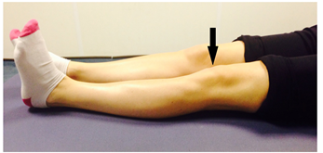

Inner Range Quads Exercise
Place a rolled up towel or small pillow under your injured knee.
Tense your thigh muscle and try to straighten your knee. Keep the back of your knee in contact with the towel/pillow.
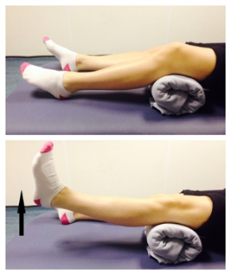
Repeat 10 times. If you can, try to hold your knee straight for 5 seconds.

Knee Flexion and Extension:
Sit or lie with your legs out stretched.
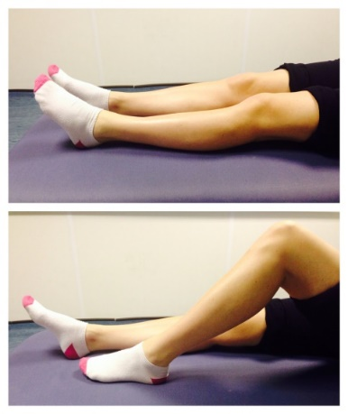

Bend and straighten your injured leg. Go as far as you feel comfortable.

Repeat 7-10 times.

Seated knee flexion and extension:
When you can do the first knee bending exercise easily, you can progress to this exercise.
Sit on a chair or on the edge of your bed. Bend and straighten your knee, lifting your heel off the floor.
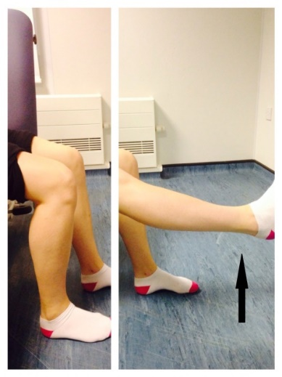
Repeat this 10 times.
If you can, try holding your knee straight for 5 seconds.

Frequently Asked Questions

I am struggling with my brace. What do I do?
Please contact the Virtual Fracture Clinic.
When can I start driving?
You can return to driving when:
- You are no longer using your brace,
- You can walk comfortably
- You can perform an emergency stop pain free.
Always test your ability to drive in a safe environment first.
How can I get a certificate for work?
You can get a fitness for work statement from your GP or the doctor at your Fracture Clinic appointment.
What do I do with my brace and crutches when I no longer need them?
We are not able to use brace again. These should not be return to the hospital.
Crutches can be returned to the Fracture Clinic or A&E.
I haven’t received my appointment letter. What do I do?
Your first appointment will be made by the Virtual Fracture Clinic team. If you have not received your appointment letter please contact us.
How do I contact the Virtual Fracture Clinic?
Call 01582 718121. Messages will be checked every morning Monday-Friday.
Email VFC@ldh.nhs.uk

Some pictures and content produced by Brighton and Sussex University Hospital and shared with permission.

Bedfordshire Hospitals NHS Foundation Trust
Luton and Dunstable University Hospital
Lewsey Road
Luton, LU4 0DZ

www.bedfordshirehospitals.nhs.uk
@LandDHospital

