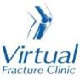

Trauma and Orthopaedics

Base of 5th Metatarsal Fracture
This is a break to the bone on the outside of your foot.

Healing:
It can take up to 6-12 weeks for these fractures to heal.
Smoking will slow down your healing. We would advise that you stop smoking while your fracture heals. Talk to your GP or go to www.smokefree.nhs.uk for more information.

Pain and swelling:
You may have foot pain and swelling for 3-6 months after your injury. Swelling is often worse at the end of the day.
Taking pain medication, elevating your foot and using ice or cold packs will help. More information is on the next page.
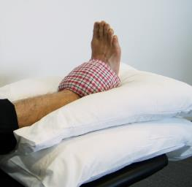

Walking and your boot:
Your foot will be in a cast or specialist boot. You should wear this all the time.
You are not allowed to put weight through your foot and will need to use crutches or a frame to move around.
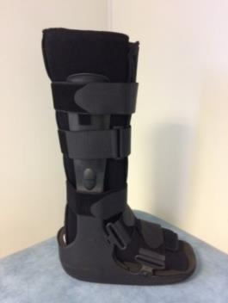

Follow up:
You will receive a face to face appointment in the Fracture Clinic 6 weeks after your injury. Contact us if you have not received your appointment letter within one 1 week.

Caring for your injury – Week 1 to 6
Try to rest your foot, especially in the first 24-72 hours. You should not attend school or college. Raise your foot on a stool or cushions to that it is above the level of your hip. This will help to reduce your swelling.
Exercise
Try to maintain movement in the parts of the leg not encased in the cast by maintaining movement at the knee and hip.

Frequently Asked Questions
I am struggling with my boot. What do I do?
The boot has a thicker sole; this can make you feel uneven. Make sure you wear a supportive shoe or trainer on your uninjured foot. This will reduce stress on other joints. If you are struggling to wean out of your boot please contact us.
If you need more advice contact the Virtual Fracture Clinic.
I am diabetic, does this change things?
If you are diabetic please contact us to discuss your boot. This is particularly important if you have problems with your skin. We may provide you with a specialist diabetic boot.
When can I start driving?
You can return to driving when:
- You are no longer using your boot
- You can walk comfortably
- You can perform an emergency stop pain free
Always test your ability to drive in a safe environment first.
How can I get a certificate for work?
You can get a fitness for work statement from your GP or the doctor at your Fracture Clinic appointment.
What do I do with my boot and crutches when I no longer need them?
We are not able to use boots again. These should not be returned to the hospital.
Crutches can be returned to the Fracture Clinic or A&E.
I haven’t received my appointment letter. What do I do?
Your first appointment will be made by the Virtual Fracture Clinic team. If you have not received your appointment letter please contact us.
How do I contact the Virtual Fracture Clinic?
Call 01582 718121. Messages will be checked every morning Monday-Friday.
Email VFC@ldh.nhs.uk
Some pictures and content produced by Brighton and Sussex University Hospital and shared with permission.
Bedfordshire Hospitals NHS Foundation Trust
Luton and Dunstable University Hospital
Lewsey Road
Luton, LU4 0DZ
www.bedfordshirehospitals.nhs.uk
@LandDHospital

