Expressing milk before your baby is born

Introduction
Mothers start to produce colostrum (first milk) while pregnant. Hand expressing is the process of gently squeezing milk out of your breast. Learning to express colostrum during pregnancy is a useful skill for all. There are also benefits to saving expressed colostrum if your baby is likely to need special care after birth.
In the early days, it is better for your baby to receive only your milk. If the unexpected happens and you and your baby are separated, or if your baby has feeding difficulties or health problems, you will find it easier to express your milk if you have practised beforehand. This leaflet contains instructions, but you can also ask your midwife to show you how.

Why express while pregnant?
- Exclusive breastfeeding is the ideal for feeding human babies – collecting colostrum during pregnancy may help you achieve this.
- If you know how to hand express your milk in pregnancy, you can use this skill after birth, should you need it.
- If you are finding breastfeeding challenging at the beginning, you can give your milk to baby through a syringe or cup (it is best to avoid bottles while establishing breastfeeding) so that baby is only getting your milk from the very start.
- Jaundice can be a normal physiological process, but colostrum has a laxative effect and helps baby to get rid of the pigment that causes jaundice.
- If you have diabetes in pregnancy (pre-existing or gestational) your baby may be at risk of low blood sugars immediately after birth. Your colostrum along with breastfeeding will help baby maintain blood sugar after birth and lower the chance of your baby requiring formula milk.
- If there is a family history of dairy intolerance or inflammatory bowel disease, it is best to give only your breast milk.
- Infants diagnosed during the antenatal period with cleft lip and/or palate and congenital conditions may have feeding difficulties and benefit from having expressed colostrum available.
- Those expecting twins or triplets may find it useful to express antenatally near to delivery
- Babies who are small for dates may be more likely to have low blood sugars or take a little longer to establish feeding.
- Antenatal expression may also be useful for:
- Women with breast hypoplasia
- Women with polycystic ovarian disease
- Women who have had breast surgery
- By hand expressing you will be able to provide colostrum for your baby if he or she is being cared for in the neonatal unit. If your baby is expected to go to the neonatal unit after birth, we would encourage you to consider expressing before delivery if appropriate. We would also strongly advise expressing immediately and frequently after delivery (ask our neonatal nurses or labour ward team for an expressing pack).
- Colostrum provides human antibodies, protects baby’s digestive system and is an adequate energy source for most babies even though the quantity is small.

Breastfeeding and Diabetes
- Babies who are breastfed are less likely to develop Type 1 diabetes.
- It is thought that cows’ milk (the main ingredient of formula milk) can trigger diabetes in some babies; this is probably more likely for your baby if you or your partner have diabetes. It is important that mothers who are diabetic avoid giving their baby formula milk if at all possible until the baby is at least 6 months old.
- If you have diabetes and are insulin dependent you may find that you need less insulin when you are breastfeeding and that you need to eat more.
- If you have gestational diabetes you are less likely to go on to develop diabetes in later life if you breastfeed your baby.
When to express
Expressing for a few minutes a day is unlikely to trigger labour, however we would still advise caution for those under 32 weeks gestation unless delivery is planned soon or thought to be imminent. Please check with your obstetric team. We would not advise antenatal expression if you have a cervical suture in situ or a history of cervical weakness. If you develop any new abdominal pains whilst expressing, you should stop and rest. Any expectant mother can express her breast milk from 36 to 37 weeks gestation. It is particularly useful if you know that your baby is at an increased risk of having a low blood sugar in the first few hours after birth.

How to hand express
Video showing how to hand express: https://www.unicef.org.uk/babyfriendly/baby-friendly-resources/breastfeeding-resources/hand-expression-video/
- Start by making sure that your hands are clean and that you have a sterilised container or syringe before you start.
- Get comfortable, ensuring that you are as relaxed as possible.
- To help the milk flow it can be useful to shower or bath before expressing; alternatively you can use some warm cloths prior to expressing.
- Use a few minutes of gentle massage before expressing. This can be kneading massage, stroking towards the nipple, or whatever feels comfortable for you.
- Cup your breast with one hand making a ‘C’ shape with your thumb and the rest of your fingers, about 2 cm behind the nipple.

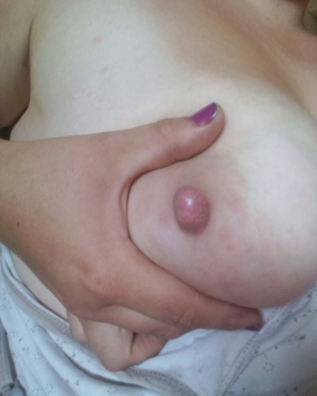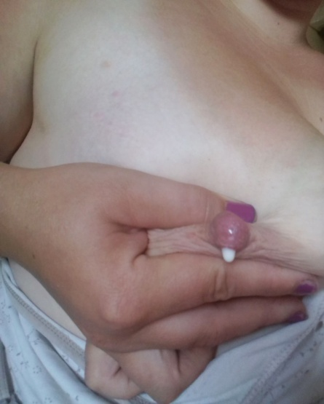

- Squeeze or compress your breast and then release the pressure. Find and build up your rhythm. Avoid sliding your fingers over the skin. Because colostrum is very concentrated, it is thick, and will come out of your breast drop by drop.

- If the milk does not flow, try moving your fingers slightly towards the nipple or further away. Find the spot that works best for you.
- Keep your hands in one position until the milk flow slows. Then you should move your hands around to a different position, ensuring that all lobes are drained.
- Aim to use both breasts, at least twice each session.
- Collect your colostrum a few times per day.
  - If you do not see any colostrum, don’t worry! It can take time to start to be able to express. Play around with the position of your fingers and keep trying regularly. Some mums may find it helpful to use a breast pump for extra stimulation, or occasionally may find a pump is effective for antenatal expression.
Ask your midwife for syringes & bungs, or colostrum bottles to express into, and some labels on which you can write your baby’s name, your hospital number and the time / date of expressing.
The same syringe / bottle can be used for a few expressions on the same day ensuring that it is stored in the fridge between expressions.
- If you are expecting to deliver within 24-48 hours, you can keep your colostrum in a fridge. Otherwise, it is best to freeze it.
- At the end of the day the containers of colostrum can be placed in a sandwich bag and then in a freezer (minimum temperature of -18°C). If you are in hospital, milk can be stored in the freezer on the neonatal unit.
- When you are admitted to hospital for the birth of your baby, you can bring your frozen colostrum into hospital. The colostrum should be handed to staff as soon as you are admitted so that it can be stored in the neonatal unit freezer.
- Defrosted colostrum must be used within 24 hours of thawing.

How much will I get?
The amount of breast milk you get will vary from a few drops to a few mls or more. This small amount is perfect for your baby as colostrum is very concentrated in nutrients and helps your baby fight infections.
Ensure that the midwives caring for you (or the neonatal team caring for your baby) are aware that you have collected your milk antenatally should it be needed by your baby.

If your baby is in special care
Antenatal expression of colostrum can be extremely useful for moderate to late preterm babies in helping them to avoid the need for intravenous fluids, central (‘long’) lines or formula supplementation. Please discuss this with your neonatal and obstetric teams.

