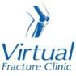

Trauma and Orthopaedics

Occult Proximal Radius Fracture
This means there are signs on your x-ray suggesting a break to a bone in your elbow

Healing:
It normally takes 6 weeks for this fracture to heal.
Smoking will slow down your healing. We would advise that you stop smoking while your fracture heals. Talk to your GP or go to www.smokefree.nhs.uk for more information. 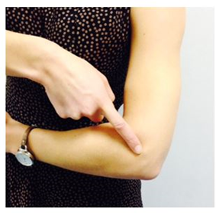

Pain and swelling:
Your elbow may be swollen and you will have some pain. Taking pain medication and using ice or cold packs will help. More information is on the next page.

Wearing your sling:
Your sling should be worn for comfort in the first 2 weeks. You can take it off to wash, dress and exercise. It does not need to be worn at night.

Exercise and activity:
Elbows get stiff very quickly. It is important to start exercising as soon as possible. You will find pictures and instructions for your exercises on the next page.
You should avoid lifting anything more than the weight of a cup of tea for the first 6 weeks. You can do light activities when your pain has settled.

Follow up:
A follow up appointment is not normally needed for this injury. Please contact the Virtual Fracture Clinic if you do not have full movement by 3 weeks after your injury. You may need a physiotherapy referral.

Any questions:
If you are concerned about your symptoms, are unable to follow this rehabilitation plan or notice pain other than at your elbow, please contact the Virtual Fracture Clinic.

Caring for your injury – Week 1 to 6
Wear your sling for the first 2 weeks. Take the sling off for washing, dressing and to do your exercises.
Using a cold pack will help with your pain and swelling. You can use an ice pack or bag of frozen peas wrapped in a damp towel. Put this on your elbow for 15 minutes every few hours. Make sure the ice isn’t in direct contact with your skin.
Try to rest your elbow, especially in the first 24-72 hours.
Exercises:
Early regular exercise will prevent stiffness and help to recover movement. Try to do these exercises every hour. If this is too painful, start with 3-4 times a day. Repeat each exercise 10 times.
Wrist Exercises
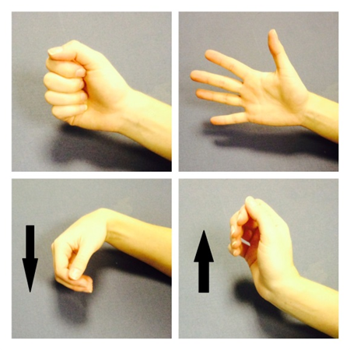
Open and close your hand. Next, move your wrist up and down.
After a few days, hold a soft ball/ball of socks. Squeeze the ball as hard as possible without pain. Hold for 5 seconds.
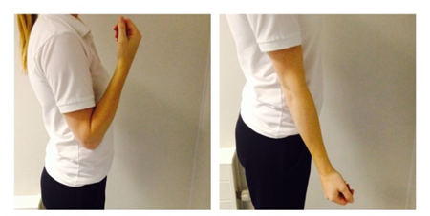
Bend and straighten your elbow so you feel a mild to moderate stretch. Do not push into pain.
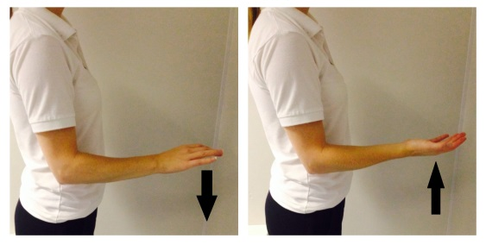
Bend your elbow to 90 degrees. Slowly turn your palm up and down until you feel a mild to moderate stretch. Do not push into pain
Contact the Virtual Fracture Clinic if you do not have full movement 3 weeks after injury.

Caring for your injury – Week 6 to 12
Your fracture should now be healed.
You can gradually increase your day to day activity. Be guided by any pain or discomfort you may still have.
It is normal to still have mild discomfort. This may continue for 3-6 months.

Frequently Asked Questions
I’m concerned about my symptoms and/or I am struggling to return to exercise.
Please contact the Virtual Fracture Clinic.
I am struggling with my sling. What do I do?
Contact the Virtual Fracture Clinic. We are happy to give further advice or change your sling if needed.
When can I start driving?
You can return to driving when:
- You are no longer using a sling,
- You can move comfortably and
- You can control the vehicle safely.
Always test your ability to drive in a safe environment first.
How can I get a certificate for work?
You can get a fitness for work statement from your GP or the doctor at your Fracture Clinic appointment.
How do I contact the Virtual Fracture Clinic?
Call 01582 718121. Messages will be checked every morning Monday-Friday.
Email VFC@ldh.nhs.uk

Some pictures and content produced by Brighton and Sussex University Hospital and shared with permission.
Bedfordshire Hospitals NHS Foundation Trust
Luton and Dunstable University Hospital
Lewsey Road
Luton, LU4 0DZ

www.bedfordshirehospitals.nhs.uk
@LandDHospital

