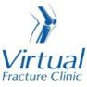

Trauma and Orthopaedics

Elbow Fracture Dislocation
This is a dislocation with a break to a bone in the elbow

Healing:
It normally takes 6 weeks for this fracture to heal.
Smoking will slow down your healing. We would advise that you stop smoking while your fracture heals. Talk to your GP or go to www.smokefree.nhs.uk for more information. 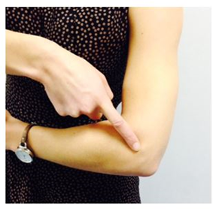

Pain and swelling:
Your elbow will be swollen and painful. Taking pain medication and using ice or cold packs will help. More information is on the next page.

Wearing your sling:
Your sling should be worn for comfort. You can take it off to wash, dress and to do your exercises.

Exercise and activity:
Elbows get stiff very quickly. It is important to start exercising as soon as possible. You will find pictures and instructions for your exercises on the next page.
You should avoid lifting anything more than the weight of a cup of tea for the first 6 weeks. You can do light activities when your pain has settled.

Follow up:
You will have a face to face appointment in the Fracture Clinic 7-10 days following your injury. They will examine the stability of your elbow. The specialist will explain the next stage of your rehabilitation.
Contact our team if you do not receive your appointment letter within 1 week.

Any questions:
If you are concerned about your symptoms, are unable to follow this rehabilitation plan or notice pain other than at your elbow, please contact the Virtual Fracture Clinic.

Caring for your injury – Week 1 to 6
Wear your sling for comfort. Take the sling off to wash, dress and to do your exercises.
Using a cold pack will help with your pain and swelling. You can use an ice pack or bag of frozen peas wrapped in a damp towel. Put this on your elbow for 15 minutes every few hours. Make sure the ice isn’t in direct contact with your skin.
Try to rest your elbow, especially in the first 24-72 hours.
Exercises:
Hand and Wrist Exercises
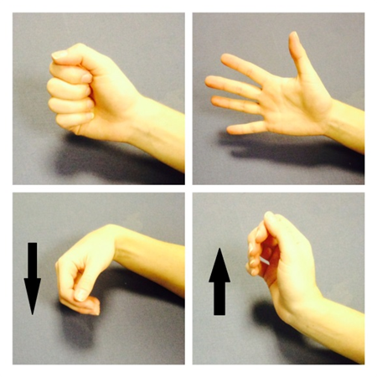
Try to do these exercises 4-5 times a day. Repeat each exercise 10 times.
Open and close your hand. Next, move your wrist up and down.
After a few days, hold a soft ball/ball of socks. Squeeze the ball as hard as possible without pain. Hold for 5 seconds.
Elbow Exercises
Try to do these exercises 4-5 times a day. Repeat each exercise 10 times. 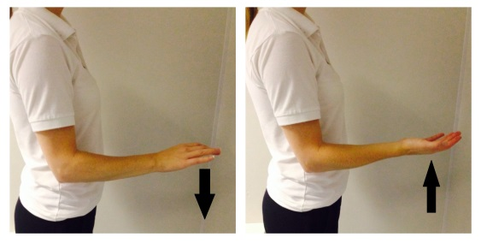
Sit or stand with your elbow supported.
Keep your elbow by your side during the exercise.
Turn your palm up and then palm down.
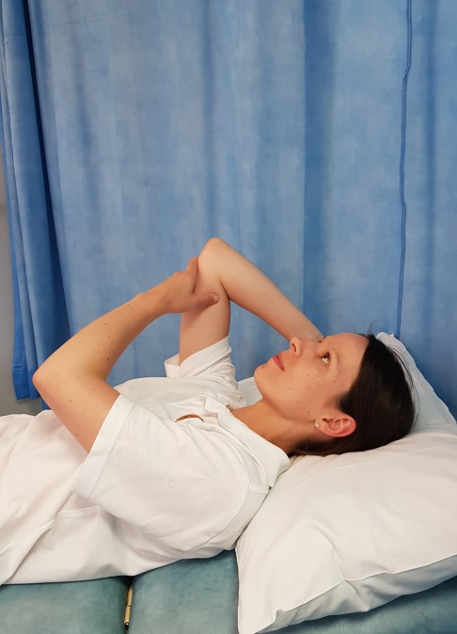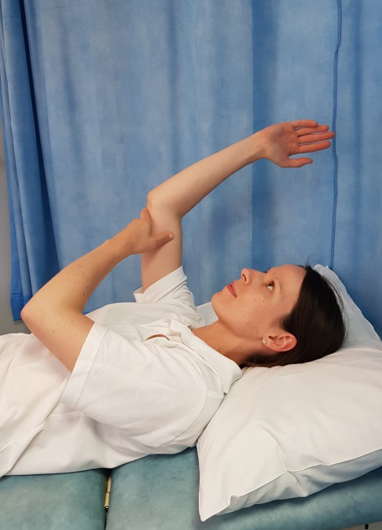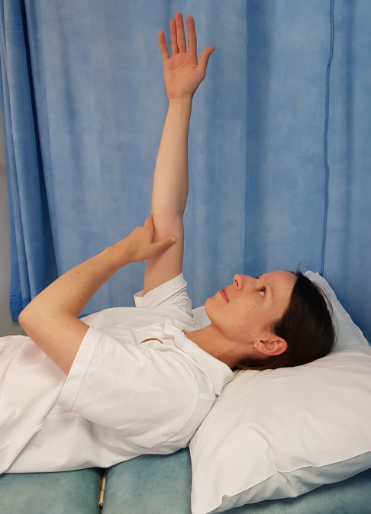
Lie on your back. Raise your injured arm so that your elbow points to the ceiling. Support your elbow with your other hand.
Slowly straighten your arm to lift the hand in the air.
Gradually lower your hand back down to the pillow. Repeat.
Modification:
If you have a problem with your shoulder, you may not be able to get into this position. You can modify the exercise to make it easier.
Lie on your back. Rest your arm by your side. Practice bending and straightening your elbow. Keep your elbow and upper arm resting on the bed while you do this movement.

Frequently Asked Questions
I am struggling with my sling. What do I do?
Contact the Virtual Fracture Clinic. We are happy to give further advice or change your sling if needed.
I have not received my appointment letter, what do I do?
If you have not received your letter for your first appointment in the fracture clinic, please contact the Virtual Fracture Clinic.
If you are expecting a follow up appointment with your consultant, please contact the booking hub on 0300 303 8360.
When can I start driving?
You can return to driving when:
- You are no longer using a sling,
- You can move comfortably and
- You can control the vehicle safely.
Always test your ability to drive in a safe environment first.
How can I get a certificate for work?
You can get a fitness for work statement from your GP or the doctor at your Fracture Clinic appointment.
How do I contact the Virtual Fracture Clinic?
Call 01582 718121. Messages will be checked every morning Monday-Friday.
Email VFC@ldh.nhs.uk

Some pictures and content produced by Brighton and Sussex University Hospital and shared with permission.
Bedfordshire Hospitals NHS Foundation Trust
Luton and Dunstable University Hospital
Lewsey Road
Luton, LU4 0DZ

www.bedfordshirehospitals.nhs.uk
@LandDHospital

