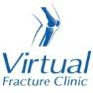

Trauma and Orthopaedics

Weber B Fracture
This is a break to the bone on the outside of your ankle

Healing:
It can take up to 8 weeks for the first symptoms to settle.
Smoking will slow down your healing. We would advise that you stop smoking while your fracture heals. Talk to your GP or go to www.smokefree.nhs.uk for more information.

Pain and swelling:
Your ankle may be swollen and painful. Swelling is often worse at the end of the day. It is normal to have mild pain and swelling for 6-12 months after your injury.
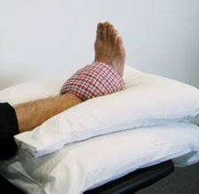
Taking pain medication, elevating your ankle and using ice or cold packs will help. More information is on the next page.

Walking and your boot:
The boot protects your ankle and will make you more comfortable. Wear the boot when you are standing and walking. You can take it off at night and at rest. You will be told when to stop using your boot at your Fracture Clinic appointment.
Please inform us if you are diabetic; you may need a special boot.
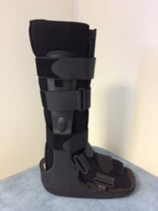
You are allowed to put weight through your foot. You may find it easier to use crutches in the early stages.

Exercises:
It is important to start exercises as soon as possible. Instructions follow.

Follow up:
There is a small chance that this fracture can displace (move) which may require an operation. You will have a weight bearing x-ray and see a specialist normally approximately 1 week after your injury. The specialist will explain the results and the next stage of your care.

Any questions:
If you are concerned about your symptoms, unable to follow this rehabilitation plan or have not received your appointment letter please contact the Virtual Fracture Clinic team.

Caring for your injury – Week 1 to 6
Remember to wear your boot whenever standing and walking. You can remove the boot when resting and at night. Wear a long sock in your boot.
You will be told when to stop wearing the boot at your appointment. When you are allowed to wean out of the boot, start by walking around your own home in your own footwear. Build up to not using the boot outside.
Using a cold pack will help with your pain and swelling. You can use an ice pack or bag of frozen peas wrapped in a damp towel. Put this on your ankle for up to 15 minutes every few hours. Make sure the ice isn’t in direct contact with your skin.
Try to rest your ankle, especially in the first 24-72 hours. Raise your ankle on a stool or cushions so that it is above the level of your hip. This will help to reduce your swelling.
Exercises:
Early exercise is important to recover movement and promote circulation. This will reduce the risk of developing a Deep Vein Thrombosis (blood clot). If you notice any swelling or redness in the calf, please attend A&E.
Do these exercises 3-4 times a day. Start straight away, you do not need to push into pain.
Ankle Exercises
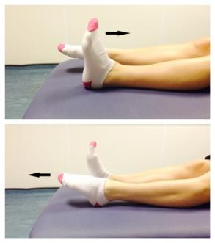
Point your foot up and down. Repeat this 10 times.

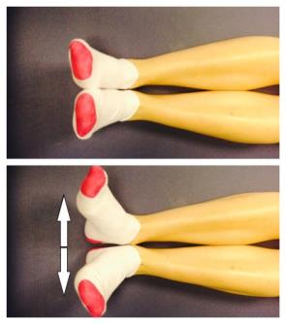
With your heels together, move your toes apart to turn the foot outwards.
Repeat this 10 times. Do this movement gently within comfort.
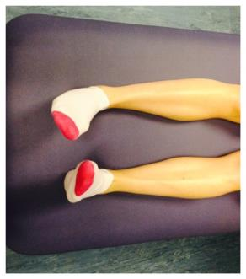
Make gentle circles with your foot in one direction and then the other direction.
Repeat this 10 times.

Caring for your injury – Week 6 to 12
It is normal to still have mild discomfort and swelling. This may continue for 6 -12 months.
Activity and Exercise:
Gradually increase your level of activity. You should avoid impact activity for 3 months. This includes running, jumping and dancing.
You can now progress your exercises.
Stretches
Sit with your leg straight out in front of you. Put a towel or bandage around your foot and pull it towards you. Feel a stretch in the back of the calf. Hold for 30 seconds.
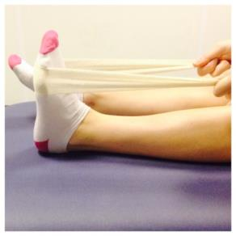
Point your toes down as far as they go, place your other foot on top and apply some pressure. This will stretch the top of your foot. Hold for 30 seconds.
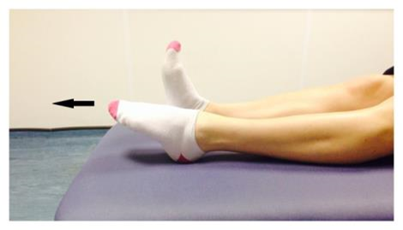
Balance
You should no longer be using your boot or crutches.
It’s time to progress your exercises and practice your balance:
Level 1: These exercises are for people who couldn’t stand on one leg before their injury.
- Stand with your feet as close together as possible. Hold onto a firm support in safe space. Hold your balance for 30 seconds.
- Now try removing your hand. Try to keep your balance for 30 seconds.
- Hold onto a firm support. Put one foot in front of the other, as close together as you can. Hold this for 30 seconds. If you can, try to let go of the support and keep your balance.
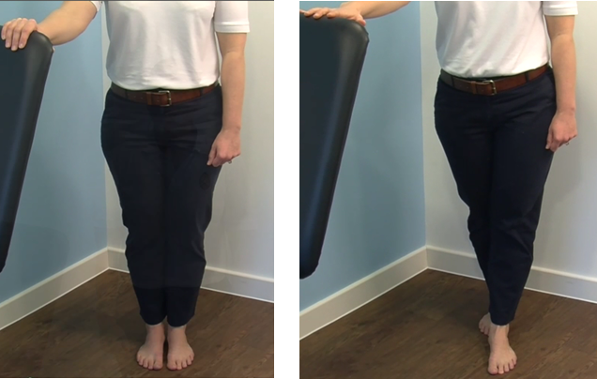

Level 2: These exercises are for people who could stand on one leg before their injury.
- Hold onto a firm surface in a safe space. Try to stand on one leg. Hold this for 30 seconds. Stop if you experience pain. When you can do this comfortably, try the next exercise.
- Try to stand on one leg without holding on to a support. Try to hold this for 30 seconds. When you can do this comfortably, try the next exercise.
- You can try these exercises with your eyes closed. Make sure you are always in a safe environment with a support to hold if needed.

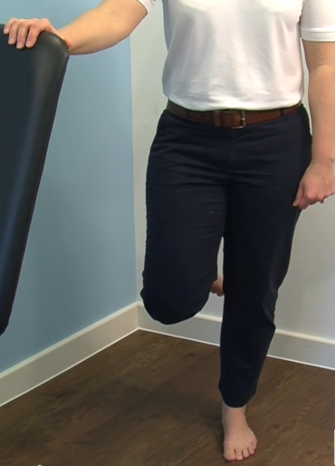
Contact the Virtual Fracture Clinic if you are struggling to recover your movement or return to activity.

Frequently Asked Questions
I am struggling with my boot. What do I do?
The boot has a thicker sole; this can make you feel uneven. Make sure you wear a supportive shoe or trainer on your uninjured foot. This will reduce stress on other joints.
If you need more advice contact the Virtual Fracture Clinic.
I am diabetic, does this change things?
If you are diabetic please contact us to discuss your boot. This is particularly important if you have problems with your skin or sensation. We may provide you with a specialist diabetic boot.
When can I start driving?
You can return to driving when:
- You are no longer using your brace,
- You can walk comfortably
- You can perform an emergency stop pain free.
Always test your ability to drive in a safe environment first.
How can I get a certificate for work?
You can get a fitness for work statement from your GP or the doctor at your Fracture Clinic appointment.
What do I do with my boot and crutches when I no longer need them?
We are not able to use boots again. These should not be returned to the hospital.
Crutches can be returned to the Fracture Clinic or A&E.
I haven’t received my appointment letter. What do I do?
Your first appointment will be made by the Virtual Fracture Clinic team. If you have not received your appointment letter please contact us.
How do I contact the Virtual Fracture Clinic?
Call 01582 718121. Messages will be checked every morning Monday-Friday.
Email VFC@ldh.nhs.uk

Some pictures and content produced by Brighton and Sussex University Hospital and shared with permission.

Bedfordshire Hospitals NHS Foundation Trust
Luton and Dunstable University Hospital
Lewsey Road
Luton, LU4 0DZ

www.bedfordshirehospitals.nhs.uk
@LandDHospital

