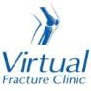

Trauma and Orthopaedics

Calf Muscle Tear
This is a soft tissue injury (sprain) to your calf muscle.

Healing:
This normally takes approximately 6 weeks to heal depending on severity of the sprain.
Smoking will slow down your healing. We would advise that you stop smoking while your fracture heals. Talk to your GP or go to www.smokefree.nhs.uk for more information

Pain and swelling:
Your calf will be swollen and painful. Swelling is often worse at the end of the day and elevating it will help.
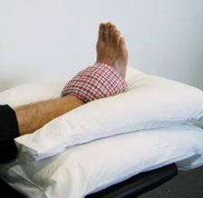
Taking pain medication, elevating your ankle and using ice or cold packs will help. More information is on the next page.

Walking and your boot:
You may have been given a boot, possibly with wedges under your heel to make you more comfortable. Wear the boot when you are standing and walking for the first 2 weeks. You can take it off at night and at rest.
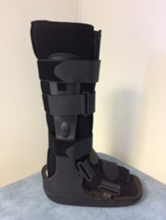
You are allowed to put weight through your leg. You may find it easier to use crutches in the early stages.

Exercises:
It is important to start exercises as soon as possible. Instructions follow.

Follow up:
We do not routinely follow up patients with this injury as they recover well with self-management. Please contact our team if after 12 weeks you still have significant pain or swelling, or if you struggle we wean out of the boot.
Any questions:
If you are concerned about your symptoms, unable to follow this rehabilitation plan or have not received your appointment letter please contact the Virtual Fracture Clinic team.

Caring for your injury – Week 1 to 2
Use with boot and/or wedges for comfort when walking. Try to stop using them as soon as possible. Start by gradually removing the wedges from your boot to lower your heel down
Using a cold pack will help with your pain and swelling. You can use an ice pack or bag of frozen peas wrapped in a damp towel. Put this on your calf for up to 15 minutes every few hours. Make sure the ice isn’t in direct contact with your skin.
Try to rest your leg, especially in the first 24-72 hours. Raise your leg on a stool or cushions so that it is above the level of your hip. This will help to reduce your swelling.
Exercises:
Early movement of the ankle and foot is important to promote circulation and reduce the risk of developing a Deep Vein Thrombosis (blood clot). If you notice any swelling or redness in the calf, please attend A&E.
Do these exercises 3-4 times a day. Start straight away, you do not need to push into pain.
Ankle Exercises
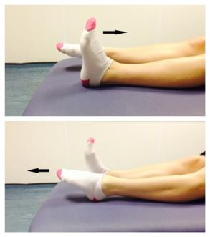
Point your foot up and down. Repeat this 10 times.

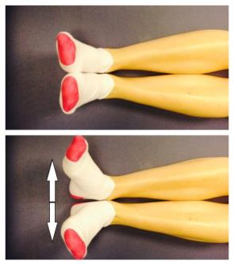
With your heels together, move your toes apart to turn the foot outwards.
Repeat this 10 times. Do this movement gently within comfort.
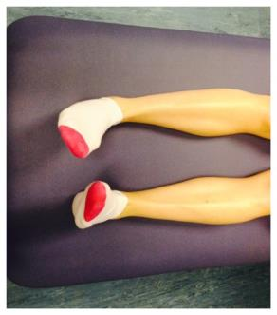
Make gentle circles with your foot in one direction and then the other direction.
Repeat this 10 times.

Caring for your injury – Week 2 to 12
Try to stop using your boot and crutches. Start by walking without them around your own home. Build up to not using them outside and for longer walks. Wearing supportive shoes such as trainers will help.
Activity and Exercise:
You can gradually increase your level of activity. It is normal to still have some mild symptoms. Contact our team if you struggle to return to sport or exercise after 12 weeks.
Balance – start these 2 weeks after injury:
- Hold onto a firm surface in a safe space. Try to stand on one leg. Hold this for 30 seconds. Stop if you experience pain. When you can do this comfortably, try the next exercise.
- Try to stand on one leg without holding on to a support. Try to hold this for 30 seconds. When you can do this comfortably, try the next exercise.
- You can try these exercises with your eyes closed. Make sure you are always in a safe environment with a support to hold if needed.
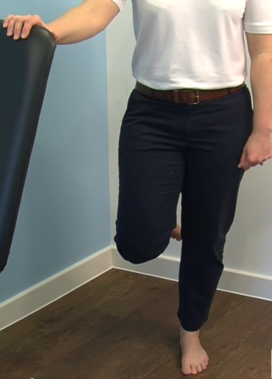
Stretches – start these 3 weeks after your injury:
Sit with your leg straight out in front of you. Put a towel or bandage around your foot and pull it towards you. Feel a stretch in the back of the calf. Hold for 30 seconds.
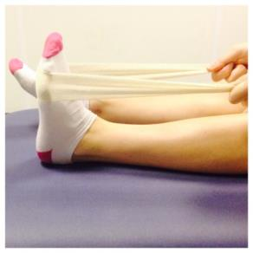
Point your toes down as far as they go, place your other foot on top and apply some pressure. This will stretch the top of your foot. Hold for 30 seconds.
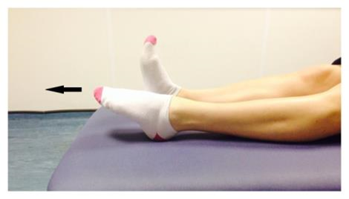

Frequently Asked Questions
I am struggling with my boot. What do I do?
The boot has a thicker sole; this can make you feel uneven. Make sure you wear a supportive shoe or trainer on your uninjured foot. This will reduce stress on other joints.
If you need more advice contact the Virtual Fracture Clinic.
I am diabetic, does this change things?
If you are diabetic please contact us to discuss your boot. This is particularly important if you have problems with your skin or sensation. We may provide you with a specialist diabetic boot.
When can I start driving?
You can return to driving when:
- You are no longer using your brace,
- You can walk comfortably
- You can perform an emergency stop pain free.
Always test your ability to drive in a safe environment first.
How can I get a certificate for work?
You can get a fitness for work statement from your GP or the doctor at your Fracture Clinic appointment.
What do I do with my boot and crutches when I no longer need them?
We are not able to use boots again. These should not be returned to the hospital.
Crutches can be returned to the Fracture Clinic or A&E.
How do I contact the Virtual Fracture Clinic?
Call 01582 718121. Messages will be checked every morning Monday-Friday.
Email VFC@ldh.nhs.uk

Some pictures and content produced by Brighton and Sussex University Hospital and shared with permission.

Bedfordshire Hospitals NHS Foundation Trust
Luton and Dunstable University Hospital
Lewsey Road
Luton, LU4 0DZ

www.bedfordshirehospitals.nhs.uk
@LandDHospital

