

**QUARTERLY REPORT ON NURSING AND MIDWIFERY STAFFING LEVELS**

**2019/2020 Q1 April – June 2019**

**1.0 Introduction**

The Luton and Dunstable Hospital workforce is assessed using the guidelines within the NHS improvement ‘Developing Workforce Safeguards’ Report 2018. Benchmarks are set against their compliance with recommendations set out in the Report to support a consistent approach to workforce decision making by delivering high quality care through safe and effective staffing.

The recommendations are as follows:

* To deploy sufficient suitably qualified, competent, skilled and experienced staff to meet care and treatment needs safely and effectively
* To have a systematic approach to determining the number of staff and range of skills required meeting the needs of people using the service and to keep them safe at all times
* To use an approach that reflects current legislation and guidance, where it is available.
  1. **Summary of Report:**

Both fill rate and CHPPD have improved in June compared to a dip in May, the increase did not impact on agency spend.

There is a higher level of sickness among healthcare assistants compared to registered nurses which has led to lower fill rates for HCAs in quarter 1.

Data from Model Hospital indicates the Trust CHPPD is above average compared to recommended peers. There is the need however to consider the fill rate includes NICU level 3, the split service of HDU and ITU that drives the fill rate up.

There is a continued focus on the recruitment and retention of Registered Nurses. The HR Team actively explores all avenues and strategies to combat recruitment and retention challenges. As part of the retention work with NHSI we are currently reviewing our recruitment of registered nurses to ensure we have a more flexible approach. Keeping this in mind we have relaunched the registered nurse pool with a focus on hard to fill day shifts.

**2.0 Safe Staffing Process**

The Trust has robust processes in place to ensure safe staffing across inpatient areas. Outlined below are the standard actions that are followed:

* Continued daily monitoring and ward RAG rating of staffing levels across inpatient wards
* Active management by the Operational Matron and support from Divisional Matrons to review staffing requirements twice a day
* Working with agencies to identify long line of rostered duties to support areas with high vacancies
* Controlled release of unfilled shifts to agencies
* Additional support provided by e-Roster and Bank
* Matrons, Specialist Nurses and the Education Team working clinically where needed
* The provision of the Clinical Site Nurse Service in the evenings to cover the handover of the night shift and support staffing across the Trust.

**2.1 Average Shift Fill Rates for the Trust**

The Trust’s average fill rate for April was 94% (RNs - 92.9% and HCAs - 83%). May’s fill rate was significantly impacted by sickness among Healthcare Assistants (an average of 6.48%, nearly twice the Trust target of 3.32%). The average fill rate for May dropped by 9.8% (from 94% in April to 84.2% in May). Not unique to May the day shifts were most difficult to fill. Generally night shifts fill better than day shifts mainly to enhanced pay. Average fill rate for day staff dropped by 8.5% (from 92.7% in April to 84.2% in May) and average night staff dropped by 5.7% (from 95.3% in April to 91.9% in May). The ward that was most affected by the low fill rate for HCAs was ward 25 (paediatrics) with a fill rate of 78.16% for HCA shifts.

The fill rates for June rose back to figures considered to be normal for the Trust. The average fill rate for day staff rose to 92 % in June (7.8% increase compared to May). The average night fill rate in June was 95.3% (3.4% increase compared to May). There are seven wards (wards 3, 10, 11, 14, 15, 24, & 33 - see Appendix 1) with fill rates below 85% in either registered staff or care staff. There are multifactorial reasons of sickness, vacancy and enhanced care needs that impacted their fill rates.

It is worth noting the increase in fill rate for June did not impact on spend for Bank and agency (see Chart 6).

*Table 1 – Average Unify Return fill rate* *by staff group*

|  |  |  |  |  |
| --- | --- | --- | --- | --- |
|  | Day | | Night | |
| Trust Average Fill Rates | Registered Nurses | Care Staff (HCA) | Registered Nurses | Care Staff (HCA) |
| June | 92.5% | 91.4% | 96.5% | 90.7% |
| May | 89.1% | 79.3% | 96.6% | 87.2% |
| April | 93.4% | 92% | 97.7% | 93% |

* *See Appendix 1 for full UNIFY return rate for June*
* *See Appendix 2 for a full list of CHPPD by ward for June*

**2.2 Care Hours per Patient day (CHPPD)**

CHPPD measures the total care hours received by each patient over a 24 hour period. The standard calculation uses hours worked by staff divided by the number of patients on the ward in the 24 hour period. The table below (Table 2) displays CHPPD for April, May and June. Given the low fill rate for HCAs in May the CHPPD in May was the lowest in this quarter. Chart 1 is the latest available data sourced from model hospital dashboard (variation chart). That chart shows comparison of the L&D CHPPD data for all nursing staff (nurses, midwives and HCAs) to peer Trusts as well as other Trusts.

*Table 2- Average CHPPD*

|  |  |  |  |  |  |
| --- | --- | --- | --- | --- | --- |
|  | | | Average 24 Hour | | |
| Trust Average | | | Registered | Care Staff | All Staff |
| June | | | 6.4 | 3.1 | 9.5 |
| May | | | 6.3 | 3.0 | 9.3 |
| April | 7.8 | 4.1 | 11.9 | | |

*Chart 1: Care Hours per Patient Day (CHPPD): Data source Model Hospital Dashboard*

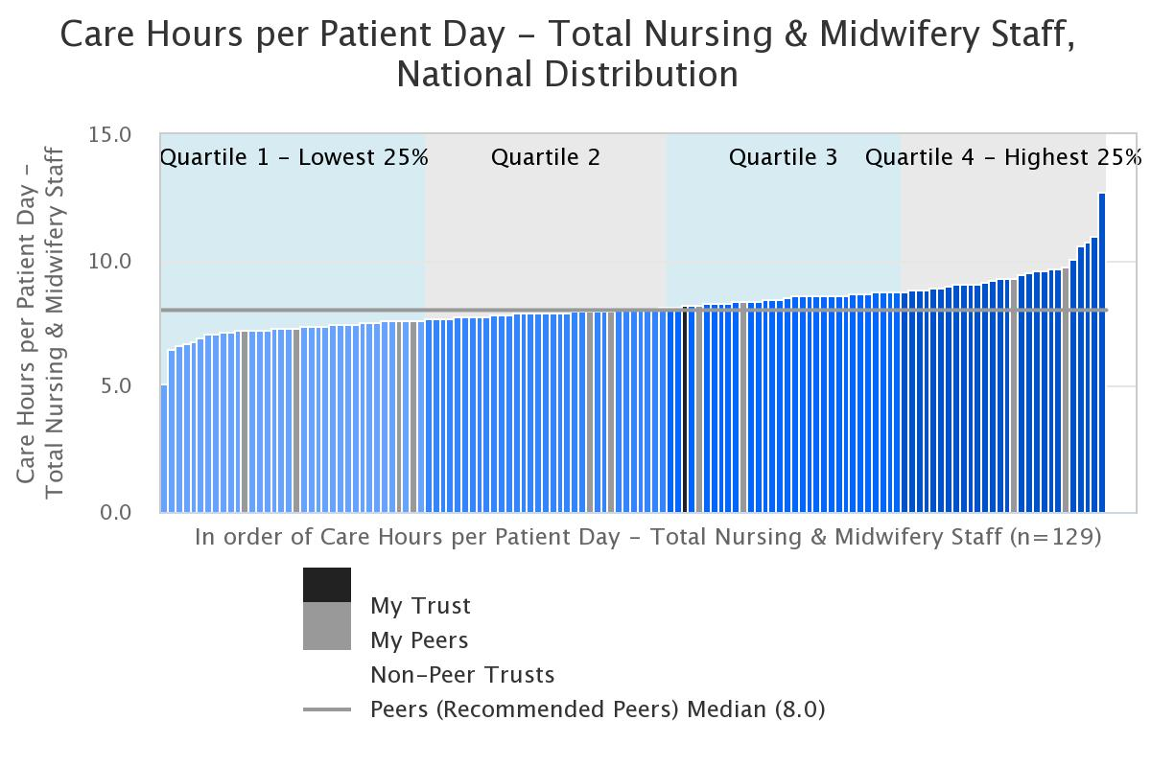

**3.0 Enhanced Care**

There remains a requirement for enhanced care provision for our highest risk patients. In the first two months of Q1 there had been an increased demand for patients needing RMNs (Registered Mental Health Nurses). In April we required 185 RMNs, this figure rose significantly to 239 in May of which only 203 of those shifts were filled. The shortfall was managed by the wards undertaking risk assessments and using HCAs to provide 1:1 care (see charts 2 & 3).

In June the overall usage of cohort bays and 1:1 care was the second lowest so far for this year. There was total of 250 occasions, which is a significant drop compared to 344 occasions in May. The reduced usage is not attributed to unfilled shifts, the requirement was lower. However as previously stated there was a significant increase in RMN use. This can be attributed to the complex needs of the patients. There is no change of trend in wards that use enhanced care. This predominately remains the Complex Medicine wards 14 and 15; Rehabilitation 19b and Trauma Orthopaedics, ward 23.

*Chart 2: Baywatch*

**3.1 RMN**

RMN requests for June were 321 out of which 236 of were filled. Shifts that are not filled the wards risk assessment and use HCAs to provide 1:1 care or change to minimise risks. (See chart 3)

*Chart 3 – RMN usage by ward*

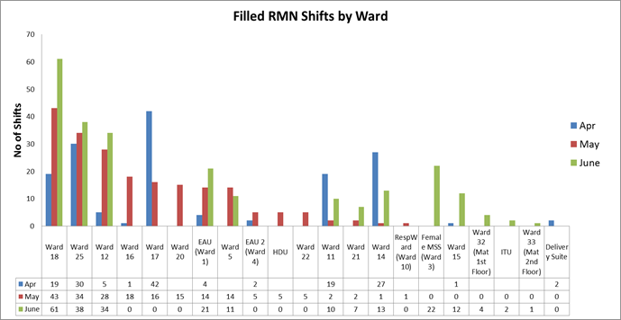

*Table 3 - filled & Unfilled RMN shifts*

|  |  |  |  |  |  |  |
| --- | --- | --- | --- | --- | --- | --- |
|  | **Apr-19** | | **May-19** | | **Jun-19** | |
|  | **Filled** | **Unfilled** | **Filled** | **Unfilled** | **Filled** | **Unfilled** |
| **RMN Shifts** | **152** | **33** | **203** | **36** | **236** | **85** |
| **Filled percentage** | **82.16%** | **17.84%** | **84.94%** | **15.06%** | **73.52%** | **26.48%** |

**4.0 Sickness**

The monthly average target of sickness absence of the Trust is 3.32%. Tables and charts below display monthly rates and trends of sickness absences of registered nurses & midwifes, and healthcare assistants. HCAs have the highest sickness rates with May being the highest (6.48%) for this financial year. ESR system runs a month behind the annual calendar therefore we do not have sickness data for June in order to understand how that would have impacted on staff fill rate and CHPPD. Months where Trusts target were missed are highlighted in yellow. According to the available data for the year HCAs have higher sick rates than RGNs. HCA rates are mostly above 5% (see table 5). It is in correlation with the fill rates for the last 3 months: RN fill rates have been consistently higher than HCAs.

*Table 4 – Nursing and Midwifery Sickness Rates*

|  |  |  |  |  |  |  |  |  |  |  |  |  |
| --- | --- | --- | --- | --- | --- | --- | --- | --- | --- | --- | --- | --- |
| **Month** | **Jun-18** | **Jul-18** | **Aug-18** | **Sep-18** | **Oct-18** | **Nov-18** | **Dec-18** | **Jan-19** | **Feb-19** | **Mar-19** | **Apr-19** | **May-19** |
| **In Month %** | **3.73%** | **3.07%** | **3.69%** | **3.71%** | **3.34%** | **3.55%** | **3.86%** | **4.39%** | **4.11%** | **3.52%** | **3.21%** | **3.73%** |
| **12Month Rolling Average** | **3.79%** | **3.80%** | **3.83%** | **3.86%** | **3.77%** | **3.73%** | **3.74%** | **3.78%** | **3.74%** | **3.72%** | **3.67%** | **3.66%** |

*Chart 4 – Nursing and Midwifery Sickness Trend*

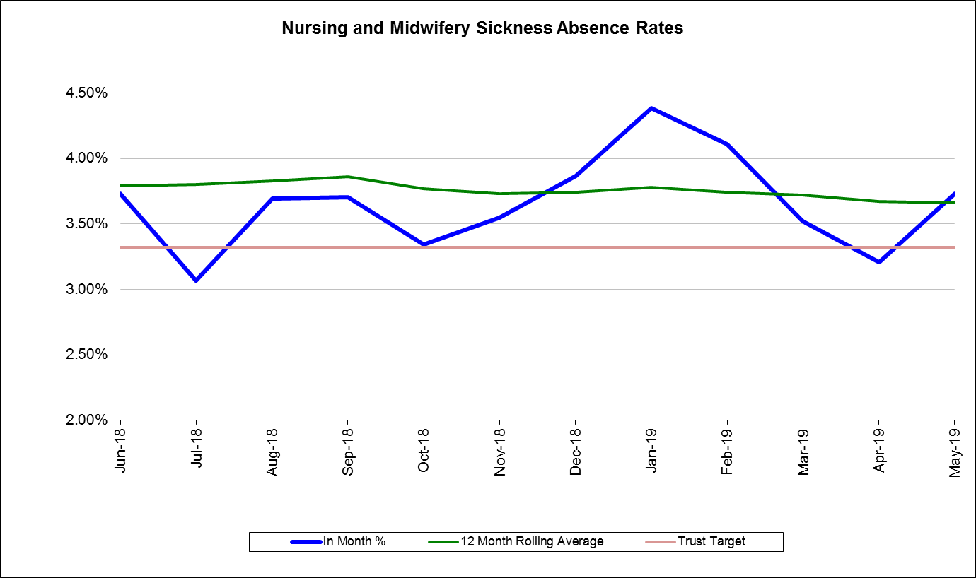

Sickness rate for HCAs remains challenging. Following some improvement in April there has been deterioration in May. Managers are being asked to focus their attention with support from Human Resources to avoid delay and cancellation of stage 2 sickness meeting.

*Table 5 – Health Care Assistants Sickness Rates*

|  |  |  |  |  |  |  |  |  |  |  |  |  |
| --- | --- | --- | --- | --- | --- | --- | --- | --- | --- | --- | --- | --- |
| **Month** | **Jun-18** | **Jul-18** | **Aug-18** | **Sep-18** | **Oct-18** | **Nov-18** | **Dec-18** | **Jan-19** | **Feb-19** | **Mar-19** | **Apr-19** | **May-19** |
| **In Month %** | **5.94%** | **6.30%** | **6.89%** | **7.28%** | **6.32%** | **5.34%** | **5.35%** | **5.98%** | **5.91%** | **5.92%** | **5.06%** | **6.48%** |
| **12Month Rolling Average** | **5.95%** | **5.99%** | **6.10%** | **6.31%** | **6.36%** | **6.31%** | **6.23%** | **6.17%** | **6.07%** | **5.99%** | **5.93%** | **6.07%** |

*Chart 5 – Healthcare Assistant Sickness Trend*

**5.0 Coverage comparisons of Bank/Agency and unfilled shifts**

There are a number of contributory factors which affects fill rates and use of bank and agency use. Vacancy, sickness absence and opening of escalation areas (Cath lab, endoscopy, Paeds ED, SSSU, theatre A- E and theatre 1-6) are 3 of the major contributory factors. Contingency areas were opened 16 days with 2 areas opened at the same time on 11 occasions. The most challenging times are when there are more escalated areas opened at the same time that happened once in June where 4 areas were opened at the same time. There were 4 occasions where only 1 area was opened. In total contingency was opened 27 times compared to May when it was opened 57 times over 15 days. Acute medicine was the division that was most impacted by the escalation areas, on 19 occasions they had to supply a registered nurse or swap one for an agency nurse to support the contingency plan.

*Chart 6 - Bank and Agency Usage*

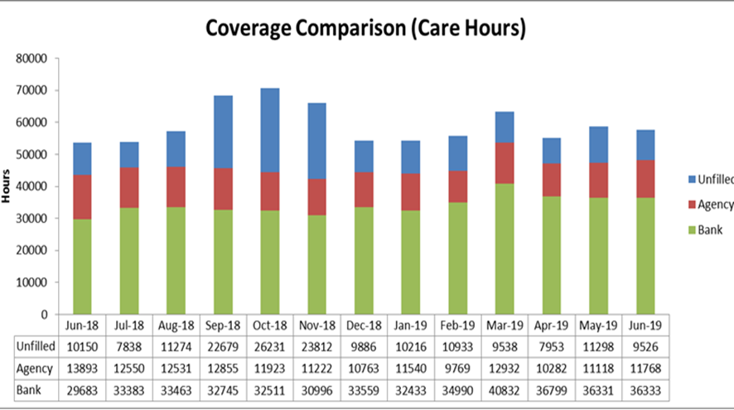

*Table 6- Bank and Agency Usage*

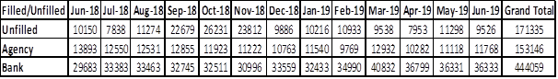

**5.1 eRostering**

Table below shows Healthroster KPIs of the various divisions. Net hours refer to unused hours that could be utilised to fill shifts. Divisions falling below the Trust target are highlighted in yellow. All division met the target for annual leave allocation. Roster approval targets were met by both mangers and matrons. The only KPI requiring improvement is net hours balance. Some the challenges revolve around on boarding of overseas nurses and new starters. That requires a manual intervention of the Health roster team to initialise individual rosters. Others are in relation to the need to wait for excess hours for any individual to accumulate to 12 hours before allocated (most wards work 11.5 hour shifts) [see table 7 overleaf].

*Table 7 – eRostering KPIs (averages by division)*

|  |  |  |  |  |  |  |  |  |  |  |  |  |
| --- | --- | --- | --- | --- | --- | --- | --- | --- | --- | --- | --- | --- |
|  | Trust Target | Trust Average | Emergency Medicine | Acute Medicine | Critical Care | Complex Medicine | Specialty Medicine | Cardiology | Surgical | Hospital at Home | Childrens | Womens |
| Net Hours Balance | <75 hours | 487.621 | 150.32 | 172.38 | 95.46 | 713.24 | 1164.65 | 168.97 | 886.46 | 100.69 | 1407.18 | 16.86 |
| Annual Leave | 13% -15% | 12.79% | 13.10% | 12.22% | 13.65% | 11.98% | 11.68% | 14.33% | 13.84% | 11.80% | 12.79% | 12.44% |
| Roster Approval (Partial Lead Time) | 63 days | 59 | 51 | 60 | 64 | 62 | 63 | 58 | 60 | 60 | 43 | 58 |
| Roster Approval (Full Lead Time) | 56 Days | 43 | 38 | 57 | 46 | 59 | 58 | 54 | 52 | 57 | 42 | 51 |

**5.2 Vacancies and Recruitment Activity**

Registered nurse vacancies remain a challenge both locally and nationally, there is continued focus on Skype interviews for EU and Non-EU nurses which yields an average of 15 nurses a month. The focus for the year ahead is retention of staff with some engagement sessions planned with band 5 RN’s to understand what support might increase staff satisfaction. Band 5 nurse vacancies have increased by 8 from 100 WTE in May to 108 in June. The data does not take into consideration the 12 overseas nurses who arrived in June. They are classified as band 4 until they pass the OSCE which takes approximately 3 months.

The HCA vacancy in May was 84 and we recruited 32, the June campaign yielded 27 with 12 of them joining the bank and the rest (15) are substantive.

|  |  |
| --- | --- |
| **Registered Nurses** | |
| **Local recruitment** | 20 nurses recruited externally (4 bank 16 substantive) |
| **Overseas Nurses** | 12 nurses arrived in June |
| **Vacancy (band 5)** | 108 |

**Appendix A June Fill Rate**

|  |  |  |  |  |
| --- | --- | --- | --- | --- |
| Ward Name | **Day** | **Night** | | |
| Average fill rate - registered nurses/ midwives (%) | Average fill rate - care staff (%) | Average fill rate: registered nurses/ midwives (%) | Average fill rate - care staff (%) |
| 418 F05 Haem Onc Unit | 94.0% | 86.2% | 98.4% | 93.7% |
| 418 N19 Cobham Clinic | 85.5% | 96.1% | 98.4% | 100.0% |
| 418 H30 SCBU/NICU | 99.7% | 99.7% | 99.8% | 100.0% |
| 418 H25 Paediatric Wards 25 | 100.0% | 99.2% | 87.9% | 94.0% |
| 418 H25 Paediatric Wards 24 | 100.5% | 82.3% | 81.5% | 92.4% |
| 418 G10 Ward 19b - Rehab | 91.3% | 86.2% | 100.0% | 100.0% |
| 418 G20 Ward 19a | 88.6% | 90.1% | 100.0% | 100.0% |
| 418 G16 Ward 14 | 92.3% | 82.7% | 100.0% | 96.7% |
| 418 G15 Ward 15 | 101.0% | 80.4% | 98.9% | 96.3% |
| 418 G06 Ward 17 | 98.3% | 86.4% | 100.8% | 90.6% |
| 418 G05 Ward 18 | 85.3% | 102.9% | 94.4% | 83.3% |
| 418 G02 Ward 16 | 90.2% | 106.1% | 99.0% | 92.5% |
| 418 F40 CCU (Ward 4a) | 99.0% | 104.8% | 100.0% | 86.4% |
| 418 F12 Ward 12 | 89.6% | 94.6% | 99.5% | 99.7% |
| 418 F11 Respiratory Ward (Ward 10) | 83.5% | 81.8% | 97.9% | 87.3% |
| 418 F04 Ward 11 | 84.7% | 84.0% | 87.9% | 97.7% |
| 418 F03 EAU 2 | 91.8% | 87.5% | 94.0% | 110.4% |
| 418 F02 Female MSS (Ward 3) | 93.9% | 82.2% | 95.9% | 92.0% |
| 418 E34 Ward 34 (Gynae 3rd Floor) | 100.6% | 85.4% | 100.0% | 100.1% |
| 418 E33 Ward 33 (Mat 2nd Floor) | 80.3% | 101.2% | 86.0% | 92.1% |
| 418 E32 Ward 32 (Mat 1st Floor) | 92.6% | 86.2% | 108.0% | 101.2% |
| 418 D60 ITU | 84.4% | 108.9% | 92.7% | - |
| 418 D20 Theatres - HDU | 99.8% | 88.0% | 98.0% | 89.9% |
| 418 B23 Ward 23 | 94.9% | 93.7% | 97.5% | 80.4% |
| 418 B01 EAU (Ward 1) | 88.1% | 84.4% | 96.6% | 90.2% |
| 418 A22 Ward 22 | 92.0% | 102.0% | 94.5% | 92.9% |
| 418 A21 Head & Neck Unit (Ward 20) | 97.1% | 89.5% | 99.4% | 90.1% |
| 418 A20 Short Stay Unit (Ward 21) | 92.0% | 87.0% | 96.9% | 90.7% |

**Appendix B - June CHPPD**

|  |  |  |  |
| --- | --- | --- | --- |
| Ward Name | Registered midwives/ nurses | Care Staff | Overall |
| 418 F05 Haem Onc Unit | 4.6 | 2.9 | 7.5 |
| 418 N19 Cobham Clinic | 4.7 | 2.7 | 7.4 |
| 418 H30 SCBU/NICU | 11.9 | 0.7 | 12.6 |
| 418 H25 Paediatric Wards 25 | 10.6 | 3.6 | 14.2 |
| 418 H25 Paediatric Wards 24 | 6.9 | 3.8 | 10.7 |
| 418 G10 Ward 19b - Rehab | 2.9 | 3.9 | 6.8 |
| 418 G20 Ward 19a | 3.8 | 4.3 | 8.1 |
| 418 G16 Ward 14 | 2.7 | 4.6 | 7.3 |
| 418 G15 Ward 15 | 2.4 | 4.1 | 6.5 |
| 418 G06 Ward 17 | 4.5 | 3.4 | 8.0 |
| 418 G05 Ward 18 | 4.3 | 3.8 | 8.1 |
| 418 G02 Ward 16 | 3.0 | 2.7 | 5.8 |
| 418 F40 CCU (Ward 4a) | 6.1 | 2.1 | 8.2 |
| 418 F12 Ward 12 | 3.6 | 2.6 | 6.1 |
| 418 F11 Respiratory Ward (Ward 10) | 3.0 | 2.3 | 5.3 |
| 418 F04 Ward 11 | 2.9 | 3.5 | 6.4 |
| 418 F03 EAU 2 | 6.0 | 2.8 | 8.8 |
| 418 F02 Female MSS (Ward 3) | 3.9 | 2.5 | 6.4 |
| 418 E34 Ward 34 (Gynae 3rd Floor) | 5.9 | 3.3 | 9.2 |
| 418 E33 Ward 33 (Mat 2nd Floor) | 3.8 | 3.5 | 7.2 |
| 418 E32 Ward 32 (Mat 1st Floor) | 3.9 | 2.0 | 6.0 |
| 418 D60 ITU | 32.8 | 0.9 | 33.7 |
| 418 D20 Theatres - HDU | 22.9 | 3.6 | 26.4 |
| 418 B23 Ward 23 | 3.4 | 3.8 | 7.2 |
| 418 B01 EAU (Ward 1) | 6.9 | 3.2 | 10.1 |
| 418 A22 Ward 22 | 3.5 | 2.9 | 6.5 |
| 418 A21 Head & Neck Unit (Ward 20) | 4.0 | 2.9 | 6.9 |
| 418 A20 Short Stay Unit (Ward 21) | 4.6 | 3.4 | 8.0 |