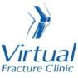

Trauma and Orthopaedics

Patella Dislocation
This is when your knee cap comes out of joint.

Healing:
It can take approximately 6 weeks for this injury to heal.
Smoking will slow down your healing. We would advise that you stop smoking while your injury heals. Talk to your GP or go to www.smokefree.nhs.uk for more information.

Pain and swelling:
Your knee will be swollen and you will have some pain. Swelling is often worse at the end of the day.
Taking pain medication, elevating your knee and using ice or cold packs will help. More information is on the next page.
It is normal to have mild pain and swelling for 3-6 months.

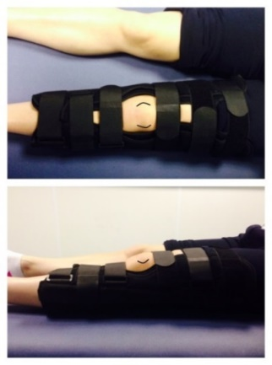
Walking and your brace:
The knee brace must be worn day and night. You can only take it off to wash or use a cold pack. You must keep your knee straight and replace the brace when you are finished.
You are allowed to put weight through your leg. You may find it easier to use crutches in the early stages.

Exercises:
It is important to start exercises as soon as possible. Instructions are on the next page.

Follow up:
You will have a face to face appointment 2 weeks after your injury. They will tell about the next stage of your rehabilitation. If you have not received your appointment letter within 1 week, please contact us.

Any questions:
If you are concerned about your symptoms, unable to follow this rehabilitation plan or have pain other than at your knee, please contact the Virtual Fracture Clinic team.

Caring for your injury

Remember to wear your brace. The specialist will tell you when you no longer need the brace. This video provides you with a guide for fitting your brace: https://vimeo.com/386673392
Using a cold pack will help with your pain and swelling. You can use an ice pack or bag of frozen peas wrapped in a damp towel. Put this on your knee for up to 15 minutes every few hours. Make sure the ice is not in direct contact with your skin.
Try to rest your knee, especially in the first 24-72 hours. Raise your leg on a stool or cushions to that it is above the level of your hip. This will help to reduce your swelling.
Exercises:
Early movement of the ankle and foot is important to promote circulation and reduce the risk of developing a Deep Vein Thrombosis (blood clot). If you notice any swelling or redness in the calf, please attend A&E.
Do these exercises 3-4 times a day. Start straight away, you do not need to push into pain.
Ankle Exercises
Point your foot up and down. Repeat this 10 times.
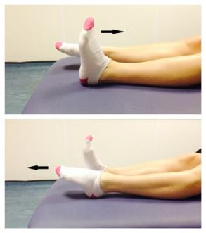

Static Quadriceps Exercise
Rest with your leg supported and straight. Gently tense the muscles in your thigh and try to straighten your knee further. Hold for 5 seconds and repeat 7-10 times.
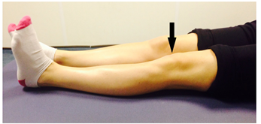

Frequently Asked Questions

I am struggling with my brace. What do I do?
Please contact the Virtual Fracture Clinic.
When can I start driving?
You can return to driving when:
- You are no longer using your brace,
- You can walk comfortably
- You can perform an emergency stop pain free.
Always test your ability to drive in a safe environment first.
How can I get a certificate for work?
You can get a fitness for work statement from your GP or the doctor at your Fracture Clinic appointment.
What do I do with my brace and crutches when I no longer need them?
We are not able to use brace again. These should not be return to the hospital.
Crutches can be returned to the Fracture Clinic or A&E.
I haven’t received my appointment letter. What do I do?
Your first appointment will be made by the Virtual Fracture Clinic team. If you have not received your appointment letter please contact us.
How do I contact the Virtual Fracture Clinic?
Call 01582 718121. Messages will be checked every morning Monday-Friday.
Email VFC@ldh.nhs.uk

Some pictures and content produced by Brighton and Sussex University Hospital and shared with permission.

Bedfordshire Hospitals NHS Foundation Trust
Luton and Dunstable University Hospital
Lewsey Road
Luton, LU4 0DZ

www.bedfordshirehospitals.nhs.uk
@LandDHospital

